Associate/Assistant Deans Council
Agenda for January 21, 2025
2:00 – 3:00pm

Upcoming Meetings, Spring 2025
- Tuesday, February 25, at 2:00 – 3:00pm (Revised Date - Moved from February 18)
- Tuesday, March 18, at 2:00 – 3:00pm
- Tuesday, April 15, at 2:00 – 3:00pm

Upcoming Meeting for Summer 2025
- Tuesday, June 17, at 2:00 – 3:00pm

CONTINUED AGENDA ITEMS

Graduate Studies
Carl Mummert

Midterm Grades – All Grades for All Students
Sherri Stepp
- We confirmed that our last catalog update for midterm grades was not updated on the actual policy, UPAA-5. The current policy says midterm D/F/W for freshmen and sophomores only.
- We are going to move forward with proposing the midterm grade policy be updated to ALL grades for ALL undergraduate students. In the case that is not approved, we will need to propose the policy be updated to include the current practice (as reflected in the catalog) of D/F/W grades for all undergraduate students.

NEW AGENDA ITEMS

Academic Dishonesty Policy
Anna Mummert

Catalog Updates - Dean’s List & President’s List
Elizabeth Hanrahan

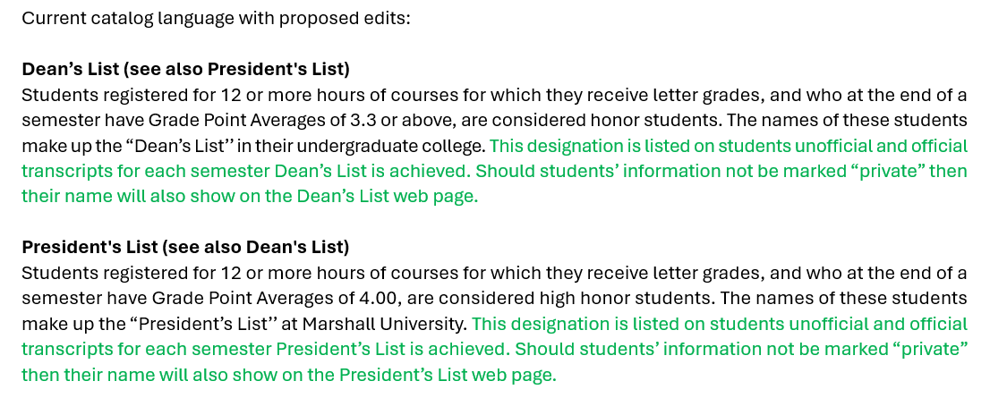

ADDITIONAL DISCUSSION

