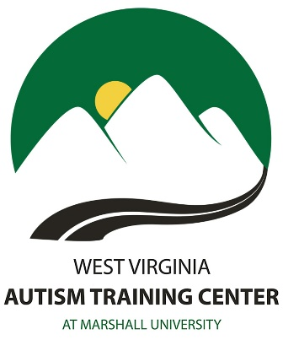

Each fall and spring semester, The College Program holds weekly, one-hour long skill group meetings for students with a diagnosis of Autism Spectrum Disorder. These meetings, called Discovery Groups, are facilitated by College Program staff and provide an opportunity for students to learn about and practice a variety of skills and strategies related to the areas of academics, socialization, and independent living. Discovery Group is also a chance for students to connect with their peers and share their experiences in a safe and comfortable environment.

Ideal participants for Discovery Group should
a) possess a growth mindset essential for effective skill development;
b) be able to communicate with College Program staff and other group participants about their challenges, experiences, and goals;
c) show respect for diverse identities and perspectives

An application to be considered to attend “Discovery Group” and will be accepted only if it includes:
- A clinical psychological evaluation (school-based, or psycho-educational evaluations, will not be accepted) dated within three years of this application;
- The results from an intelligence evaluation, such as the WAIS-III, accompanied by subtest scores and a detailed, narrative report;
- Results from achievement testing (for example, the Woodcock-Johnson Achievement and the Peabody Individual Achievement tests);

The cost to attend Discovery Group is $500.

Below is a list of example topics from previous semester agendas used by College Program staff. Please note, this list is not a definitive indicator of the agenda for the coming semester.

- Developing a social radar
- Time management and smart goals
- Relationship building and communication
- Romantic relationships
- Building a reputation on campus
- Decision making and conflict resolution
- Stress and anxiety
- Anger management

If these topics seem interesting and worthwhile to you, then we encourage you submit an application by providing the necessary information found on the second page of this form and then mailing it to us at the following address:

Rebecca Hansen, Ed.D.
Director of Campus-Based Services
The West Virginia Autism Training Center
Old Main, Room 316
One John Marshall Drive
Huntington, WV 25755
Or you can email the application to fuller26@marshall.edu

Applicant Name: _________________________________________________________
Nickname, or the name you prefer to be called: _________________________________
Street or mailing address: __________________________________________________
City: ___________________, State: ______________ Zip code: ___________________
Home telephone: ___________________ Cell Phone: ___________________________
Email: ____________________________________________
Date of birth: _____________ Age: _____
Gender Identity: _____________ Citizenship______________
Parent Name(s): __________________________________________________________
Parent Email(s):__________________________________________________________

Diagnostic Information:
Please check off the diagnosis you have received that make you eligible for our services:
- Asperger’s Disorder
- Autistic Disorder
- Pervasive Developmental Disorder, Not Otherwise Specified (PDD-NOS)
- Autism Spectrum Disorder (Level_____)

Please list the name and contact information of the licensed professional who provided the ASD diagnosis, along with the date the diagnosis was given.
Diagnostician name: ______________________________________________________
Telephone number: ______________________ Date of diagnosis: _________________
The diagnostician is a (check one): _____ Licensed psychologist; _____ Licensed psychiatrist; _____ Licensed medical doctor; _____ other (write-in):_______________

CONSENT: I hereby authorize College Program staff to contact the person(s) listed above to obtain diagnostic confirmation of my Autism Spectrum Disorder (please sign below):

Name: _________________________________ Date: ___________________________

Please list your reasons for wanting to participate in Discovery Groups at Marshall University: _____________________________________________________________ ________________________________________________________________________

What topics do you hope to learn about and discuss as a participant in Discovery Groups? ________________________________________________________________________________________________________________________________________________

