Blackboard - Creating an Assessment

Quick Guide for Faculty

To create an Assessment:
- Proceed to the Course Content area to which you would like to add an Assessment.
- Click Assessments, then click Test.

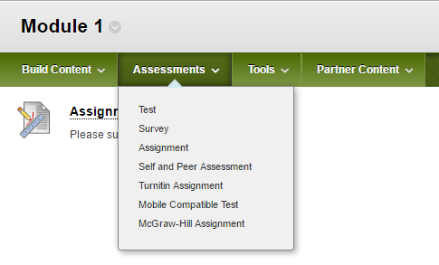
- Click Create to create a new test.
- Provide a name for the Assessment.
- Choose to either Create Questions or Reuse Questions.
- In this example, a multiple choice question will be created.
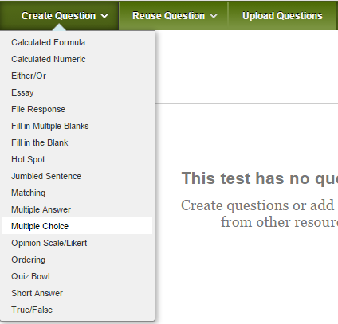

- A question title can be added, but is not required. Include the Question Text.
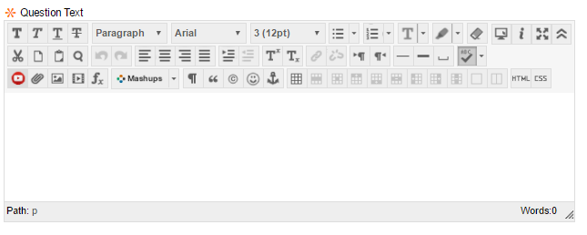

- Select the number of answer choices to display to the students.
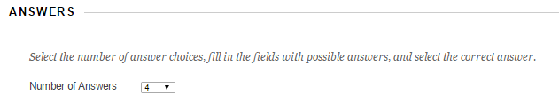

- Include an answer choice for each box.
- Click the radio button to the left of the correct answer.
- Correct Response Feedback and Incorrect Response Feedback can be entered, but neither are required.
- Click Submit button at the top or bottom to save the changes and create the question.
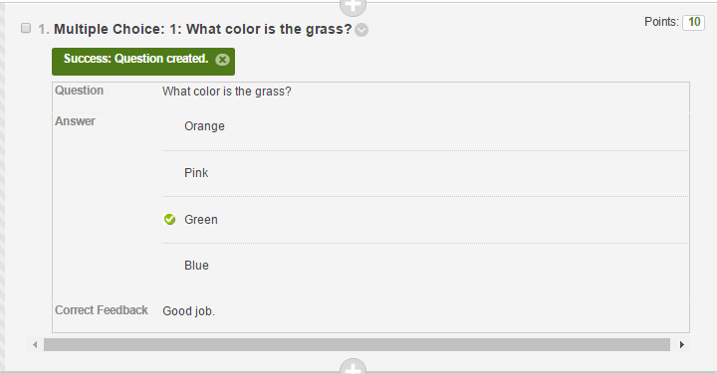

- Click Ok in the lower right.
- It will return to the page that gives the options of creating a new test or adding an existing test. We want to add the test we just created to the Module 1 content area. Click to highlight the test, then click Submit.
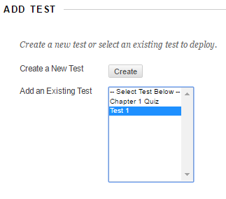

- Before adding the test to the content area, it will proceed to the Test Options.
- The name can be changed and a Content Link Description can be provided to give a brief description about the assessment, but it is not required. 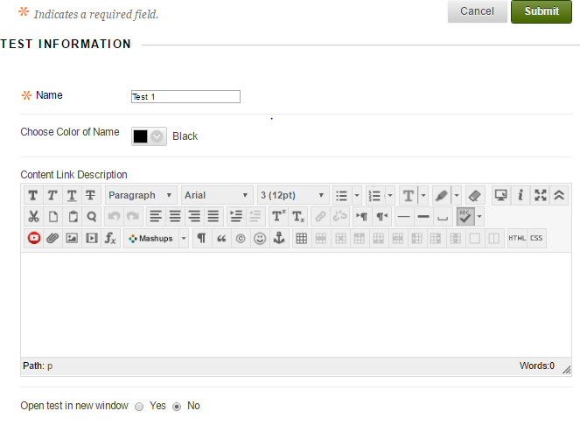
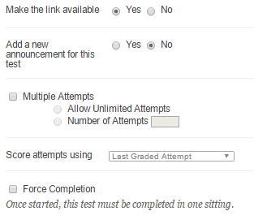
- Make the link available controls the availability of the assessment to students. Note: This availability can be narrowed by Availability dates, mentioned in later steps.
- Adding a new announcement will post an Announcement on the My Annoucements page. If the test is controlled by an availability date, the announcement will not appear until the beginning of that availability date.
- Leaving Multiple Attempts UNCHECKED allows students ONLY 1 attempt on the assessment. To allow Multiple Attempts, check the box and then select either Allow Unlimited Attempts or Number of Attempts and type in the number of attempts you wish to provide to students.
- If Multiple Attempts are selected, several options will be listed for Score Attempts using. That choice can be selected from the drop down menu.
- DO NOT check Force Completion. If on, it could interfere with test taking as any glitch in connection will directly submit the student’s atttempt, even if they have not completed the assessment. If a browser crashes, the student will be able to click on the exam again to continue where they left off, with the timer still running.
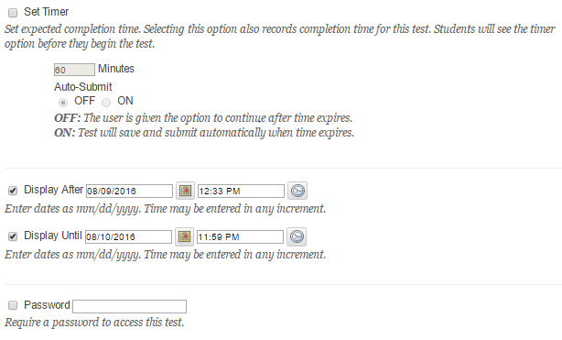
- If the assessment is timed, check the box for Set Timer and then include a value in terms of minutes.
- Auto-Submit allows the ability to submit the exam when time runs out, or the ability to allow more time.
- OFF: The user is given the option to continue after time expires.
- ON: Test will save and submit automatically when time expires.
- Test Availability Exceptions can be used to allow students with Academic Accommodations a different amount of time for the assessment, a different test date; or one can alter other settings to allow for different conditions than the normal test settings.
- A Due Date can be included for the Assessment. There is the option to not allow students to take the Test after the due date has passed, or leave it unchecked to allow students to continue to take the assessment after the due date has passed.
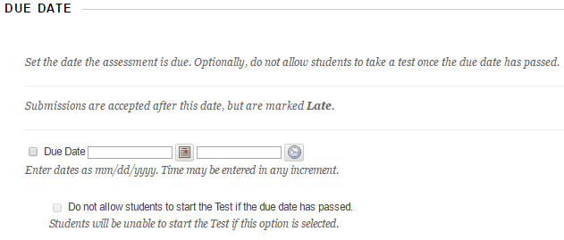

The Feedback options can be edited to provide students a certain amount of feedback at a certain time.
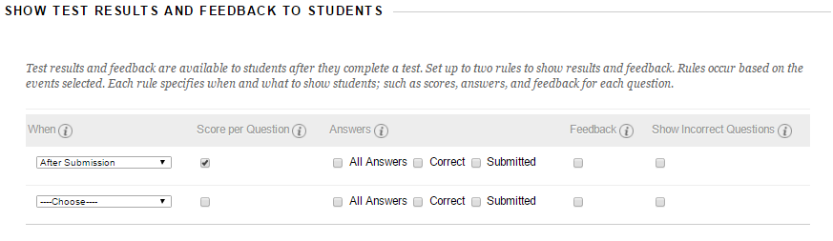

- The assessment questions can be presented all at once, displaying all questions on one screen; or they can be displayed one at time. Prohibit backtracking can be used if allowing questions to be viewed one at a time, preventing students from revisiting previous questions. Randomize Questions also randomizes questions for each test attempt.
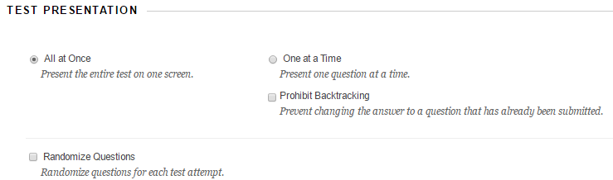
- Click Submit to save the changes.

