Respondus Lockdown Browser &
Monitor Instructions for Faculty

What is Respondus LockDown Browser (LDB)?
LockDown browser is a custom browser that locks down the testing environment in Blackboard. When students use LockDown Browser to take an assessment, they are unable to print, copy, go to other websites, access other applications, or close a test until it is submitted for grading. The browser functions much like a regular browser (like Chrome, Safari, Firefox), but some options have been removed or work differently.
Note: if you have an assessment that requires students to use another software or tool on their computer in order to evaluate a question and answer it, LDB will not allow them to access those other materials. If you require students to use a weblink in conjunction with a question, a new secure browser will open for students to see the weblink you have provided.
What makes the Lockdown Browser different from a regular browser?

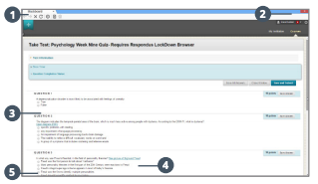
- Modified Toolbar – the condensed toolbar includes only forward, back, refresh, and stop functions.
- Test Mode – tests are shown full-screen and cannot be minimized, resized, or exited until submitted for grading.
- Disabled controls – all printing, keystroke combinations, screen grab, function keys, and right-click menus are disabled.
- Links – links to other web servers will open in a new, secure window, and prevent browsing beyond that page.
- Blocked features and applications – the Start button (for Windows PCs), system tray, and menu bars have been removed.

Considerations When Planning to Employ the Use of LDB for a Test:
- Have I used other methods for ensuring test integrity? Offering more quizzes for students to self-assess their competencies as they move through content, with shorter number of total questions, with a timer, randomized questions, with no back-tracking, are all features of a regular test that can be applied first. When these features are utilized, it greatly reduces the need for LDB.
- LockDown Browser is a browser, so students must install it first on any computer they plan to use for an exam. Students must be told about this; if they are using a computer they do not own, like at a public library, they may not be able to download the browser on that computer. They should work with a library employee to determine whether or not this is feasible. The students must understand they have to download this and test its use prior to taking the first exam with LDB deployed.
- Have I provided students with a low-stakes, zero-point, opportunity to test the browser and troubleshoot issues prior to taking a graded assessment? Many instructors create a short quiz for students to practice using LDB prior to using it in an exam. Students should have ample opportunity to troubleshoot and learn the new tool prior to using it in an actual assessment.

Preparing a Test with LockDown Browser
To set up a test in Blackboard that requires LDB, follow these steps:
- Make sure the test has been created and deployed to a content area (meaning, it’s linked somewhere in your course where students would be able to click the link to begin the test).
- From the Control Panel (bottom left of course, under the students’ Course Menu) in your course, select Course Tools, then select Respondus LockDown Browser.
- A list of deployed tests will be displayed on your screen.
  - Tests labeled with “Required” require students to use LDB.
  - Tests labeled with “Not Required” do not require students to use LDB.
- To change the setting for the test, select Settings from the drop-down arrow menu to the left of the test title.
  - Select “Require.”
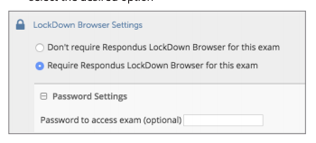
  - IMPORTANT: DO NOT add a password to the test. The test pairs to Blackboard through a password that the system automatically creates. In your Edit Test Option page, you are also given an option to add/change the password. You will see an auto-generated password in this text area that note that a password has already been applied. Do not change/add to/remove this password on the Edit Test Options page. This password is how the system connects your test to LDB.
- There are several “Advanced Settings” available as well: 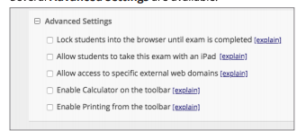
  - “Lock students into the browser until the exam is completed” will prevent students from exiting the browser until the exam is completed. If a student is logged out of Blackboard during a test in which LDB is being used, the student won’t be able to exit and come back and resume the test, so use caution with this choice.
  - “Allow students to take this exam with an iPad” is straight-forward; however, you should consider that there is no “tracking” system on mobile devices for Blackboard, so a student will have no recourse if they believe an exam has been submitted and there’s no record of it in the Grade Center. We can track this sort of data for non-mobile devices.
  - “Allow access to specific external web domains” is the choice for allowing students to access web links during the test, but you must specify the web links.
  - “Enable calculator on the toolbar” provides the students with a calculator.
  - “Enable printing from the toolbar” will enable the print function on the browser for that exam.
*Note: You must select Save and Close to apply the settings.

Link for Students to Use to Download LockDown Browser
The URL that should be provided to students in either the Syllabus, the Start Here, or the first area of course content is:
http://www.respondus.com/lockdown/download.php?id=323615594

Adding Respondus Monitor
What is Monitor?
Respondus Monitor is a webcam feature for LockDown Browser that records students during online, non-proctored exams. When this feature is enabled for a test, students are required to use LockDown Browser, plus a webcam and microphone. After the exam is complete, the instructor can view details of the assessment, even the recorded videos.

Considerations for Using Monitor:
- How will I be able to accommodate or work with students who are testing in a public area?
- Did I remember to tell my students in the Syllabus that they should have access to a webcam and microphone?

How to Add Monitor to an Assessment
Any exam that requires Monitor must also require LockDown Browser.
- On the Repondus dashboard (in Course Tools), set the exam so it requires the use of LockDown Browser. Several options are then available for Respondus Monitor. To require Monitor, select “Require Respondus Monitor for this Exam.”
- Now you will select items to be included in the student’s “Startup Sequence.” These are the steps a student must complete prior to the start of an exam. The settings are optional and can also be re-ordered by dragging and dropping them into the desired order. You will also be able to preview each item, as well as Edit your test to include instructions for certain items (if applicable).
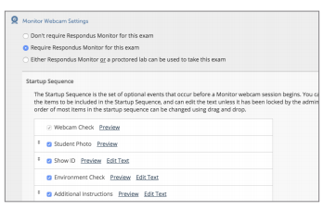
  - Webcam check
  - Student Photo (will take photo)
  - Show ID
  - Environment check (show your surroundings)
  - Additional instructions you would like to add.
Note: All of these items that you choose must be first given to the students in the Instructions area of the exam or prior to the exam. Otherwise, students may not have their ID with them or be unable to show their surroundings due to the nature of the test location they have chosen.

How Do I Review Monitored Videos?
Once the video session report has been completed, instructors can access information about the exam sessions and can review the recorded videos. Respondus is meant to be a deterrent, so the instructor must determine the level of review warranted.
To review student videos:
- Return to the Respondus dashboard in Course Tools.
- From the drop-down arrow menu to the left of the test name, select Class Results.
- A roster of students in the course is shown, along with the date, time, duration of the test, review priority, and grade (if applicable).
- Click the plus sign [+] to expand the section for a student.
- Details of the startup sequence and the exam session are shown in thumbnails. Click a thumbnail to view the video from the time indicated. Videos can be marked as reviewed or have comments added by the instructor.

Other Training and Support
- Student Quick Start Guide from Respondus
- Demo Movies
- Knowledge base and Ticket-based Support

