# logo1Blackboard SafeAssign

## Quick Guide for Faculty

### SafeAssign

*SafeAssign* is a plagiarism prevention tool that detects unoriginal content in students' papers by identifying areas of overlap between submitted assignments and existing works. *SafeAssign* can also be used to help students identify how to properly attribute sources rather than paraphrase without giving credit to the original source. The *SafeAssign* feature is effective as both a deterrent and an educational tool.

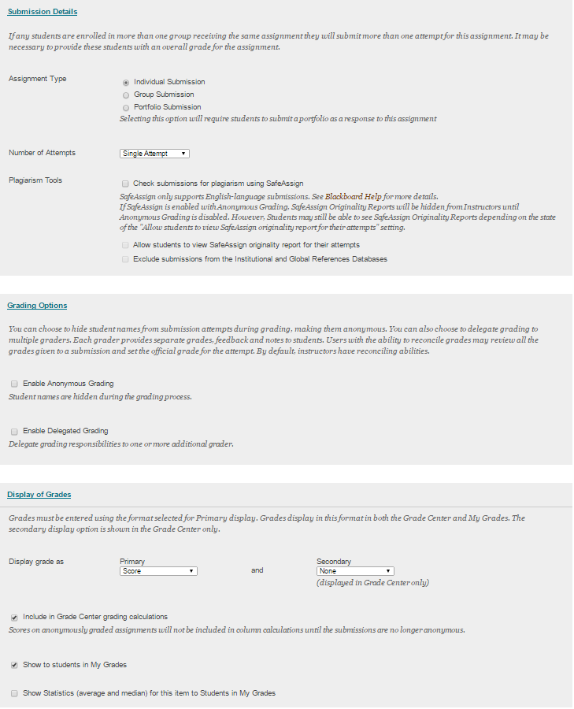

### Enabling SafeAssign

1. Log into Blackboard.
2. Open your course and navigate to the area where you would like to have an assignment placed.
3. Hover over *Assessment* in the Action Bar and click **Assignment** to create a new assignment.
4. Once in the *Create Assignment* screen, set up an assignment as you would normally.
5. Under *Submission Details*, check the **Check submissions for plagiarism using SafeAssign** box.
6. Optional: You may allow students to view the originality report, and you may exclude student submissions from the reference databases.*
7. Finish creating your assignment and click **Submit.**
8. To select a template, click the appropriate template in the pop-up box and click the **Submit** button
9. Type a *Description* (optional)
10. Click the **Submit** button

*This option will allow faculty to create Assignments that do not include any student submissions in the Institutional or Global Reference Databases, enabling students to "check their work" against SafeAssign sources prior to submitting a final version without subsequently revised drafts being flagged as matching the previous "draft" submissions.

**Accessing the SafeAssign Originality Report**

1. 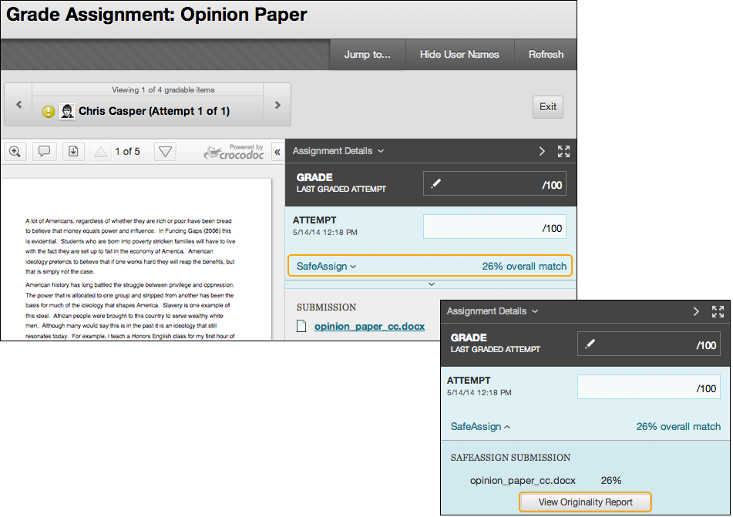Within your *Grade Center*, access the *Grade Assignment* page from the grade column or the *Needs Grading* page.
2. On the *Grade Assignment* page, a SafeAssign section appears in the grading sidebar. While the report is processing, the following statement appears: *Report in progress...* When the report is ready to view, a percentage appears in the grading sidebar.
3. Expand the *SafeAssign link* and click **View Originality Report** to view the results in a new window.
4. The SafeAssign report is divided into three areas: report information, citations, and manuscript text.
   * ***Scores below 15 percent:*** These papers typically include some quotes and few common phrases or blocks of text that match other documents. Typically, these papers don't require further analysis as there is no evidence of plagiarism.
   * ***Scores between 15 percent and 40 percent:*** These papers include extensive quoted or paraphrased material, or they include plagiarism. Review these papers to determine if the matching text is properly referenced.
   * ***Scores over 40 percent:*** A very high probability exists that text in these papers was copied from other sources. These papers include quoted or paraphrased text in excess, and need to be reviewed for plagiarism.

