THE TITLE OF YOUR THESIS GOES HERE: CENTER ON PAGE AND USE ALL CAPITAL LETTERS AND SINGLE SPACING

Marshall University

Month 2016

A thesis (dissertation) submitted to

the Graduate College of

Marshall University

In partial fulfillment of

the requirements for the degree of

Name of Degree

In

Name of Program

by

Your Full Name

Approved by

Dr. Able Baker, Committee Chairperson

Dr. Clark Davis

Dr. Edgar Forest
APPROVAL OF THESIS

We, the faculty supervising the work of [Full Name of Author], affirm that the [thesis/dissertation], [Full Title of Thesis/Dissertation Printed in Italics and Upper and Lower Case Letters], meets the high academic standards for original scholarship and creative work established by the [Name of Degree Program] and the [Name of College]. This work also conforms to the editorial standards of our discipline and the Graduate College of Marshall University. With our signatures, we approve the manuscript for publication.

Dr. Jane Doe, Department of Psychology Committee Chairperson Date

Mr. Robert Johns, Department of Psychology Committee Member Date

Dr. Jack Mason Department of Sociology Committee Member Date

{add as needed}

© 2016

Your Full Name
ALL RIGHTS RESERVED
ACKNOWLEDGMENTS

I want to thank all the people who helped me along the way.

TABLE OF CONTENTS

List of Tables vi
List of Figures vii
Abstract viii
Chapter 1 1
The Title of This Section 1
The Title of A Subsection 1
A Block Quote Example 2
A Level 4 Heading 2
References 5
Appendix A: Office of Research Integrity Approval Letter 6
Appendix B: Optional Additional Appendix/Appendices 7
Appendix X: VITA 8

List of Tables
Table 1 Full Title Table 2

List of Figures
Figure 1. Full Title of Figure 3
Figure 2. Migrant Mother (1936): Florence Owens Thompson and Her Children. 4

Abstract
Lorem ipsum dolor sit amet, consectetur adipiscing elit. Morbi velit lectus, congue a arcu nec, commodo ullamcorper dui. Nullam libero neque, suscipit nec lorem quis, ultrices ullamcorper est. Curabitur odio lectus, cursus quis commodo nec, suscipit vel eros. Curabitur commodo at quam eget rhoncus. Nulla molestie id leo sit amet rhoncus. Mauris id ultrices purus, vel sollicitudin sapien. Proin vitae neque metus. Donec ultrices nisl eu quam suscipit, quis interdum justo ultrices. Curabitur ac fringilla velit. Donec varius arcu vitae ligula ornare, eget congue lectus elementum. Nulla facilisi.–

Chapter 1

The Title of This Section
Lorem ipsum dolor sit amet, consectetur adipiscing elit. Morbi velit lectus, congue a arcu nec, commodo ullamcorper dui. Nullam libero neque, suscipit nec lorem quis, ultrices ullamcorper est. Curabitur odio lectus, cursus quis commodo nec, suscipit vel eros. Curabitur commodo at quam eget rhoncus. Nulla molestie id leo sit amet rhoncus. Mauris id ultrices purus, vel sollicitudin sapien. Proin vitae neque metus. Donec ultrices nisl eu quam suscipit, quis interdum justo ultrices. Curabitur ac fringilla velit. Donec varius arcu vitae ligula ornare, eget congue lectus elementum. Nulla facilisi
Cras venenatis lacus vel urna molestie luctus. Praesent ut fringilla mi, id convallis orci. Maecenas a vulputate arcu, id vestibulum urna. Maecenas auctor venenatis maximus. Praesent sodales lorem sed dictum porta. Morbi at augue tempor, laoreet quam vel, tempor sapien. Aliquam at bibendum urna, lacinia scelerisque arcu. Morbi scelerisque volutpat arcu, non blandit neque.

The Title of A Subsection
Nunc ultricies libero nec elit convallis, sit amet auctor justo condimentum. Vivamus at laoreet mauris. Phasellus aliquet consequat enim, quis vestibulum ligula faucibus eget. Suspendisse potenti. Ut aliquet purus ac tellus feugiat vehicula. Duis eu ex orci. In ac dolor eu ligula mollis rutrum quis in arcu. Donec sem ex, auctor sit amet nisl eu, tristique consectetur metus. Duis rutrum, metus non ultricies rhoncus, lorem magna ullamcorper mauris, ut vestibulum nisi est ac nisi. Cras eu ante rhoncus, fringilla sapien in, laoreet quam. Pellentesque consequat, nisi nec luctus pellentesque, ex sapien luctus justo, at dignissim arcu sapien non tortor. Sed ultrices convallis nunc, gravida varius ex. Nullam laoreet leo non augue convallis faucibus. Lorem ipsum dolor sit amet, consectetur adipiscing elit. Donec consequat dapibus lorem, nec pharetra dolor feugiat ac

A Block Quote Example
Maecenas sit amet elit magna. Pellentesque urna purus, auctor quis ultricies eget, pharetra quis leo. Quisque feugiat risus et massa imperdiet elementum. Donec a enim libero. Fusce in eros eros. Integer ut dolor sed mauris tristique ullamcorper. Phasellus semper scelerisque lorem at rhoncus. Cras dignissim, orci eu varius malesuada, nisl lacus varius ante, in gravida ante justo ut nulla. Quisque pulvinar arcu faucibus urna dignissim scelerisque. Vestibulum iaculis sapien ac fringilla pharetra. Curabitur scelerisque viverra nisl. Aliquam posuere massa ut ultrices feugiat. Sed pellentesque lacinia tellus, nec luctus odio porta et. (Quanto, 1232)
Nullam eros felis, placerat at semper a, consectetur rhoncus sapien. Ut vel arcu quam. Donec ultrices non purus et bibendum. Aliquam hendrerit, lectus eget sollicitudin elementum, turpis lectus viverra ligula, sed imperdiet arcu lectus at augue. Sed volutpat dolor sed commodo feugiat. Proin elementum velit eu sapien consequat, sit amet porta risus malesuada. Cras maximus malesuada mattis. Quisque vel egestas tortor. Praesent eros nisl, commodo eget nunc ac, feugiat lobortis ex. Pellentesque maximus maximus feugiat.

A Level 4 Heading
In hac habitasse platea dictumst. Proin eu dolor nec mi dapibus efficitur. Vivamus mollis nisi eget mi cursus efficitur. Aliquam sit amet commodo arcu, vel cursus purus. Nunc ac blandit lectus. Nullam tincidunt vel mi eget luctus. Duis dapibus elementum lectus, id sagittis lacus porta ac. Morbi sem nisl, ornare ac aliquam at, luctus id velit. In pretium dignissim nibh, in venenatis velit volutpat vel. Proin sit amet enim lorem.
Column Title Column Title Column Title
Row Title A = π r² 23.5
Row Title A = W H 567.0
Table 1 Full Title Table
Aliquam massa dui, malesuada quis egestas vitae, dignissim in ligula. Proin tortor mi, ultricies non sapien ac, mollis iaculis metus. Nam gravida nulla enim, a ultrices diam rutrum id. Vivamus finibus congue mollis. Donec cursus neque at imperdiet fringilla. Nulla volutpat, velit eu bibendum porta, est dolor viverra erat, sit amet interdum arcu lorem et arcu. Aliquam neque lorem, porta et porttitor non, condimentum quis diam. Aenean ex odio, vehicula non semper ut, auctor quis tellus.

Figure 1. Full Title of Figure
Donec gravida non risus quis vestibulum. Quisque pulvinar felis ligula, sed bibendum magna mattis mollis. Vivamus semper tincidunt nunc, ut suscipit arcu interdum vel. Fusce pretium, odio ac porta ullamcorper, purus lorem bibendum nunc, nec scelerisque elit nisl non dolor. Cras ut eros in eros lobortis suscipit ac in risus. Duis sit amet ex eget neque rhoncus sollicitudin sit amet vel eros. Mauris at vehicula tellus. Phasellus iaculis elit non magna pellentesque tempus. Aliquam ultricies tellus a ligula consectetur semper.
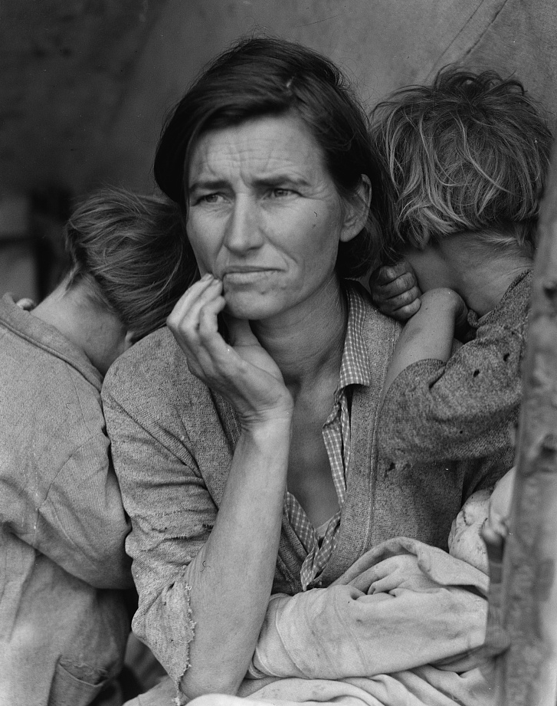
Figure 2. Migrant Mother (1936): Florence Owens Thompson and Her Children.
The photograph was made as a part of the Farm Security Administration project to document the effects of the great depression. Migrant Mother (1936), Dorothea Lang. Library of Congress Prints and Photographs Division Washington, DC 20540 http://hdl.loc.gov/loc.pnp/pp.print.

References
French, A. M., & Read, A. (2013). My mom's on Facebook: An evaluation of information sharing depth in social networking. Behaviour & Information Technology, 32(10), 1049-1059. doi:10.1080/0144929X.2013.816775
Gromer, J. (2014). Review of 'All we have to fear: Psychiatry’s transformation of natural anxieties into mental disorders'. Research On Social Work Practice, 24(1), 158-159. doi:10.1177/1049731513498515
{Please note that the example presented here may be different from the format used by your discipline’s preferred style guide. As such, you can change the format as necessary. Regardless, the citation should remain single spaced with a 12-point space after the entry. If you need to change the indentation of the citation, right click on the “Citation” button in the Styles Ribbon and then select the Update Citation to Match Selection option. Once you accept the changes, all paragraphs marked Citation will be formatted using the modifications you made. Text that needs to be italicized or underlined will need to be changed manually.}

Appendix A: Office of Research Integrity Approval Letter
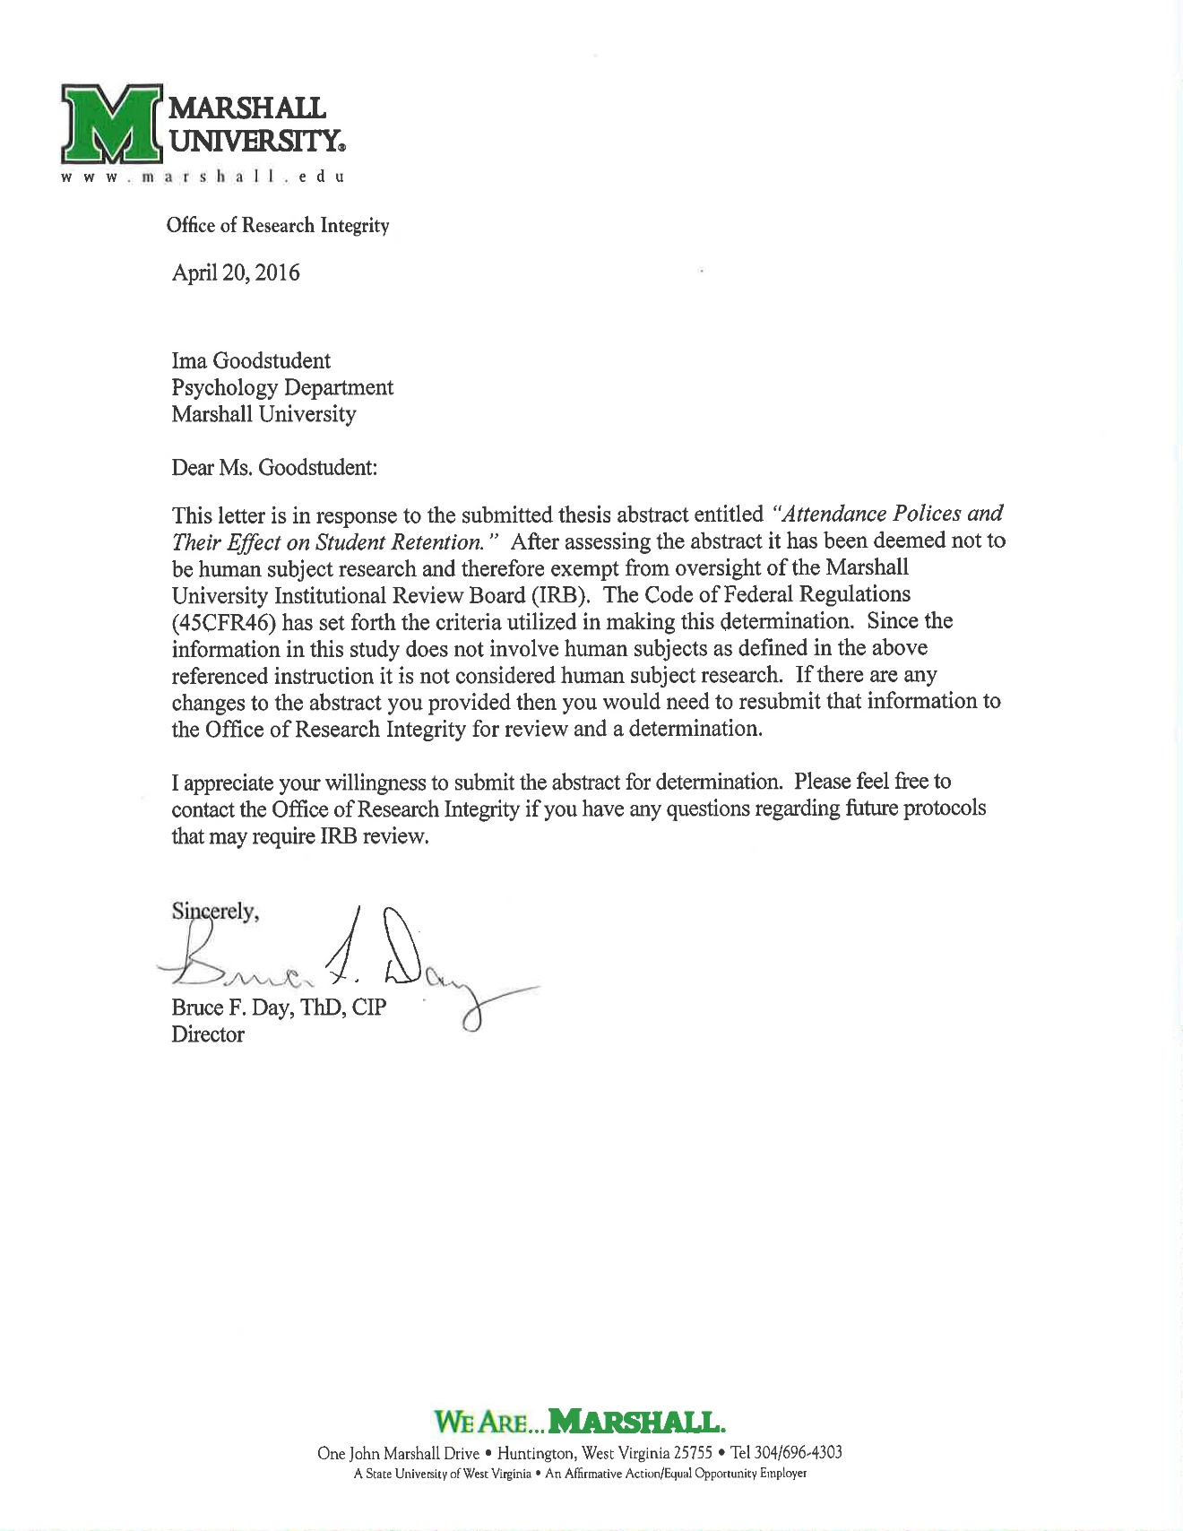

Appendix B: Optional Additional Appendix/Appendices
{You may add appendices to supplement your thesis as needed. For example, you may have lengthy tables, transcription of dialogue, survey questions, or other material that, while important for integrity of the thesis, is not appropriate for the narrative section of your work.}

Appendix X: VITA
–––IMA GOODSTUDENT
Education
2012 BA Psychology Bethany College
Bethany, WV 26032
Cumulative GPA 3.89
Work Experience
2010-2012 Graduate Teaching Assistant
Department of Psychology

2008-2010 Admissions Counselor
Bethany College

2006-2008 Residence Hall Associate
Bethany College

2002-2008 (summers) Grounds Crew
Ideal Greens Golf Course
Bethany, WV

General Skills
Language Proficiency: Fluent in French
Computer Skills: Proficient with Microsoft Office Suite, Adobe Photoshop and InDesign, SPSS, and Visual Basic and C++ languages.

Publications
Goodstudent, I., & Mewaldt, S. (2010). Revisiting the value of Spence’s concept of D to explain the partial reinforcement extinction effect. Poster presented at the annual meeting of the West Virginia Psychological Convention, Charleston, WV.

