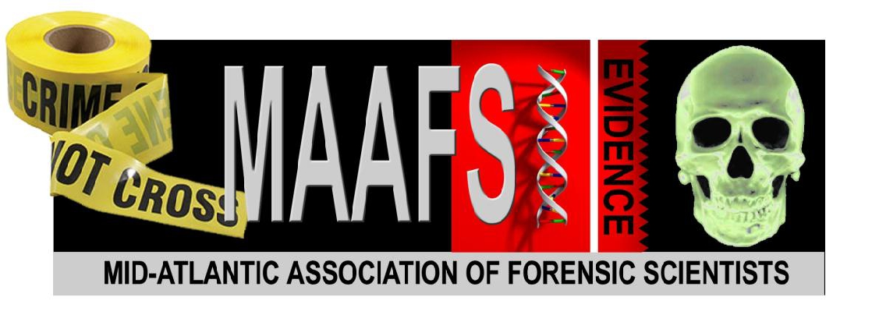

2013 Mid-Atlantic Association of Forensic Scientists Annual Conference
May 6-10, 2013
Hotel Roanoke, Roanoke, Virginia

CALL FOR PAPERS – ABSTRACT FORM

Deadline for Papers – MARCH 1, 2013
PRESENTER/AUTHOR INFORMATION

First Name: Last Name:

Agency:

Phone: Email:

Co-Author(s) if applicable:
Note: Only the presenting author is eligible for the Paper Presenter Registration rate. Co-Authors must pay full registration fee.

Forensic Discipline: Please select one.

BIOLOGY CRIMINALISTICS QUESTIONED DOCUMENTS OTHER

PRESENTATION INFORMATION

Time Needed for Presentation: Please check one. 10min. 20 min. 30 min.

Schedule Preference: Section chairs will try to accommodate time slots as much as possible. Please check below if you have a preference.

Wednesday, May 8, 2013 – Afternoon

Thursday, May 9, 2013 – Morning

Friday, May 10, 2013 – Morning

No Preference

Note: A projector and laptop computer will be provided as well as a microphone if necessary. If you have any additional audiovisual equipment needs, please indicate below.
>
Please type abstract below or include your abstract in a Word document when submitting this form.
PRESENTATION ABSTRACT
Limit your presentation abstract to 4-5 sentences. MAAFS reserves the right to truncate abstracts that exceed the length necessary.
>

SUBMITTING FORM & ABSTRACT

Complete form and email it to the Meeting Planning Co-Chair AND your appropriate Section Chair. Please check the appropriate people you will be emailing.
Allison Murtha, Meeting Planning Co-Chair maafsmtg@gmail.com, 724-387-1876
Kelly Knight, BIOLOGY Chair
kelly.knight@maryland.gov, 443-357-1423

Graham Rankin, CRIMINALISTICS Chair
rankinj@marshall.edu, 304-691-8950

Diane Lawder, QUESTIONED DOCUMENTS Chair
diane.lawder@maryland.gov, 443-357-1395

