The identification, derivatization, and quantitation of fentanyl analogs in solid-dose form.
Bailee J. Short, BA¹, Lauren M. McCormick, BS², Lauren R. Waugh, PhD², Carolyn E. Trader-Moore, MS², ¹Marshall University, 1401 Forensic Science Drive, Huntington, WV 25701; ²Kentucky State Police, 1550 Wolohan Drive, Suite 2, Ashland, KY 41102

Abstract
Fentanyl is a schedule II synthetic opiate analgesic first synthesized in 1960 that has similarities to morphine, but is far more potent. Like heroin and morphine, fentanyl works by binding to opioid receptors in the brain. This causes higher levels of dopamine in the body, resulting in a euphoric, relaxed state. Because of these desirable effects, fentanyl was widely abused in the past. It is still abused presently, though not with the same rate due to its scheduling. However, analogs of the drug have been created and the prevalence of their abuse has been increasing in recent months. In fact, one of these analogs, acetyl fentanyl, has been linked to over 50 deaths in Rhode Island and Maryland. Due to this, the objective of this research was to first accurately identify and potentially derivatize these analogs using GCMS and then validate a quantitation method for acetyl fentanyl.
While having near-identical elution times, the analogs were easily differentiated by their mass spectra with the only analogs not differentiated being the cis and trans versions of the 3-methylfentanyl. Therefore, derivatization was mostly unnecessary. However, a cursory attempt at derivatization was performed and was successful in derivatizing and increasing the response of the acetyl norfentanyl but was unsuccessful in differentiating the cis and trans 3-methylfentanyl or in derivatizing any of the other analogs.
A quantitation method was developed and validated for acetyl fentanyl. The calibration models were successful in creating accurate curves that produced results for the controls within ±20% error of their expected values. Relative Standard Deviation and Coefficient of Variation (RSD and %CV) values produced from the data were within a narrow range (0.74% - 2.5%) and showed the relatively small deviation of the results. However, these results are in relation to the GC-FID results, the GCMS results were not as successful. Tailing was a major problem during this project that was unable to be resolved via changes to the method and could not be resolved with the instrument due to ongoing KSP casework. The selectivity study showed that acetyl fentanyl was able to be differentiated from the more commonly seen drugs of abuse, with the exception of heroin, which co-eluted with acetyl fentanyl in both the GC-FID and GCMS total ion chromatograms, though the GCMS spectra could still be differentiated by subtracting out the interfering spectra for each drug.
In future studies, it would be beneficial to develop more calibration models for the quantitation of other fentanyl analogs. Budget and time restraints prevented such action for this study but could be done at a later time. Other potential leads for this research could be discovering a derivatization agent that would be successful in derivatizing the analogs, more so to differentiate their elution times in the case of mixed samples than for the mass spectral results. The main issue that should be addressed in the future is developing a better GCMS method that resolves the tailing issues and better separates compounds with similar elution times.

Introduction
Fentanyl is a schedule II synthetic opiate analgesic first synthesized in the 1960s that has similarities to morphine, but is much more potent(1). Fentanyl was created by Paul Janssen, who was interested in developing the most potent narcotic analgesic possible. His logic was that with increased potency and specificity came increased safety(6). His success occurred in 1960 with the creation of fentanyl, a synthetic opiate 150 times more potent than morphine. His accomplishments resulted in a greater interest in understanding structure-activity relationships of narcotic analgesics and increased research into making more potent and also safer compounds(6). Like heroin and morphine, fentanyl works by binding to opioid receptors in the brain. Through this mechanism, the action of the drug causes higher levels of dopamine in the body, resulting in a euphoric, relaxed state(1). As such, fentanyl is a powerful pain reliever used for treating patients suffering from moderate to severe pain, whether from injury, illness, or post-surgery. It is also prescribed to those suffering from chronic pain who are physically tolerant to opiates(1). Side effects from fentanyl include such symptoms as euphoria, sedation, and respiratory depression. These symptoms are the same as those from exposure to other opioids such as morphine and heroin. Therefore, symptoms alone cannot be used to differentiate among exposure to different opioids(5).
Due to its effects, fentanyl was widely abused in the past and though its abuse continues at present, it is not as prevalent due to its scheduling and risk of overdose. However, like with many drugs of abuse today, chemists with clandestine labs are creating analogs of fentanyl to supply the demand for illegal opiates. Such analogs include acetyl and butyryl fentanyl, para-fluorofentanyl, 3-methylfentanyl, and several others. These analogs have no approved human use(5). It should be noted that there are analogs of fentanyl that exist outside of clandestine production, such as sufentanil and alfentanil, both of which have valid medical uses. Sufentanil is five to ten times more potent than fentanyl. Alfentanil, while less potent, works four times as fast as fentanyl. As such, both have applications in legitimate medicine, though both can still be abused.
As fentanyl analogs are being increasingly abused, there have been arrests with seizure of these drugs, along with cases of overdose, with a growing frequency in recent months. For example, from November 2013–March 2014, twice as many drug overdose deaths were reported in Rhode Island than were reported during the same period in past years(3). Further research finds that between 10 to over 50 deaths in Rhode Island and Pennsylvania in the past months have been attributed to acetyl fentanyl(2,3). Overdoses can be fatal and fentanyl is one of a few drugs where an overdose can result from a single ingestion. Toxicological screens of fentanyl analog overdose cases often show cocaine, ethanol, and benzodiazepines as well, indicating that these analogs are usually combined with other intoxicating substances(2).
As these cases are seen more frequently by drug analysts, an accurate identification and quantitation method will need to be developed and validated for drug chemists who need such information when analyzing seized drugs. There is research that has been performed on quantifying these analogs in urine for toxicologists, but not for the drugs in the seized, solid dosage forms that are analyzed by drug chemists(4,5,7). Thus the following research was performed to establish such a method for forensic drug laboratories, with the purpose of making the identification and quantitation of these analogs more straightforward for drug chemists. As part of this validation study, it was also important to establish certain parameters outside of the calibration model, such as selectivity, accuracy (bias), precision (repeatability), and limits of detection and quantitation (LOD and LOQ respectively).

Experimental
Materials
Due to the relative newness of the fentanyl analogs, it was necessary to purchase standards from various chemical companies, resulting in various forms of the purchased analogs including 1.0 mg/mL methanolic standards or solids which were then made into 1.0 mg/mL methanolic standards. Table 1 shows this data for each drug. Methanol was purchased from Fisher-Scientific (Pittsburgh, PA). Ethyl Acetate, Heptafluorobutyric Anhydride (HFBA), Pentafluoropropionic Acid (PFPA), and Procaine were obtained from Sigma-Aldrich (St. Louis, MO). Procaine was used as an internal standard during the identification and derivatization portion of the study. Deuterated fentanyl (for use as an internal standard for the quantitation portion of the research), cocaine, methamphetamine, heroin, alprazolam, and oxycodone standards were purchased from Cerilliant (Round Rock, TX) for use as an internal standard for the quantitation portion of the research. All reagents and solvents were either GCMS, LCMS, or HPLC grade. Drug standards were certified reference materials.
Table 1 - Drugs Purchased, source, and form received in
Drug | Company | Form Received In
Fentanyl | Cerilliant | 1.0 mg/mL methanolic std
Acetyl Fentanyl | Cerilliant/Cayman | 1.0 mg/mL methanolic std/Powder
Acetyl Norfentanyl | Cayman | Powder
Butyryl Fentanyl | Cayman | Powder
Para-Fluorofentanyl | Cayman | Powder
Alfentanil | Lipomed | 1.0mg/mL methanolic std
Sufentanil | Lipomed | 1.0mg/mL methanolic std
Cis-3-Methylfentanyl | Lipomed | 1.0mg/mL methanolic std
Trans-3-Methylfentanyl | Lipomed | 1.0mg/mL methanolic std

Sample Preparation for Identification/Derivatization
A method was adapted from Sabina Strano-Rossi et al(4). 50.0 µL of 1.0 mg/mL methanolic standard of each fentanyl analog was placed in a test tube on a hot plate for the methanol to evaporate. The residue was reconstituted with 100 µL of a derivatization agent (both PFPA and HFBA were tested separately) and then heated for 20 minutes at 55°C. The solvent was then evaporated and the residue was reconstituted with 300 µL ethyl acetate. 5.0 µL of procaine was added as the internal standard. The sample was then ready for analysis. For the initial underivatized samples, the same procedure was followed, with the exception of the addition of the derivatization agent. The underivatized samples were also run as plain methanolic standards, with no additional procedure except for the addition of 5 µL procaine as the internal standard. Samples were injected and analyzed on the instrument the same day they were prepared. The derivatization agents were decided upon based on the same paper that the preparation method was adapted from and by looking at other derivatization agents that were commonly tested in conjunction with PFPA.
Sample Preparation for Calibration Set-Up/Accuracy and Precision
For the preparation of the acetyl fentanyl calibrators and controls, five calibrators were prepared at 1.0, 0.75, 0.5, 0.1, and 0.01 mg/mL concentrations by diluting the initial 1.0 mg/mL standard with methanol. The controls were prepared in the same manner, with concentrations of 0.9, 0.4, and 0.05 mg/mL. All samples were spiked with 40 µl of 100 µg/mL deuterated fentanyl as the internal standard. Each set of calibrators and controls were analyzed on the same day they were prepared. To be considered valid data, the concentration of the controls established by the calibration model had to be within ±20% of the expected value. Percent Error, RSD, and %CV values were established for the data resulting from the control samples. Ion ratios for the mass spectra were established by running standards of the middle three calibrators and determining the average primary and secondary ion ratios. Each set of calibrators tested and used for the calibration model had to have average primary and secondary ion ratios that fell within ±20% of the initial standard ion ratios.
GC-FID/GCMS
An Agilent Technologies GCMS equipped with a 6890N Network GC system and a 5973 mass spectrometry detector and flame ionization detector was used as the chromatography instrument in this project. The column was 10 meters in length, had an I.D. of 0.18 mm, and a film thickness of 0.18 µm. The column had a ZB-Drug-1 stationary phase. The parameters used for the identification and quantitation can be found in Table 2, the only difference being the pressures.
Table 2 - GC-FID/GCMS Parameters
Ionization Port Temperature | 270°C
Initial Temperature | 85°C held for 0.75min
Ramp Rate | 15.0°C/min
Final Temperature | 305°C held for 0.75min
(Identification) Initial Pressure | 5.0 psi
Ramp Rate | 150.0 psi
Middle Pressure | 15.0 psi held for 6 min
Final Pressure | 40.0 psi
(Quantitation) Pressure | 20.0 psi held constant

Selectivity
The selectivity was established by spiking a 50 µL sample of acetyl fentanyl with 50 µL each of heroin, cocaine, methamphetamine, oxycodone, and alprazolam. The sample was run twice using the same GCMS method as the quantitation model.
LOD/LOQ
The limits of detection and quantitation were determined by locating the approximate point of elution of acetyl fentanyl on a gas chromatograph of a blank sample. The integration of the noise of this elution time was forced and then multiplied by three to determine the limit of detection and by ten to determine the limit of quantitation.

Results and Discussion
Identification and Derivatization
During the identification portion of the project, though the elution times were near-identical for many of the analogs, they were successfully differentiated from one another and from fentanyl itself by their mass spectra, with the exceptions of acetyl norfentanyl and cis/trans 3-methylfentantyl. The spectrum of acetyl norfentanyl was adequate, but had a miniscule abundance in comparison to the internal standard, while cis and trans 3-methylfentanyl were indistinguishable from each other. Confirmation of identifications were made by comparing spectra to known library matches. The mass spectrum for each fentanyl analog studied can be reviewed in Figure 1.

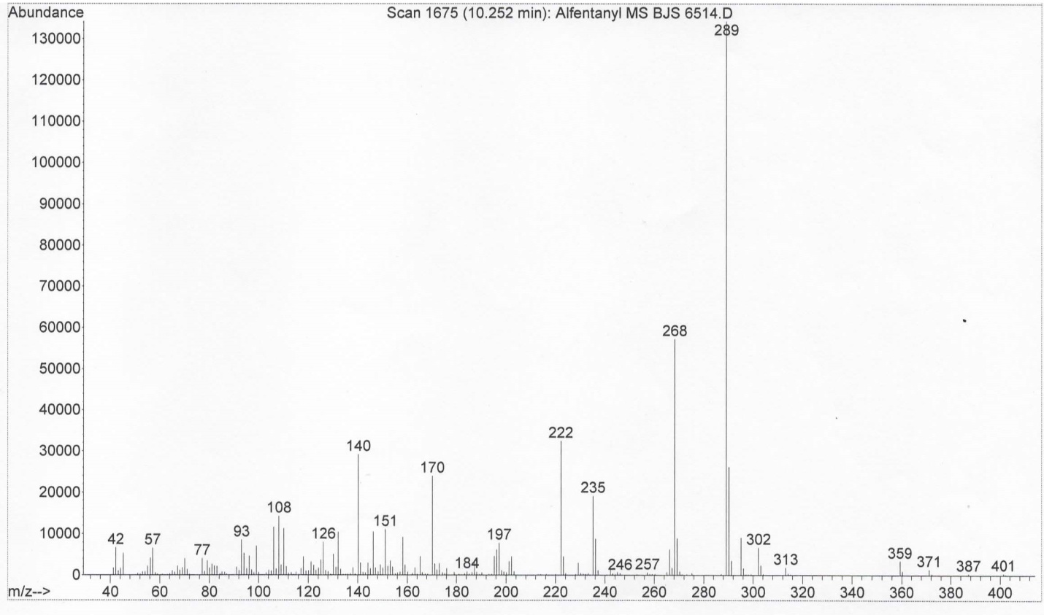
Figure 1A - Alfentanil Mass Spectrum

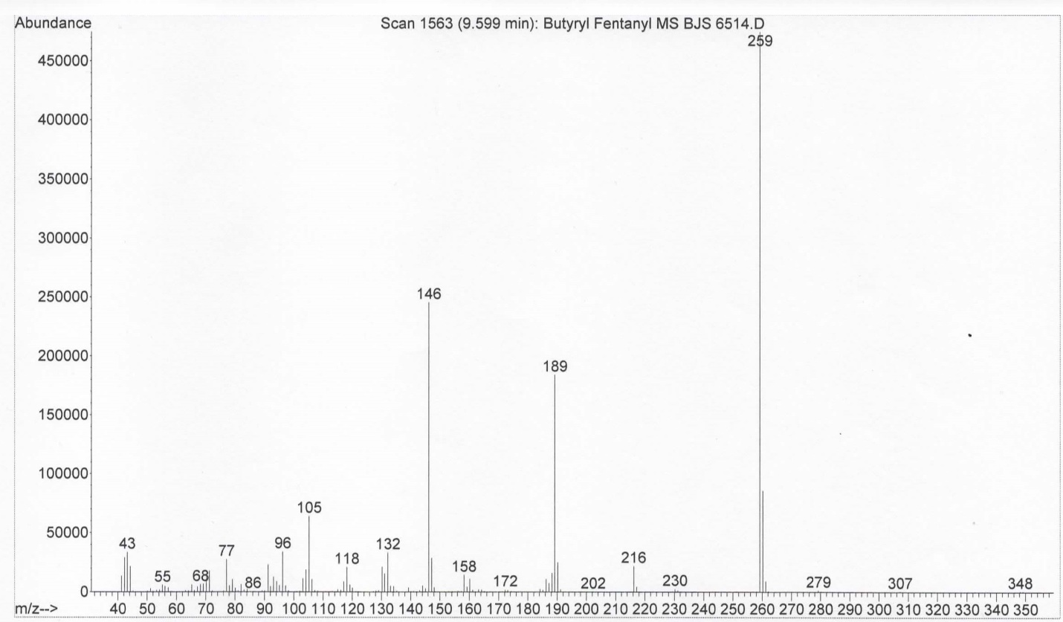
Figure 1B - Butyryl Fentanyl Mass Spectrum

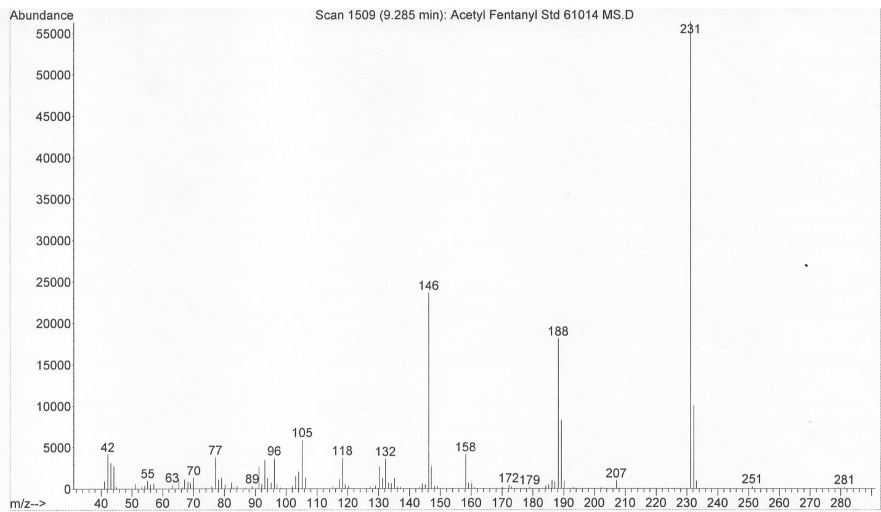
Figure 1C - Acetyl Fentanyl Mass Spectrum

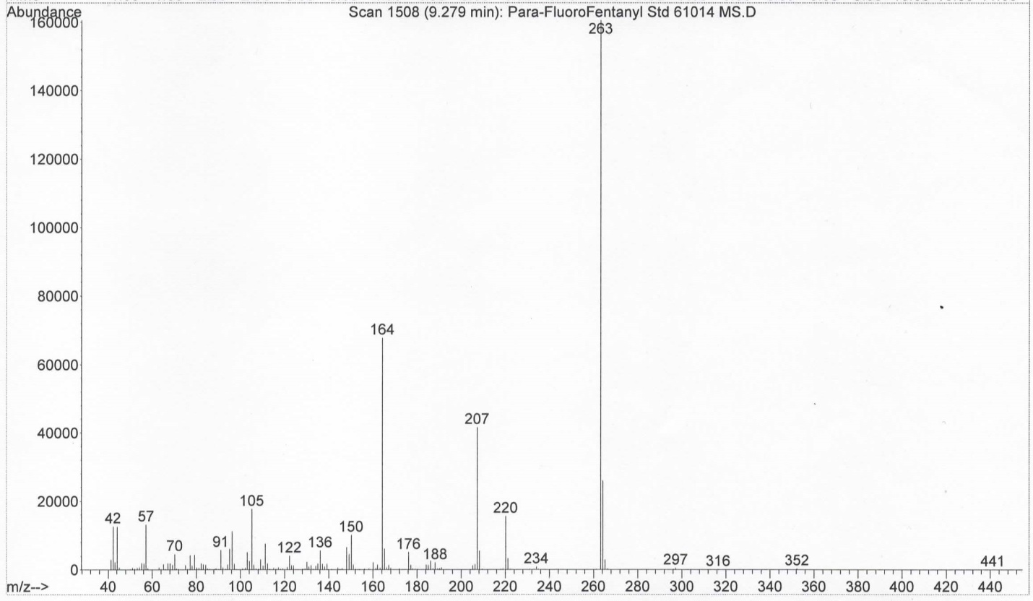
Figure 1D - Para-Fluoro Fentanyl Mass Spectrum

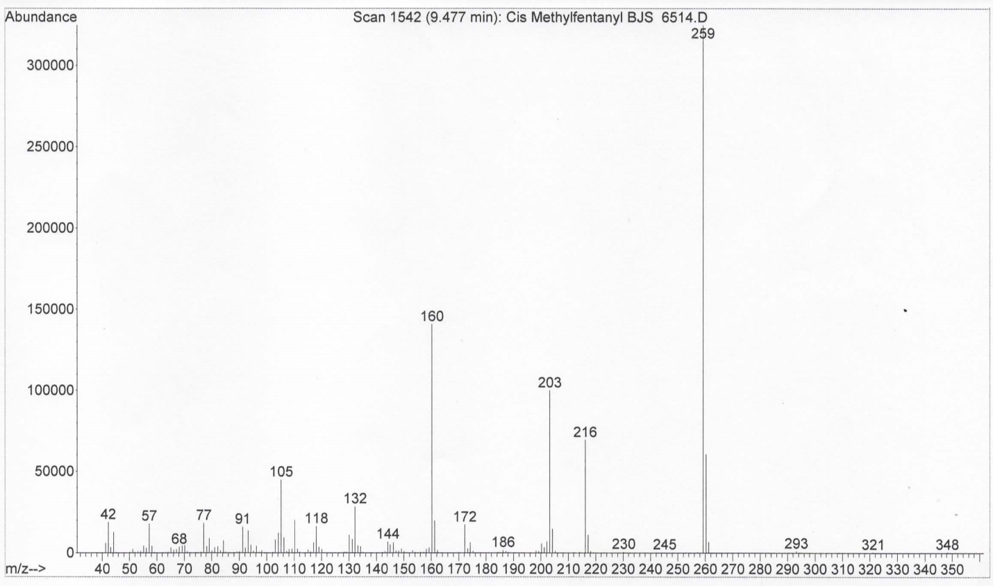
Figure 1E - Cis-3-Methylfentanyl Mass Spectrum

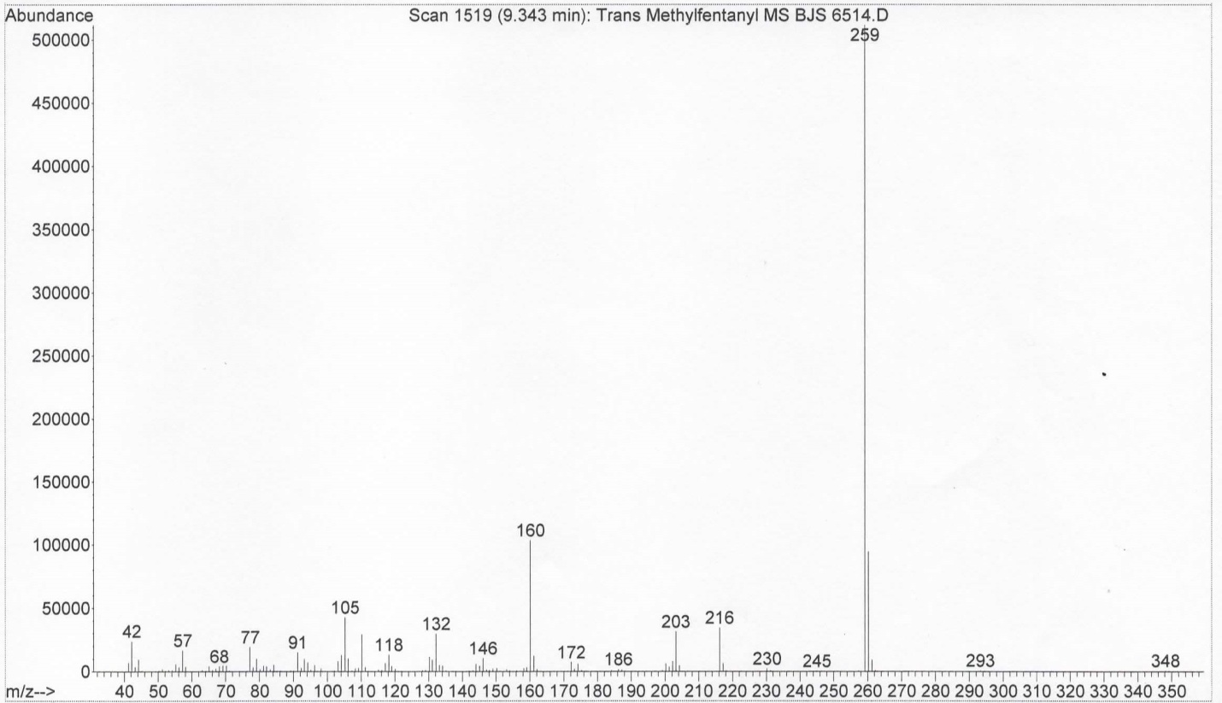
Figure 1F - Trans-3-Methylfentanyl Mass Spectrum
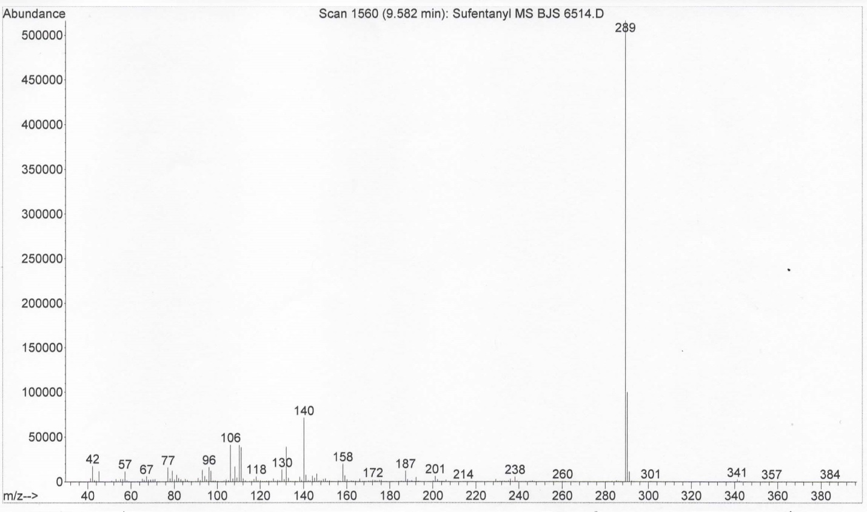
Figure 1G - Sufentanil Mass Spectrum

Figure 1 - Fentanyl Analogs - Mass Spectra

After this initial identification, it was decided that while derivatization was mostly unnecessary, it would be attempted to see if differentiation between cis and trans 3-methylfentanyl was possible, and to see if it would improve the response of the acetyl norfentanyl. Derivatization was attempted with both Heptafluorobutyric Anhydride (HFBA) and Pentafluoropropionic Acid (PFPA) separately. The results showed that acetyl norfentanyl was derivatized while no other analogs were. Cis and trans 3-methylfentanyl continued to be identical to one another in their mass spectra. The response of acetyl norfentanyl was approximately tripled. The mass spectra of acetyl norfentanyl for both before and after the derivatization are shown in Figures 2 and 3. Note the acetyl norfentanyl peak at 6.57 pre-derivatization and 6.85 post-derivatization.
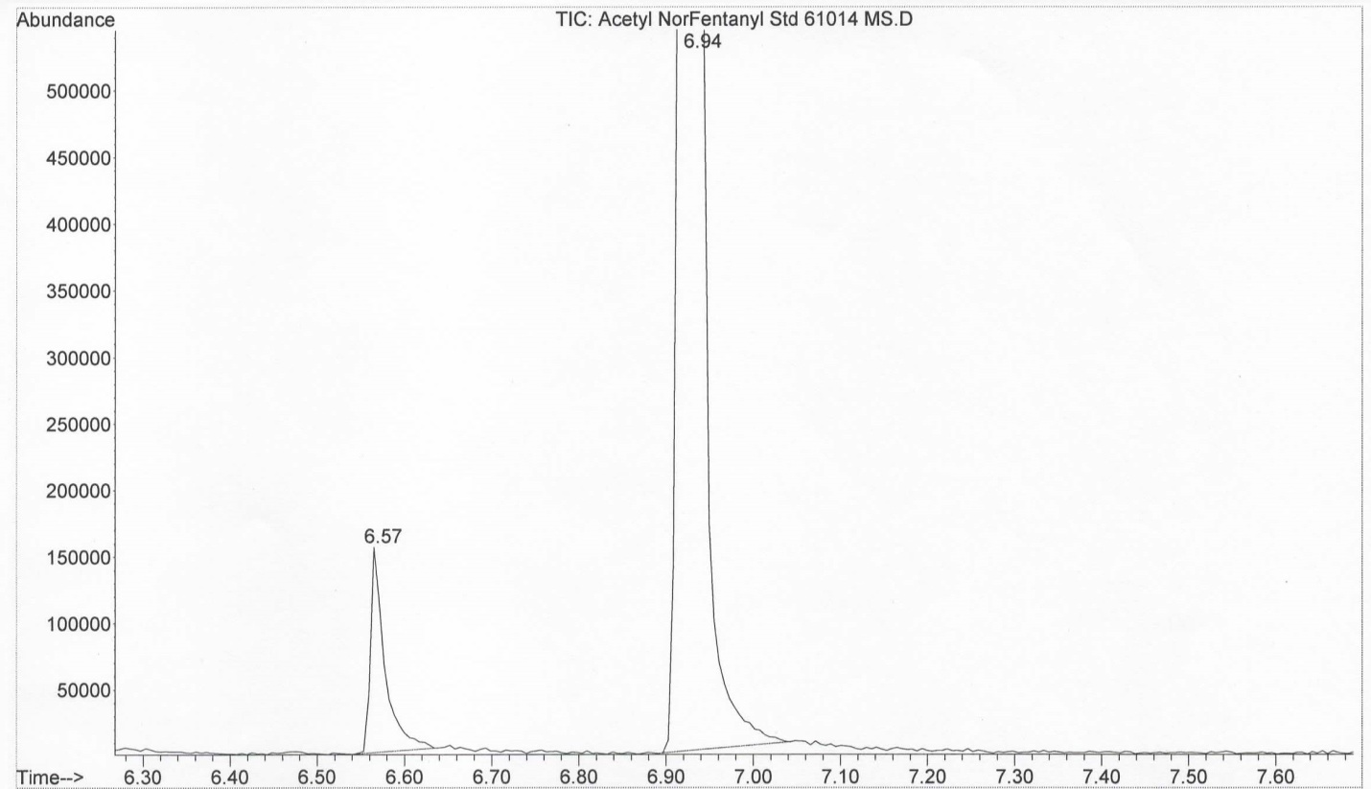
Figure 2A - Acetyl Norfentanyl TIC
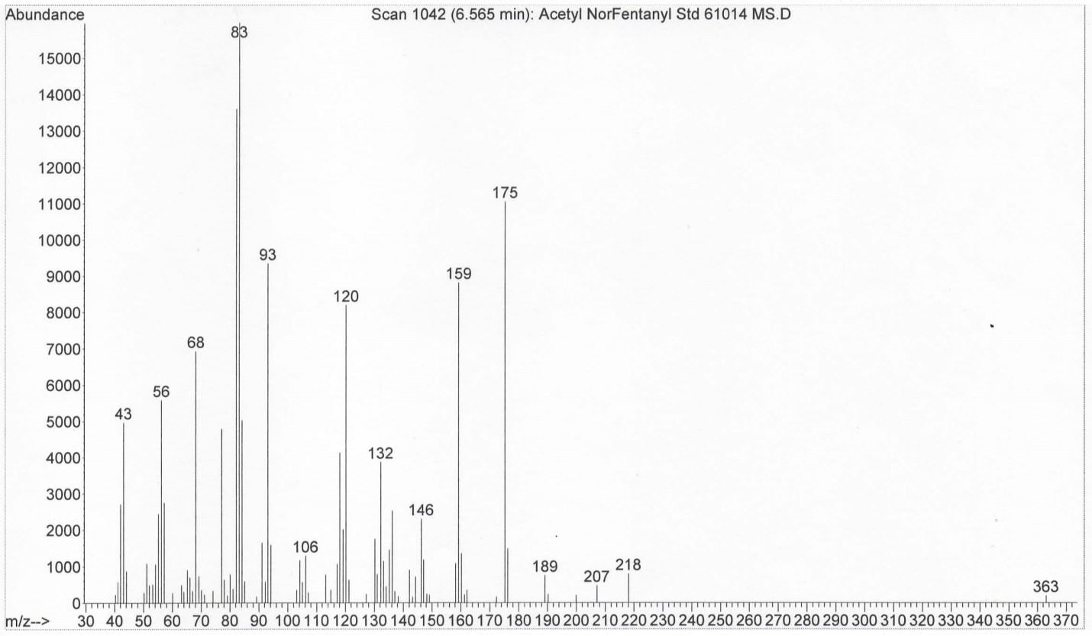
Figure 2B - Acetyl Norfentanyl Mass Spectrum
Figure 2 - Acetyl Norfentanyl Pre-Derivatization
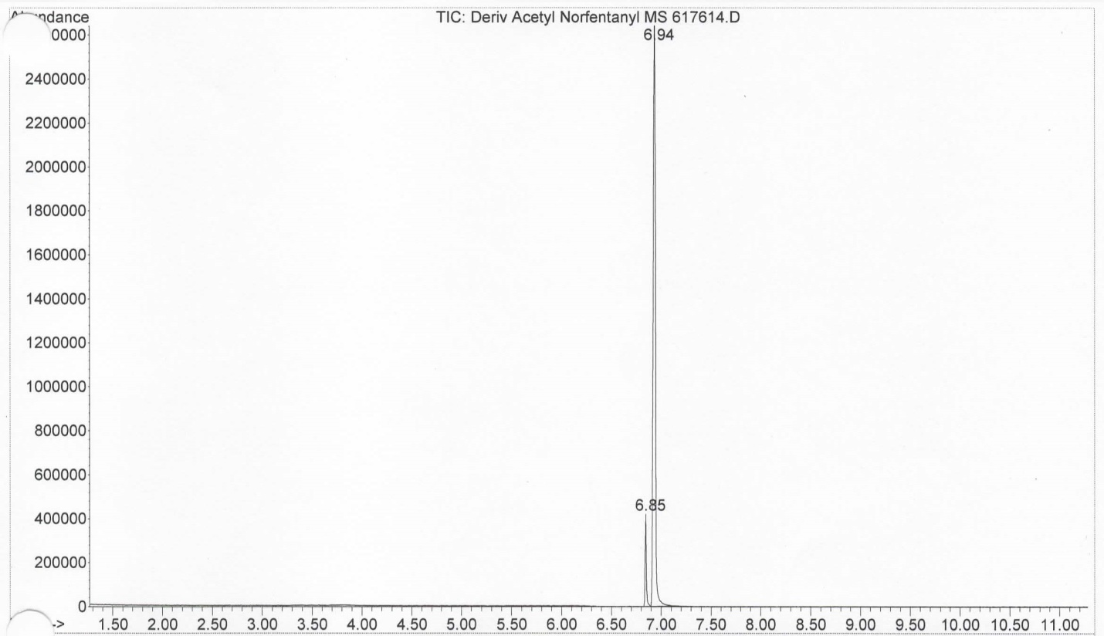
Figure 3 - Acetyl Norfentanyl Post-Derivatization
Figure 3A - Acetyl Norfentanyl TIC Post-Derivatization
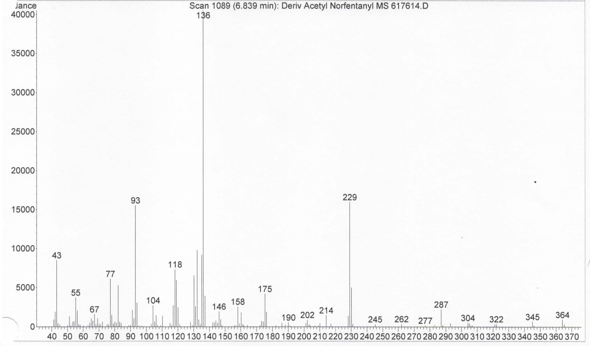
Figure 3B - Acetyl Norfentanyl Mass Spectrum Post-Derivatization
Upon further literature review, it seems that derivatization for fentanyl and its analogs has only been accomplished in the past for increasing the sensitivity of metabolites and indeed, it seems to be unnecessary and unsuccessful for the analogs alone(4).
What this portion of the project resulted in was the knowledge that the fentanyl analogs studied are sufficiently structurally different from one another. Derivatization is unnecessary unless there is a need to increase the response of a metabolite or to differentiate between cis and trans isomers. However, as noted previously, the analogs tested do have very similar elution times, meaning that if a street sample of these drugs were to ever contain a mixture of multiple analogs, co-elution would likely be a problem. Future studies would benefit from focusing on this issue.
Quantitation Validation / Accuracy and Precision
GC-FID
The data resulting from the calibration model showed good linearity of the calibration curves and exceptionally consistent data between runs on different days. After the calibration curve was created for each run, a linear regression was performed to determine the equation of the curve. The GC-FID data for each control was then plugged into this equation and a concentration value for that control in mg/mL was determined and compared to the experimental value. The percent error for each control was within ±20% and the RSD and %CV values showed a tight range for the data, indicating a small variation in the results. The data and results for the controls are shown in Table 3. The equations used for determining these values are shown in Equation 1.
Table 3 - Control Data
Control (mg/mL) | Run 1 (mg/mL) | Run 2 (mg/mL) | Run 3 (mg/mL) | Run 4 (mg/mL) | Run 5 (mg/mL) | Avg. mg/mL | Avg.  % Error | RSD | %CV
0.9 | 0.898 | 0.890 | 0.890 | 0.880 | 0.883 | 0.887 | 1.42% | 0.00768 | 0.768%
0.4 | 0.399 | 0.395 | 0.396 | 0.391 | 0.394 | 0.395 | 1.27% | 0.00743 | 0.743%
0.05 | 0.0444 | 0.0446 | 0.0424 | 0.0441 | 0.0454 | 0.0442 | 13.2% | 0.0250 | 2.50%

$$Percent Error=\frac{|experimental value-actual value|}{|actual value|}x 100$$
$$RSD= \frac{Standard Deviation}{Mean}$$
$$\%CV=RSD x 100$$
Equation 1 - Equations for Data Analysis
GCMS
The only issue with the overall data was in regards to the GCMS results, specifically the internal standard, deuterated fentanyl. Because of tailing issues that could not be resolved despite heavy experimenting with the method and due to similar elution times of the acetyl fentanyl and deuterated fentanyl, it was difficult to obtain a clean spectrum of the deuterated fentanyl. It was accomplished by subtracting out the acetyl fentanyl spectrum from the deuterated fentanyl spectrum. However, as the GCMS results were merely for confirmatory purposes and not involved in the calibration model, it did not affect the calibration model's results. The total ion chromatograms from the GC-FID did not suffer this problem as there was a clean separation between the two compounds, with a retention time of 12.70 and 12.89 for acetyl fentanyl and deuterated fentanyl respectively.

Selectivity
After spiking a sample of acetyl fentanyl with heroin, cocaine, methamphetamine, oxycodone, and alprazolam, it was analyzed via GC-FID and GCMS using the same method as the calibration model. The results of this can be seen in Figures 4 and 5. Table 4 outlines the drugs used in the study, along with their GC-FID and GCMS retention times. Retention times were matched by running each compound separately and comparing the retention times of the individual runs to the combined run. The TICs of both the GC-FID and GCMS show that acetyl fentanyl was able to be separated from all the drugs used except heroin. The two co-elute, although their mass spectra are sufficiently different and they can be separately identified by subtracting out the mass spectrum of the acetyl fentanyl from the heroin and vice-versa.
However, this is still problematic, especially considering heroin is one of the many drugs seen mixed with acetyl fentanyl in overdose cases. Due to time constraints, this was unable to be explored further beyond attempting changes to the GCMS method that were unsuccessful. This problem should definitely be addressed in future studies. It should be noted that tailing has been a huge issue with the TICs for GCMS during this entire project, but multiple attempts to remedy the tailing proved ineffective. A different instrument or newer column may not have this problem.
Table 4 - GC/MS Retention Times
Drug | GC-FID Retention Time | GCMS Retention Time
Acetyl Fentanyl | 12.69 (Co-elution) | 13.57 (Co-elution)
Heroin
Cocaine | 9.94 | 10.73
Methamphetamine | 1.97 | 2.08
Oxycodone | 12.22 | 13.14
Alprazolam | 14.67 | 15.61

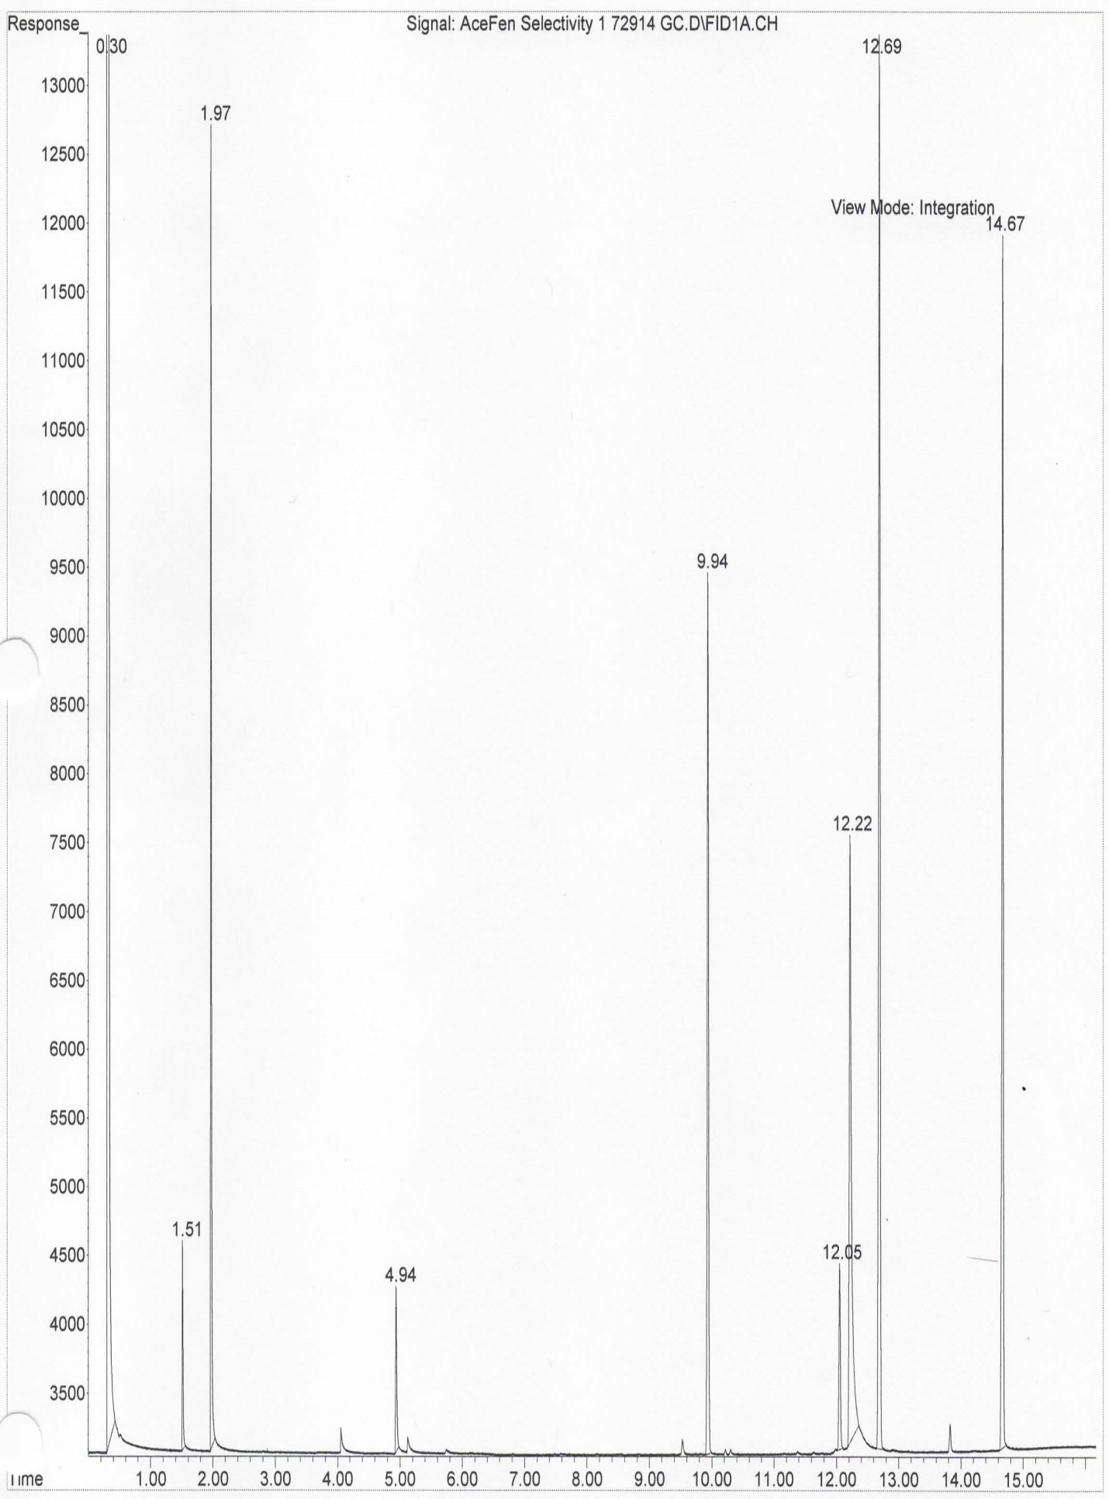
Figure 4 - GC-FID Results
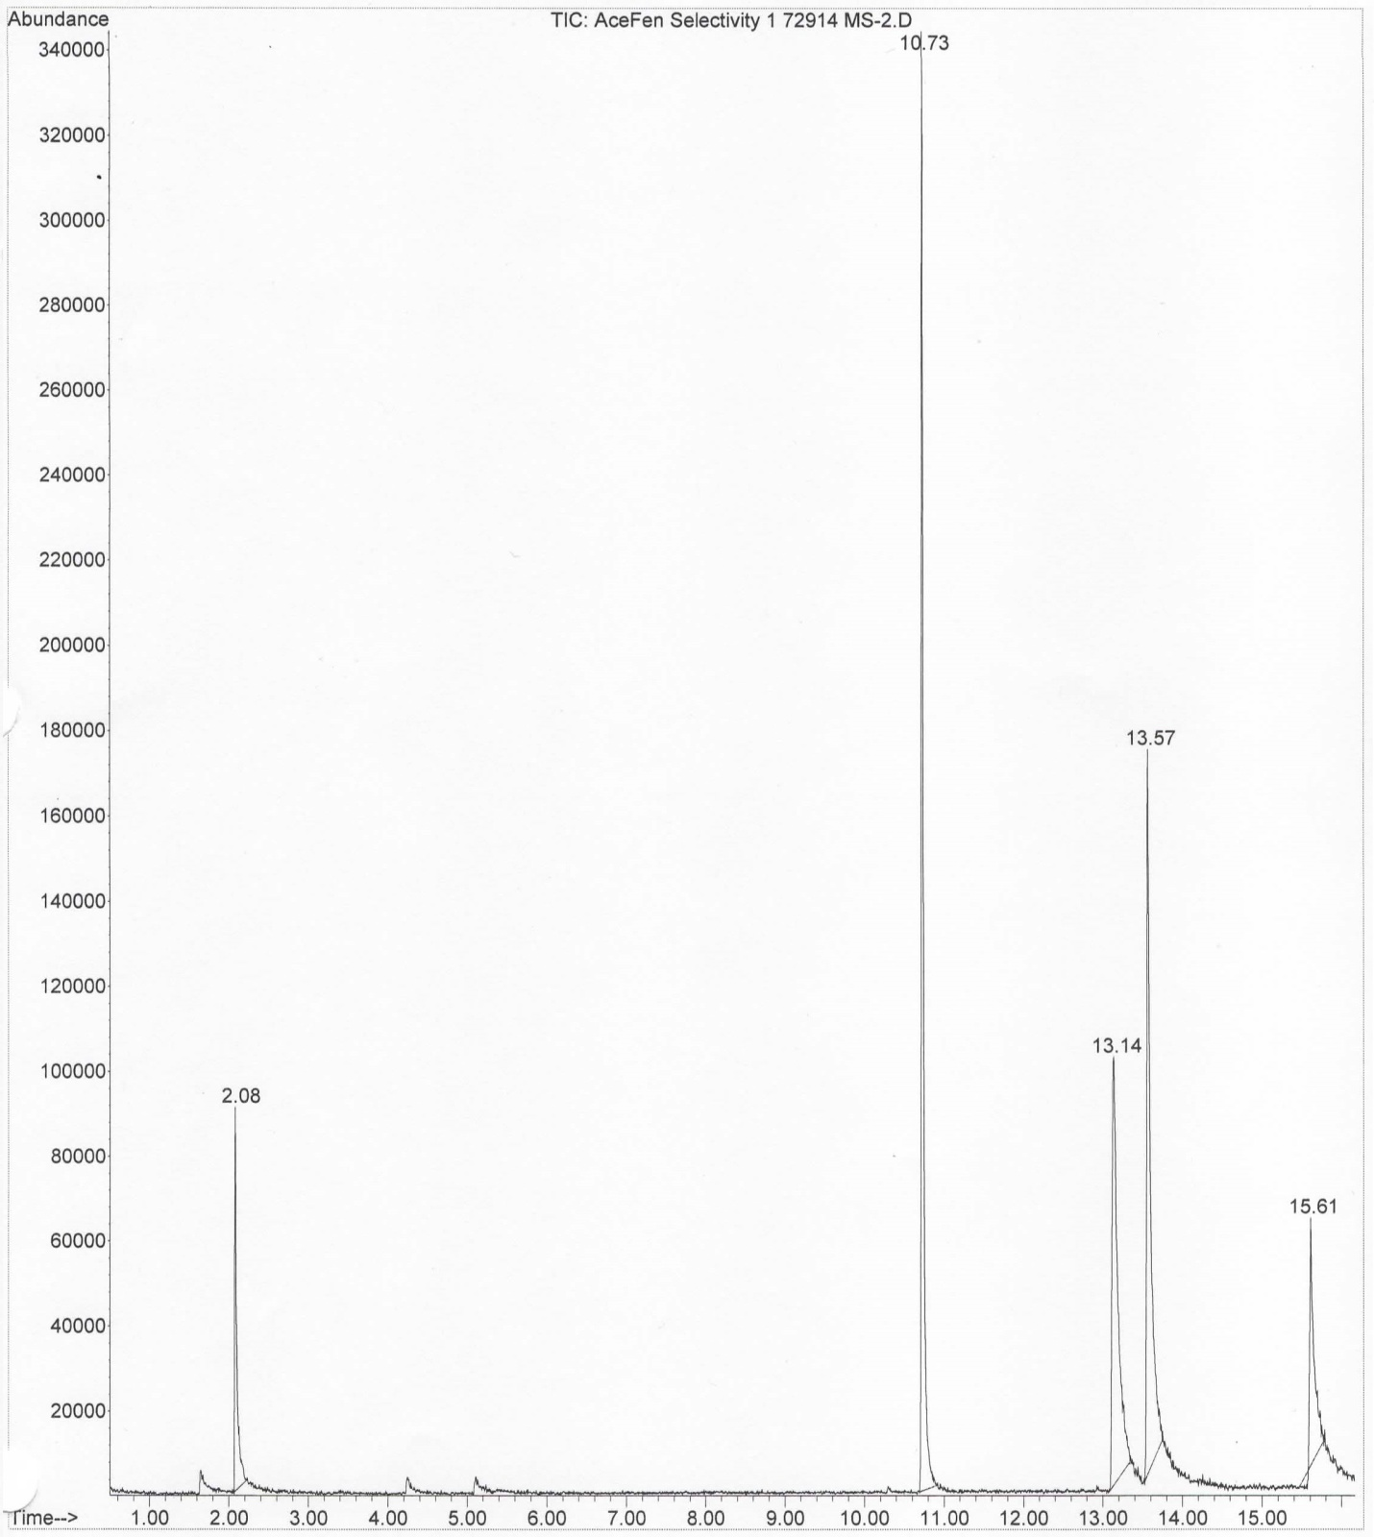
Figure 5 - GCMS Results

LOD/LOQ
A random blank spectrum from one of the calibration model runs was analyzed and the integration of the noise was forced at the approximate elution time of acetyl fentanyl. The following data is theoretical. This response was 354. For the limit of detection, this number was multiplied by three, resulting in the LOD for the instrument response being 1062. For the limit of quantification, the same 354 was multiplied by ten, indicating a LOQ for the instrument response being 3540. All results from the calibration model fall above the LOQ, so no re-testing of the data was necessary. During the initial look into developing the calibration model, multiple concentrations of acetyl fentanyl were run to determine a rough LOD so values could be decided for the model. Based on the above numbers and the response from these initial runs, the approximate concentration value for the LOD is 0.003mg/mL and the approximate concentration value for the LOQ is 0.007mg/mL
Ion Ratios
After the standard ion ratios were determined by dividing the peak area of the quantitation (largest) ion by the first qualifier (second largest ) ion for the primary ion ratio and the second qualifier (third largest) ion for the secondary ion ratio, each set of calibrator's mass spectral data was analyzed and the primary and secondary average ion ratios were established. These values can be found in Table 5. All values fell within ±20% of the standard average primary and secondary ion ratios, which means the mass spectral data falls within SWGDrug guidelines for identification.

Table 5 - Primary and Secondary Ion Ratios
Run | Average Primary Ion Ratio | Average Secondary Ion Ratio
Standards | 2.08 | 3.31
Calibrator Run 1 | 2.00 | 3.33
Calibrator Run 2 | 2.15 | 3.42
Calibrator Run 3 | 1.96 | 3.50
Calibrator Run 4 | 2.02 | 3.04
Calibrator Run 5 | 2.14 | 3.35

Overall, the results from developing the calibration model for gas chromatography indicate that it could be successfully implemented in forensic laboratories that quantitate drug seizures. The method demonstrated both accuracy and precision with the control values all being within ±20% of the expected values and the RSD and %CV values being 2.5% or less, giving a small range of deviation for the data. The main issues with this method occurs with the GCMS data and include the close elution of the acetyl fentanyl and deuterated fentanyl, and the co-elution of heroin with acetyl fentanyl. These problems may not occur with a different instrument or column, but that is an unknown variable at this point. The first issue could be solved by selecting a different internal standard, but as deuterated internal standards are the gold standard, perhaps looking into a better way to separate the two compounds would be a better option. The second issue could potentially be resolved with a different GC-FID or GCMS method. However, the biggest issue with the co-elution problems seems to be tailing, which was unable to be resolved with multiple changes to different parameters of the method and was likely an instrument issue that could not be addressed due to ongoing KSP casework.

Conclusion
Fentanyl analogs are one of the latest types of illicit drugs whose use seems to be on the rise due to the numerous overdose cases seen in past months, with acetyl fentanyl being the most commonly seen of these analogs. With this rise, drug analysts will need a method of identifying, and in some cases, quantifying these drugs. The main objectives of this project were to identify, potentially derivatize, and develop a quantitation method for these analogs.
After concluding that most of the analogs, despite similar elution times, have mass spectra that are able to be sufficiently differentiated from each other without derivatization, derivatization was still attempted. This was done to see if it would increase the response of the acetyl norfentanyl metabolite and/or possibly differentiate the cis and trans isomers of 3-methylfentanyl. After this proved successful for the metabolite but unsuccessful for the isomers, the next step in the project was developing a calibration model for the quantitation of acetyl fentanyl, chosen due to its major prevalence in overdose cases. The GC-FID results for the calibration model proved extremely successful with data that showed little variation and high accuracy, indicating that it could be potentially put to use in real-life quantitation casework.
However, the GCMS data, though perhaps not as crucial to the calibration model, was not as successful. The first issue being the tailing, causing the internal standard, deuterated fentanyl, to co-elute with the acetyl fentanyl, resulting in problems with separating the two spectra. The second problem had to do with the selectivity of the method, with acetyl fentanyl and heroin co-eluting. On the other hand, the spectra were still able to be isolated from one another by subtracting out the acetyl fentanyl GCMS from the heroin GCMS and vice-versa, so it is not quite as large of a problem. It should also be mentioned that ion ratios for all the calibrators were within ±20% of the standard ion ratios so the mass spectral data is not invalid, just not quite as neat as the gas chromatography data.
For future studies, the development of more calibration models for the quantitation of other fentanyl analogs not done with the project due to budget and time restraints would be beneficial. The other main topic for potential studies would be developing a better GCMS method that can curb the tailing problems seen in this project and perhaps develop an improved GC-FID/GCMS method of separating the co-eluting heroin and acetyl fentanyl. Derivatization may even be a possibility here, as it can possibly improve both tailing and resolution issues.

References
- Fentanyl. Drugabuse.gov. December 2012. National Institute on Drug Abuse. <http://www.drugabuse.gov/drugs-abuse/fentanyl>.
- Mercado-Crespo MC, Sumner SA, Spelke MB, Sugerman DE, Stanley C. Notes from the Field: Increase in Fentanyl-Related Overdose Deaths -- Rhode Island, November 2013-March 2014. CDC. June 2014; (24):531
- Notes From the Field: Acetyl Fentanyl Overdose Fatalities -- Rhode Island, March-May 2013. CDC. Aug 2013; (34):703-704
- Patton A, Seely K, Pulla S, Rusch N, Moran C, Fantegrossi W, Knight L, Marraffa J, Kennedy P, James L, Endres G, Moran J. Quantitative Measurement of Acetyl Fentanyl and Acetyl Norfentanyl in Human Urine by LC-MS/MS. Anal Chem. Feb 2014; (3):1760-1766
- Shaner RL, Kaplan P, Hamelin EI, Bragg WA, Johnson RC. Comparison of two automated solid phase extractions for the detection of ten fentanyl analogs and metabolites in human urine using liquid chromatography tandem mass spectrometry. J Chromatogr B Analyt Technol Biomed Life Sci. Jul 2014; 52-58
- Stanley TH. The History and Development of the Fentanyl Series. J Pain Symptom Manage. Apr 1991; (7):3-7
- Strano-Rossi S, Alvarez I, Tabernero MJ, Cabarcos P, Fernandez P, Bermejo AM. Determination of fentanyl, metabolite and analogs in urine by GC/MS. J. Appl. Toxicol. Oct 2010; (7):649-654
Acknowledgements
The author thanks Lauren M. McCormick, Dr. Lauren R. Waugh, and Carolyn E. Trader-Moore for helping develop this project and reviewing the work that resulted. The author also thanks the Kentucky State Police for allowing the internship that was needed for this project and for the use of their facilities and instruments for said project.

