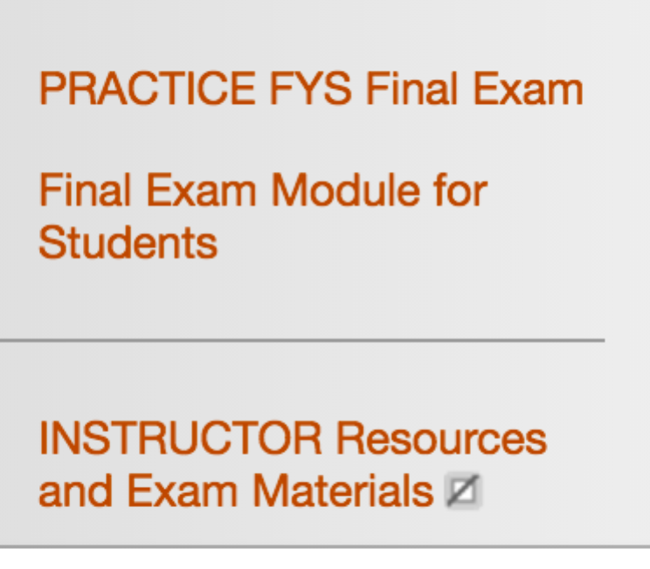
FYS Faculty Meeting
8-9 am, Thursday, October 13, 2016
Drinko 349
Agenda

Old Business
FYS Final Exam – visit this area in Blackboard/MUOnline to preview the Final Exam (PLEASE don’t share that with students in advance of the Final Exam). However, DO make use of the Practice Exam and allow students to practice. The Practice Exam contains updated exam directions/definitions, etc.

New Business
- How are you meeting your min/max reading and writing requirements in FYS – discussion. Mary Welch shares her Blackboard design.
- Demo of a successful activity/instruction plan – Isaac Wait.
- Call for volunteers – New video testimonials from FYS instructors on the benefits of teaching FYS.
- Please regularly visit www.marshall.edu/fys - particularly the Faculty tab for updates and resources

Open Forum – questions, comments, suggestions
Last meeting of the semester – mark your calendar:
- FYS Faculty Meeting 3: Tuesday, November 15 from 8-9 am. Location: Drinko Library 349. Agenda includes: 1. FYS Exam reminders 2. Demo of a successful activity/instruction plan – Sabrina Thomas & Jayme Waldron 3. HIP Project presentation – Damien Arthur, Bill Gardner & more

*Please send other agenda item suggestions to Jennifer

