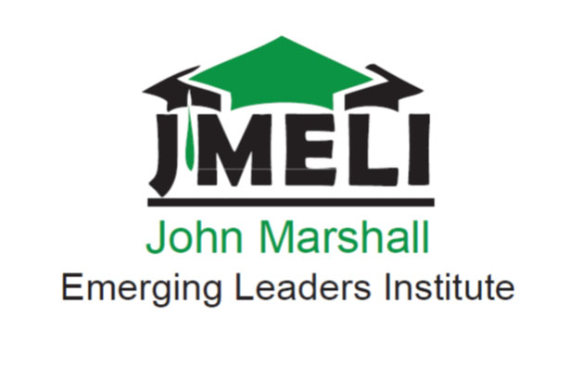

Membership Application
2013-2014
**The established application deadline is August 28th, 2014.**
Applications should be completed and submitted as noted on the application
John Marshall Emerging Leaders Institute
Office of Student Activities, MSC 2W31
One John Marshall Drive
Huntington, WV 25755
(304) 696-2283 or Kourtney Hughes at hughes215@marshall.edu

NOTE: Phone interviews will be given to those considered or notified if not considered. Also, attach resume to application.
Full Name: _______________________________________________________________________________________
Marshall ID Number:________________________________
Marshall Email:_________________________________________________________________________________
Alternate Email:________________________________________________________________________________
Home Address: _________________________________________________________________________________
_________________________________________________________________________________
Home phone number: ___________________________ Cell Phone: _______________________________
Local/College Address: _____________________________________________________________
_____________________________________________________________
_____________________________________________________________
Major:_____________________________________ Minor: __________________________________
School year (circle one): freshman or sophomore
Cum High School GPA:_____________
T-shirt size:

*Please complete the following short answer essays. If need for more room please finish on separate sheet of paper and attach to application.

1. How would you define leadership and what does it personally mean to you?
____________________________________________________________________________________________________________________________________________________________________________________________________________________________________________________________________________________________________________________________________________________________________________________________________________________
2. Who is your leadership model and how have they impacted you personally?
_________________________________________________________________________________________________________________________________________________________________________________________________________________________________________________________________________________________________________________________________________________________________________________________________________________________________________________________________________________________________________________________
3. What do you want to gain as becoming a member of JMELI? What areas of your leadership do you want to develop?
_______________________________________________________________________________________________________________________________________________________________________________________________________________________________________________________________________________________________________________
4. What high school activities or opportunities did you experience that were valuable or impacted you as a future leader?
____________________________________________________________________________________________________________________________________________________________________________________________________________________________________________________________________________________________________________________________________________________________________________________________________________________
5. What positive changes do you want to make in regards to yourself and the community?
____________________________________________________________________________________________________________________________________________________________________________________________________________________________________________________________________________________________________________________________________________________________________________________________________________________
6. How would you describe your level of dedication and commitment if given the honor of becoming a member of JMELI?
____________________________________________________________________________________________________________________________________________________________________________________________________________________________________________________________________________________________________________________________________________________________________________________________________________________

Student signature: _________________________________Date: ____________________

Mail to: John Marshall Emerging Leaders Institute
Office of Student Activities, MSC 2W31
One John Marshall Drive
Huntington, WV 25755
Or deliver to: Andy Hermansdorfer or Kourtney Hughes (MSC 2w31)
**Applications are due by**
Monday August 28th, 2014

