2014 Marshall University Mathematics Competition

1. A diagram for a baseball field is shown below. The infield is the playing area inside the large square containing the four small black square bases. The remaining playing area is called the outfield. The circle in the center of the infield is the pitcher’s mound.
You will notice that the baseball field itself is not a circular sector. The top edge of the outfield is the arc of a circle with center at the center of the pitcher’s mound, creating a circular sector.
The length between bases is 90 feet. The length from the center of the pitcher’s mound to the top arc of the outfield is 95 feet. The central angle of the circular sector is 146◦.
Find the area of the baseball field.
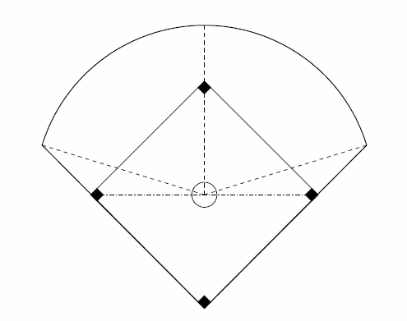

2. 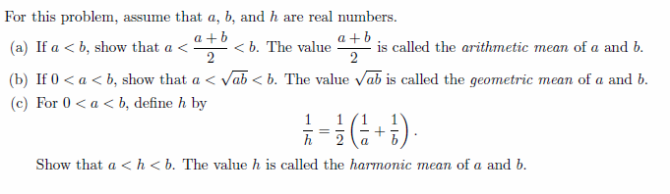
3. Any integer n can be written as n = 4q or n = 4q +1 or n = 4q + 2 or n = 4q + 3 for some integer q.
(a) Provide an example for each form of an integer.
(b) Show that the square of any odd integer has the form 8m + 1 for some integer m.

4. Arithmetic and geometric sequences have been studied for more than 3500 years. The Rhind papyrus was scribed around 1650 BCE by the Egyptian, Ahmes. Below is a problem translated from the Rhind papyrus:
One hundred loaves of bread are to be divided among five people so that the number of loaves of bread that each receives forms as arithmetic sequence. Together the first two people receive one-seventh of what the last three receive. How many loaves does each receive?

5. Find the values of A, B, C, D so that $\frac{x}{x^{2}-5x+6}= \frac{A}{x-B}+ \frac{C}{x-D}.$

6. Sally normally leaves for work at 8am. But today she left at 8:20. She needs to start work at 9am. She can either take the bus or cycle. The bus takes an average of 40 minutes with a standard deviation of 12 minutes. Cycling takes an average of 50 minutes with a standard deviation of 2 minutes. What option should she take
(a) if she will be fired if she is even a few minutes late?
(b) if she knows that she can be up to 15 minutes late before she is in trouble?

7. Let A = $\left[\begin{matrix}1 & 1 & x \\ -1 & 3 & 4 \\ z & 4 & 3\end{matrix}\right]$ and B = $\frac{1}{y}\left[\begin{matrix}7 & 3 & -4 \\ -3 & -3 & 4 \\ 4 & 4 & -4\end{matrix}\right]$
If B is the inverse of matrix A, find x, y, z.

8. In computer programming, a process called probing is used to assign a sequence of numbers to slots in a one-dimensional array (referred to as a hash table). For example, linear probing with modular arithmetic works as follows.
Suppose that the table has m slots. Number these slots 0, 1, 2, …, m–1.
When a number x comes in, attempt to assign it to slot location b₀, where x ≡ b₀ (mod m).
If that slot is occupied, check slots b₀+1, b₀+2, b₀+3, …, until an unoccupied slot is found.
(In order to avoid an infinite loop, one slot in the table must always be empty.)
Then repeat the process with each of the other numbers in the sequence.
For example, consider a table with m = 6 slots, as shown in the diagram below. We will attempt to place the following numbers into this table, in the given order: 15, 8, 18.
0
1
2
3
4
5

(Step 1) 15 = 2(6) + 3 → Place 15 in slot 3.
(Step 2) 8 = 1(6) + 2 → Place 8 in slot 2.
(Step 3) 18 = 3(6) + 0 → Place 18 in slot 0.
It is easy to see that linear probing will be able to assign all of the numbers to slots in the table, as long as there are no more than m–1 numbers in the sequence. However, linear probing can produce long strings of occupied slots (referred to as clustering). This is inefficient, since it can lead to a large number of attempts before an unoccupied slot can be found. An alternative is quadratic probing, which works in the same way as linear probing, except for the following.
If slot b₀ is occupied, check slots b₀+1², b₀+2², b₀+3², …, until an unoccupied slot is found.
Now for your question. Again consider a table with m = 6 slots. We will attempt to use quadratic probing to place the following numbers into this table, in the given order: 15, 8, 18, 14, 26.
(A) Use quadratic probing to place the following numbers into the table, in the given order: 15, 8, 18, 14. Explain every step of your reasoning.
(B) Prove that it will be impossible to use quadratic probing to place 26 into an unoccupied slot.
Finally, a more general question.
(C) Consider the general case of quadratic probing for a table with m slots. Derive a rule for determining the minimum number of slots that must be checked in order to verify that a number cannot be placed into the table. Be as specific as possible.

