Program

Title Composer
Date

Title Composer
Date

Title Composer
Date

Title Composer
Date

Title Composer
Date

Title Composer
Date

Title Composer
Date

Title Composer
Date

This recital is presented in partial fulfillment of the requirements for the Bachelor of Fine Arts degree in Music Performance. STUDENT NAME is a student from the studio of NAME. For more information about this or other music events, please call (304) 696-3117.

If you would like to support the School of Music through a donation and assist with student scholarships, academic travel for students and ensembles, or general support of MU music please contact:
School of Music
SMH 154/ 304-696-3117
music@marshall.edu
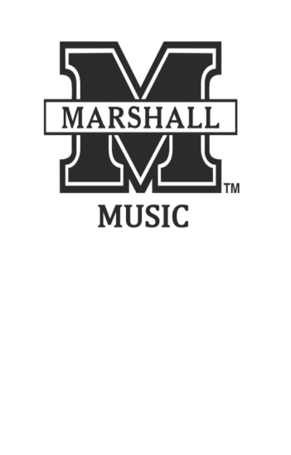

School of Music

presents

XXXX Recital
Student Name,
Instrument

assisted by
XXXXX

Date
Location
Time

This program is presented by the College of Arts and Media through the School of Music. For more information about this or other music events, please call (304) 696-3117, or view our website at www.marshall.edu/cam/music.
Page 1

Program Notes

(Flip side of front and back sheet)

Page 6
Program Notes

Page 5
(Sheet Two)

Page 2

(Flip side of sheet two)
Page 3 (Inside fold)

Page 4 (Inside Fold)

