PROGRAM NOTES (If needed)

The Marshall University School of Music is grateful for the support of many families and individuals who help to make our school strong and vibrant. If you would like to support the School of Music through a donation and assist with student scholarships, academic travel for students and ensembles, or general support of our music programs please contact:
College of Arts and Media
SMH 158/304-696-6433
music@marshall.edu

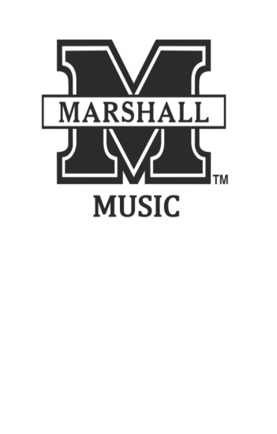

School of Music

presents

Senior Recital
Student Name,
instrument

accompanied by
accompanist name, piano
accompanist, piano

Day, Month Date, Year
Location
Time

This program is presented by the College of Arts and Media through the School of Music, with the support of student activity funds. For more information about this or other music events, please call (304) 696-3117, or view our website at www.marshall.edu/music.

Program

Title Composer
Year-Year

Title Composer
Year-Year

Title Composer
Year-Year

Title Composer
Year-Year

Title Composer
Year-Year

Title Composer
Year-Year

Title Composer
Year-Year

Title Composer
Year-Year

PROGRAM NOTES

Program Notes

Program Notes

Roster

Roster

Roster

Roster

