Marshall University  RN to BSN Program  Required Qualifications for Your Program | TIME SENSITIVE  DO NOT DELAY

ATTENTION Students:

We’ve partnered with Verified Credentials, Inc. to help you supply the required qualifications for your program. To get started, carefully follow the instruction below:

How it Works:
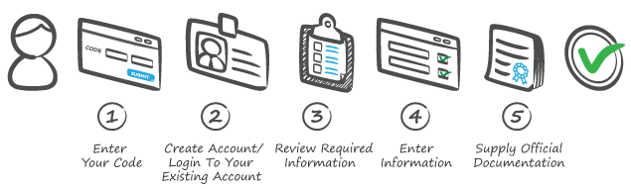

IMPORTANT – Use the CODE that matches your phase:

Program Phase: | Code:
Background Check & Drug Screen - RN to BSN Program – Due by application deadline – For fall semester due by April 1 and for spring semester due by Oct 1. | WXFGV-93486
Additional Requirements due after Admission - RN to BSN Program | PRYTM-79764

NOTE: If you do not complete the Drug Screen within the allotted 30 day window after payment, you will be required to pay again for the service.
GET STARTED NOW at:
http://scholar.verifiedcredentials.com/marshall

For Best Results - Use a laptop or desktop computer to complete this process.

