How-to lift a registration hold
- Log-in to MU Banner. http://www.marshall.edu/banner/
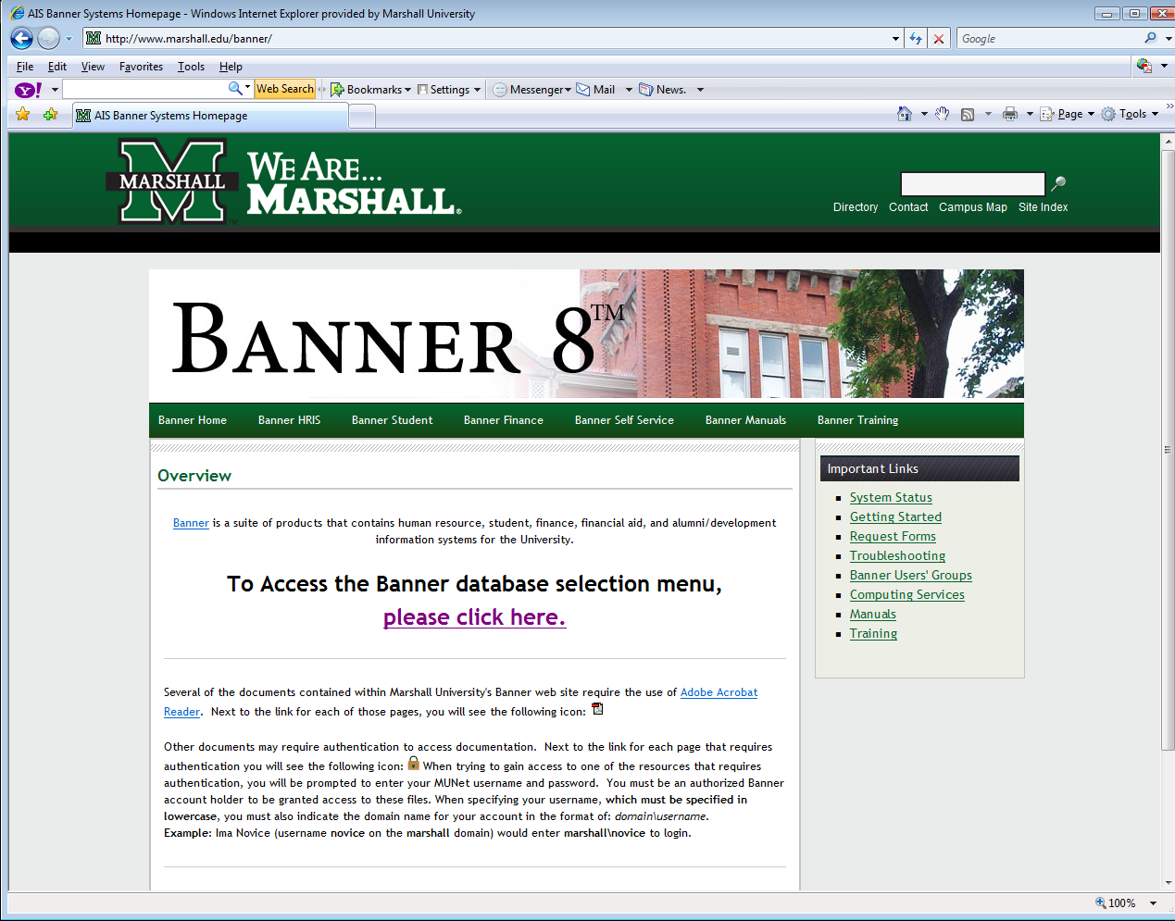
- Choose MU Banner 8 Production. http://www.marshall.edu/banner/banner_links.asp
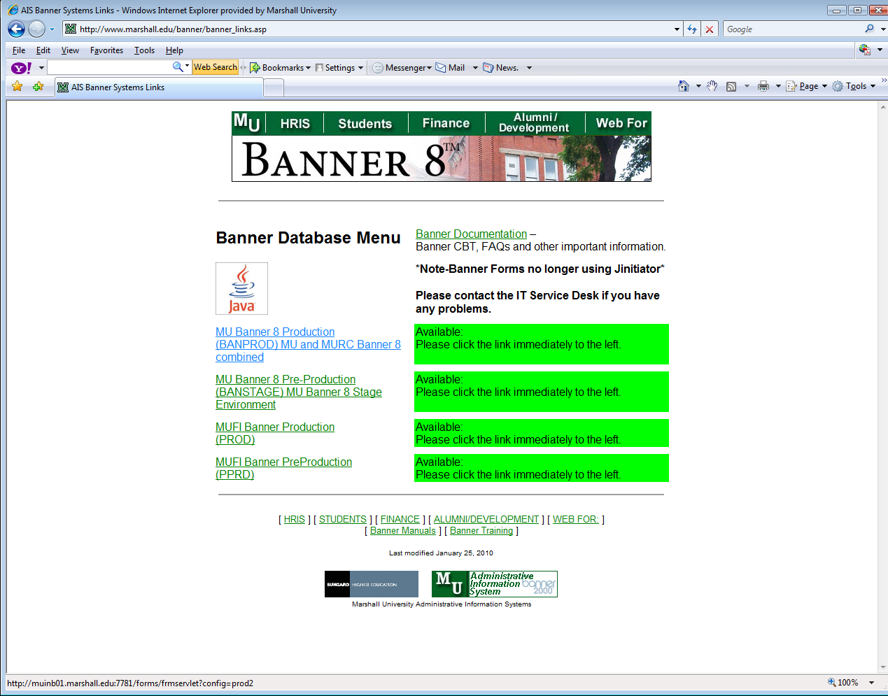
- Choose Run. There will be two Oracle windows that open. Leave both of them open the entire time you are using Banner.
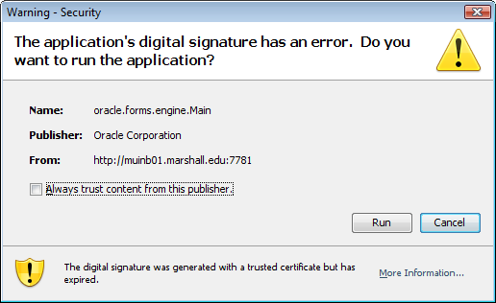
- Enter your user name and password. If your email address is johndoe1@marshall.edu, your username would be johndoe1. Banner passwords expire frequently, so please make sure to update frequently.
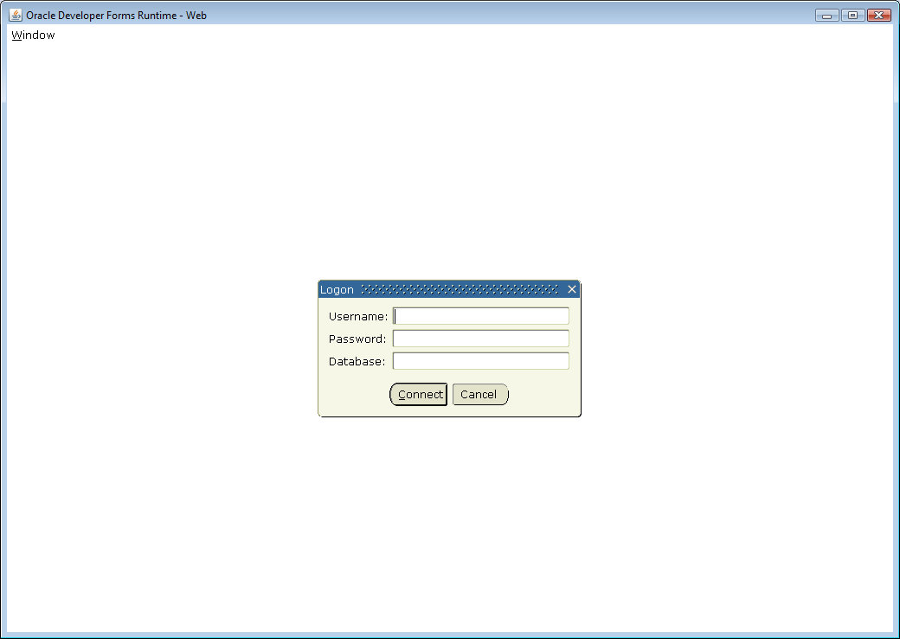
- Once you enter you username and password, choose Connect.
- You should now have access to your main Banner page.
- On the main Banner page, choose Main Dean’s Menu [*DEANS]
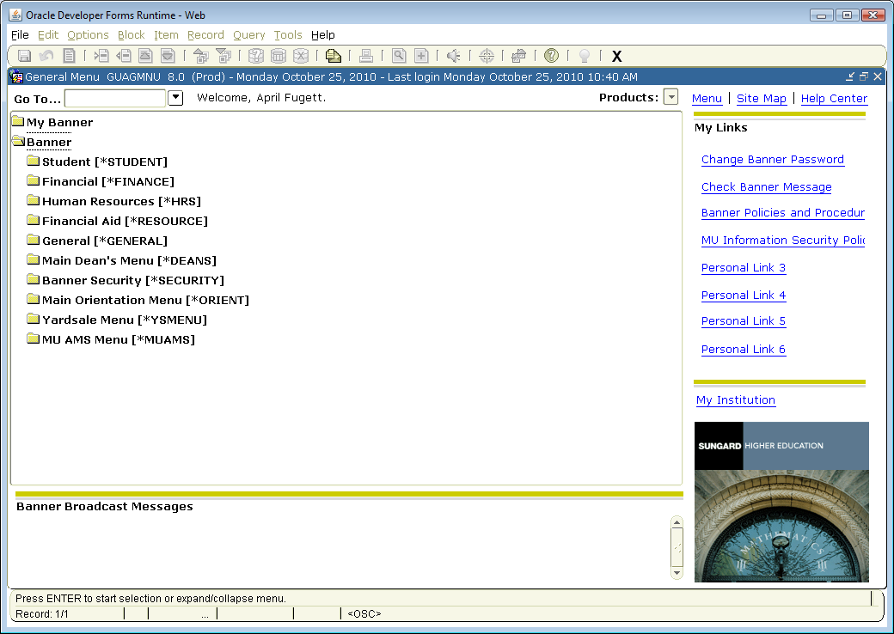
- From the Main Dean’s Menu, choose Hold Information [SOAHOLD].
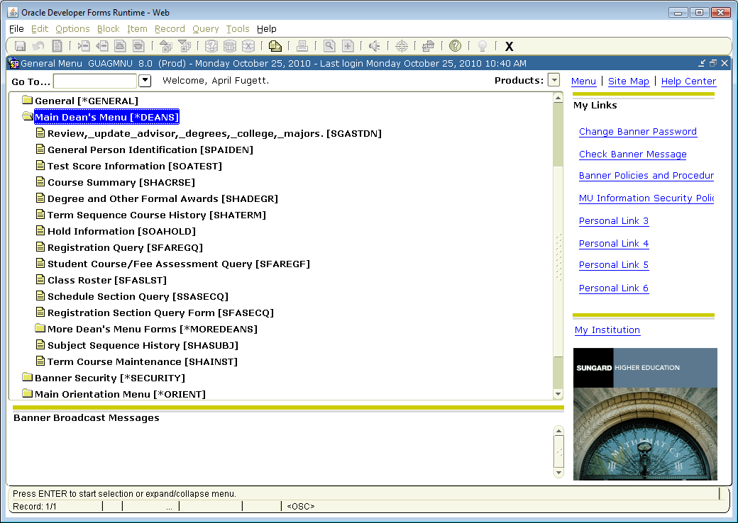
- Type in the Student ID (901) number. Then click down on Hold Details. Any hold for that student will be listed along with the origination code. (Note: We can only remove holds that are Advisor Holds generated by CoLA.)
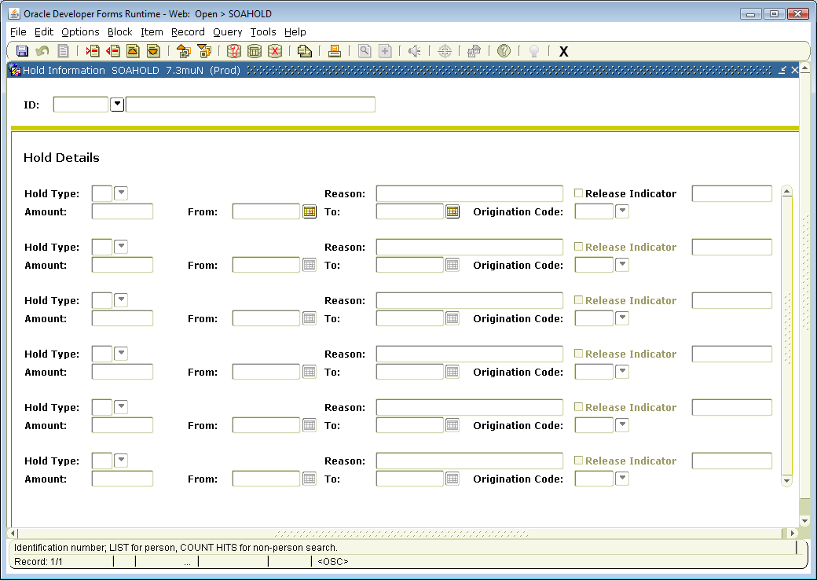
- Choose the hold you want to remove. Click Remove Hold.
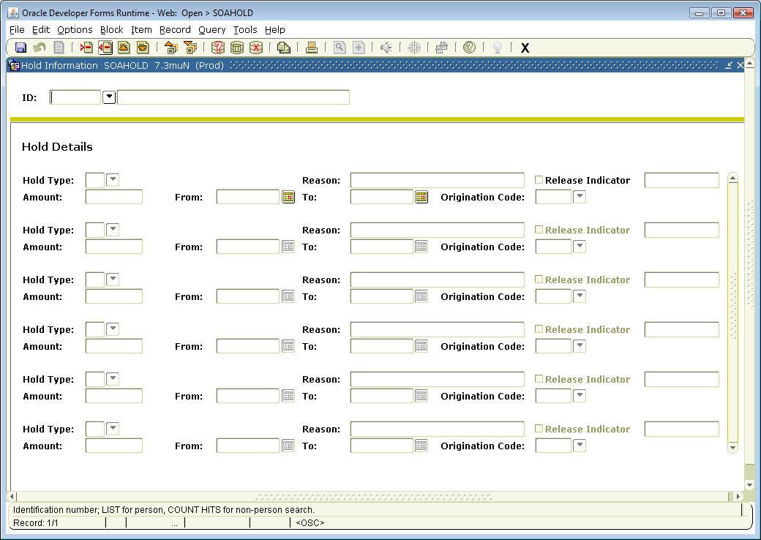
- From the Menu tabs (File, Edit, Options, Block, Item, etc) choose File. From the drop-down menu, choose Save.
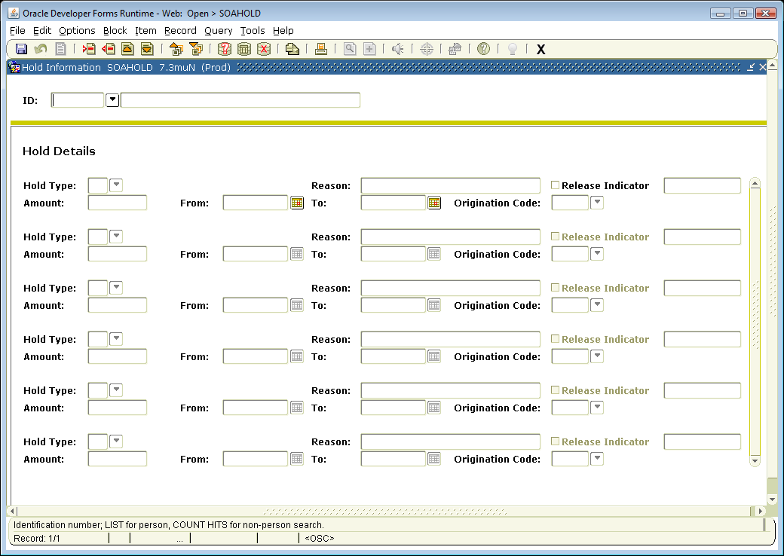
- Repeat for all holds you need to lift.
- When you are finished removing holds, choose File. From the drop-down menu, choose Exit. This will take you back to the main Banner window.
- When you wish to exit Banner, choose File. From the drop-down menu, choose Exit. Banner will ask you if you are sure that you want to exit your session. Choose yes.
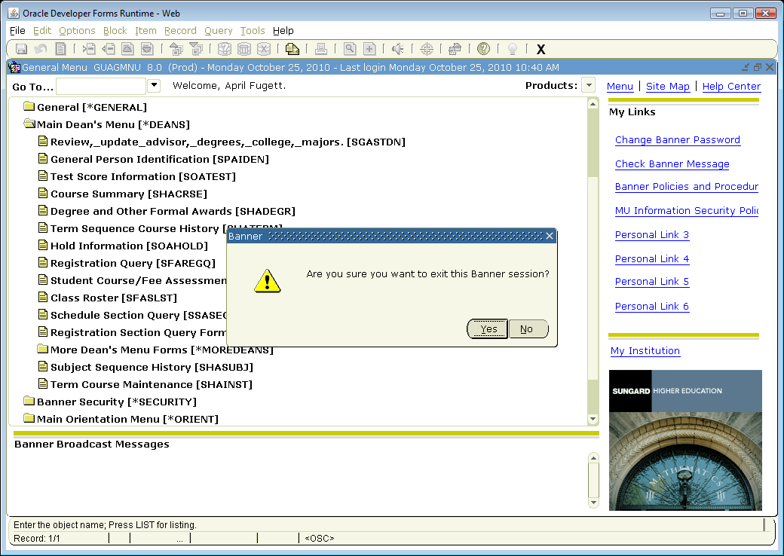
- You have successfully exited Banner.

