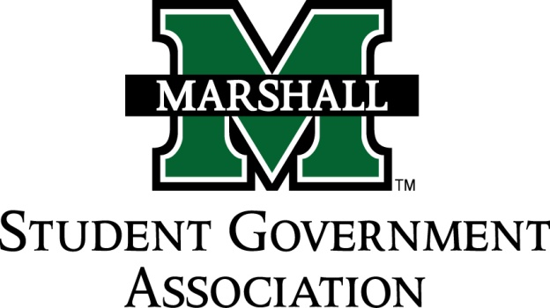

STUDENT SENATE
SESSION 71
October 1st, 2013
MEETING 6

CALL TO ORDER
INVOCATION
PLEDGE OF ALLEGIANCE
ROLL CALL

OLD BUSINESS
SB 71.04 Funding Bill (Alpha Phi Alpha)
SB 71.05 Funding Bill (CRU)
SB 71.05 Funding Bill (Ratio Christi)

NEW BUSINESS

MESSAGE FROM EXECUTIVES
Student Body President – Elisha “E.J.” Hassan
Student Body Vice President- Ashley Lyons
Senate President Pro-Tempore – Nick Chancey
Senate Parliamentarian – Chad Thompson
Senate Treasurer – Duncan Waugaman
Campus Life and Service Committee – Bekkah Brown
Constituency Project Committee – Cameron Ross

DEAN MEETING REPORTS

MESSAGES FROM ADVISORS
Executive Advisor - Dean Steve Hensley
Advisor - Vanessa Keadle
Senate Advisor – Matt James

CONCERNS OF THE STUDENT BODY
OPEN FORUM
ADJOURNMENT

