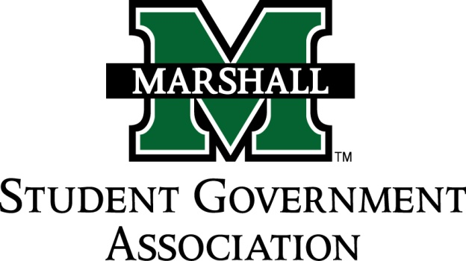

STUDENT SENATE
SESSION 71
September 17th, 2014
MEETING 4

CALL TO ORDER
INVOCATION
PLEDGE OF ALLEGIANCE
ROLL CALL

OLD BUISNESS
SB 71.01 Funding Bill (MUATA)
SB 71.02 Funding Bill (Alpha Kappa Psi)
SB 71.03 Funding Bill (MUPROS)

NEW BUSINESS
SB 71.04 Funding Bill (Alpha Phi Alpha)
SB 71.05 Funding Bill (CRU)
SB 71.06 Funding Bill (Ratio Christi)

MESSAGE FROM EXECUTIVES
Student Body President – Elisha J. Hassan
Student Body Vice President – Ashley Lyons
Senate President Pro-Tempore – Nick Chancey
Senate Parliamentarian – Chad Thompson
Senate Treasurer – Duncan Waugaman

DEAN MEETING REPORTS

MESSAGES FROM ADVISORS
Executive Advisor - Dean Steve Hensley
Senate Advisor- Matt James

CONCERNS OF THE STUDENT BODY

OPEN FORUM

ADJOURNMENT

