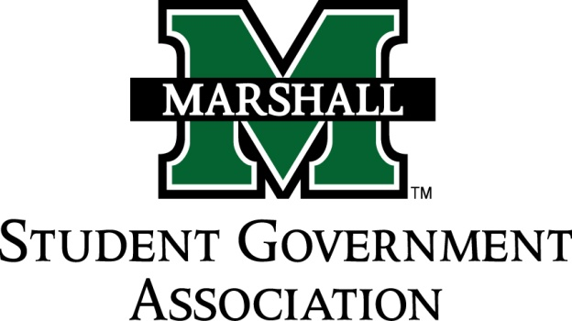

STUDENT SENATE
SESSION 71
September 17th, 2014
MEETING 4

CALL TO ORDER
INVOCATION
PLEDGE OF ALLEGIANCE
ROLL CALL

OLD BUISNESS
SB 71.01 Funding Bill (MUATA)-Tabled
SB 71.02 Funding Bill (Alpha Kappa Psi)-Tabled
SB 71.03 Funding Bill (MUPROS)-Tabled

NEW BUSINESS
SB 71.04 Funding Bill (Alpha Phi Alpha)-Sent to Finance
SB 71.05 Funding Bill (CRU)-Sent to Finance
SB 71.06 Funding Bill (Ratio Christi)-Sent to Finance

MESSAGE FROM EXECUTIVES
Student Body President – Elisha J. Hassan
- Partnership with WMUL: by-weekly time slot on radio show to discuss what is going on in student government. Starting a week from tomorrow.
- Unity Walk is October 1st, Starting at 5:00pm
- Veterans affairs partnering with wounded warrior to put together a 5K for veteran support.
- Homecoming: groups apply for floats. Application deadline is the 27th.
Student Body Vice President – Ashley Lyons
Senate President Pro-Tempore – Nick Chancey
- Please join campus life and service committee! Vital that this gains membership.
- Anyone interested in being on the constituency project committee please talk to Nick about joining, especially if you want chairmanship
- Senate Exec please give Nick headshots and bio for website.
Senate Parliamentarian – Chad Thompson
- Make sure you are recording your office hours.
Senate Treasurer – Duncan Waugaman
- Meeting next week at 3:20 on Tuesday.

DEAN MEETING REPORTS

MESSAGES FROM ADVISORS
Executive Advisor - Dean Steve Hensley
Senate Advisor- Matt James
- Time management workshop tonight and tomorrow @ 7PM
- Unity Walk Oct. 1st.

CONCERNS OF THE STUDENT BODY
- Dustin Murphy: Free Speech On Campus

OPEN FORUM

ADJOURNMENT

