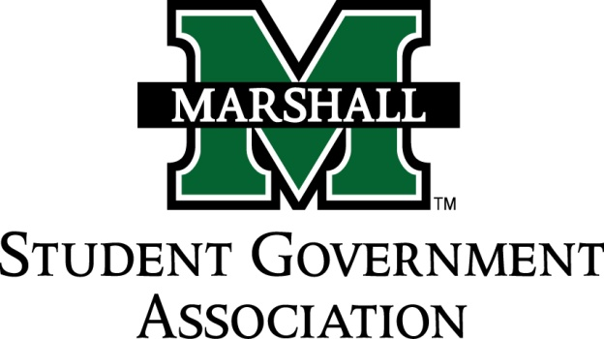

STUDENT SENATE
SESSION 71
October 1st, 2013
MEETING 6

CALL TO ORDER
INVOCATION
PLEDGE OF ALLEGIANCE
ROLL CALL

OLD BUSINESS
SB 71.04 Funding Bill (Alpha Phi Alpha)
- Passed
SB 71.05 Funding Bill (CRU)
- Passed
SB 71.06 Funding Bill (Ratio Christi)
- Passed

NEW BUSINESS

MESSAGE FROM EXECUTIVES
Student Body President – Elisha “E.J.” Hassan
- Signup sheet for homecoming parade, must be at 21 club by 8 am. Can receive a free breakfast for volunteering. Come tonight to meeting @ 9:15 to go over things
Student Body Vice President- Ashley Lyons
- Committee roll run through. You must be on either Judiciary or Finance and you are encouraged to join either campus life and service committee or the constituency project committee.
- If you missed the retreat please get with Ashley Lyons about your excused absence if you have not already done so.
- Victoria Perri is decorating the SGA office after the Unity walk for homecoming, please assist her after the walk if you can.
- Possible SGA sponsored blood drive on Dec. 4th, 11-5pm. Please let Ashley Lyons know if you are willing to volunteer.
- Shirts & sweatshirts are in the works. Optional crewneck sweatshirt that you can order. Estimated prices between $12-$18. Each committee needs to have a quote to submit for ballot next week.
Senate President Pro-Tempore – Nick Chancey
Senate Parliamentarian – Chad Thompson
Senate Treasurer – Duncan Waugaman
Campus Life and Service Committee – Bekkah Brown
- Hoping to have a meeting ASAP, Senator Brown will be in touch
Constituency Project Committee – Cameron Ross
- Please continue to join committee. Meeting in

DEAN MEETING REPORTS

- COLA: report submitted via senator from Tommy Ferrell.
  - Dean Advisory Board in the works for COLA
  - Majors, Minors, and More event: COLA senators and apprentices please sign up.

MESSAGES FROM ADVISORS
Executive Advisor - Dean Steve Hensley
- Theatre: Go check out the current production at the University Theater! Regular show is at 7:30 tomorrow and tickets are free to all students.
Advisor - Vanessa Keadle
Senate Advisor – Matt James
- Unity walk is @ 5:30, meet at campus rec.
- Retreat was successful, if you have any questions please feel free to talk to Matt.

CONCERNS OF THE STUDENT BODY

- Senator Roberts: Concern over new parking garage and getting locked in the garage due to no employee at exit to let her out.
- Professor Beller on Budget Cuts: New budget tightening measures are coming down from the state legislature. The next move is going to be cutting courses, etc. She is asking us to become involved in the fight against further budget cuts. These are new petitions from last year and would be a huge coalition if thousands of students signed. Asks that we put campus email instead of home. Please encourage your college to get involved as well as any fellow students that attend other West Virginian schools of higher education. This will affect not only the school budget but also the economy of West Virginia.
  - Please Senators, read through the potential petition for spell checks, grammar, or any other general issues that you feel need to be addressed in the petition. Next week we will discuss adopted an official petition.
  - Encourage timely manner with adopting and carrying out this petition. If signatures could be gathered by the first of November it would create a huge effect in the legislature when it meets.

OPEN FORUM
ADJOURNMENT

