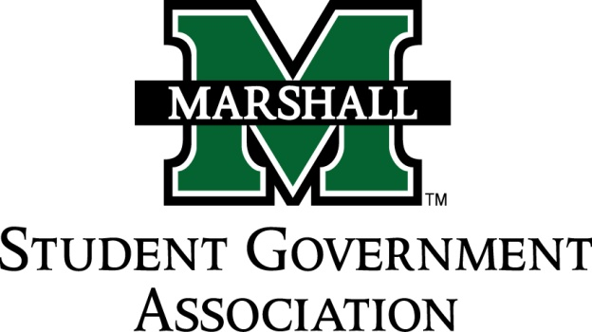

STUDENT SENATE
SESSION 71
October 1st, 2013
MEETING 7

CALL TO ORDER
INVOCATION
PLEDGE OF ALLEGIANCE
ROLL CALL

OLD BUSINESS
State Budget Cut Discussion
- Next week judiciary and student life & services will have a resolution to present to the general senate.
- Judiciary members need to have revisions completed and sent to chad by tomorrow evening.
- Speed and efficiency is key on this issue
Deviation to vote in new members of senate.
Deviation by Chief Terry on new parking garage issue.
- Video was looked at and employee talked with. Chief says the issue has been corrected and will not be occurring further.

NEW BUSINESS
SB 71.07 Funding Bill (Student Ambassadors) Moved to Finance
SB 71.08 Funding Bill (Alpha Chi Sigma) Moved to Finance
SB 71.09 Funding Bill (Sado Club) Moved to Finance
SB 71.10 Funding Bill (Pi Kappa Phi) Moved to Finance

New business via Senator Robinson on this issue on funding policies concerning funding bills. Primarily on the issue on SGA funding food.
- Senator Waugman as Finance chair backed the funding on food for previously passed bills because it was deemed education and useful for recruitment, retention, and useful in a leadership capacity.
Deviation by Senator Robinson on Syllabus Policy Act of 2013.
- Suggested revisions on syllabus criteria for the University.
- Concerns by Senator Brown on how this will be enforced concerning professors
- Senator Thompson, this resolution would only change dates on policy already in place.
- Resolution PASSED

MESSAGE FROM EXECUTIVES
Student Body President – Elisha “E.J.” Hassan
- Alpha Xi Jigsaw philanthropy event. See Senator Dodrill If you want more info.
Student Body Vice President- Ashley Lyons
- BE5 Yeager Symposium @ 7:00pm. Educational, please attend if at all possible.
- Foundation Hall at @ 7:00pm comparison on affordable healthcare act
Senate President Pro-Tempore – Nick Chancey
- Good work to Senator Robinson on resolution
Senate Parliamentarian – Chad Thompson
- See Chad about senate Apprentice program if you want an apprentice
- Scan QR code for Office hours in the SGA office.
Senate Treasurer – Duncan Waugaman
- Thanks to Jordan on Parade. Great Job
Campus Life and Service Committee – Bekkah Brown
- Emailing Chief Terry about smoking policing issue.
Constituency Project Committee – Cameron Ross
- Expect an email containing a doodle doc to figure out a meeting time for the committee.
- Come with ideas please.

DEAN MEETING REPORTS
COS meeting this Thursday at 5 pm to have a meeting.

MESSAGES FROM ADVISORS
Executive Advisor - Dean Steve Hensley
- Make sure funding also follows state and federal laws.
Advisor - Vanessa Keadle
Senate Advisor – Matt James
- Great show for Unity Walk

CONCERNS OF THE STUDENT BODY

- Concerns on overselling of parking passes and the lacking of parking.
- Getting organizations officially recognized on campus.
OPEN FORUM

ADJOURNMENT

