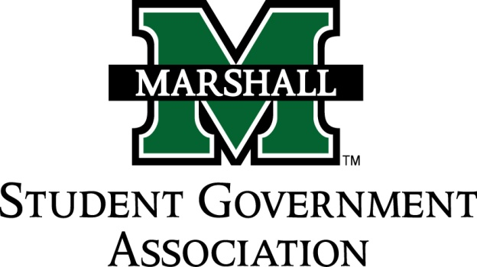

STUDENT SENATE
SESSION 71
October 15th, 2013
MEETING 8

CALL TO ORDER
INVOCATION
PLEDGE OF ALLEGIANCE
ROLL CALL

OLD BUSINESS
SB 71.07 Funding Bill (Student Ambassadors) PASSED
SB 71.08 Funding Bill (Alpha Chi Sigma)
- Tabled because of wrong representative sent to finance committee
SB 71.09 Funding Bill (Sado Club) PASSED
SB 71.10 Funding Bill (Pi Kappa Phi) PASSED

NEW BUSINESS
Faculty Senate Committees
- 12 committees that need a senator to represent the student body on the committee.
- Will have voting rights.
  - Academic Planning Committee: Senator Robins
  - Athletics Committee-Senator Kline, Khodadadi
  - Curriculum Committee-Senators Penneta, Robins
  - Faculty Development Committee-Senator Thompson
  - Faculty Personal Committee-Senator Grimes
  - Legislature Affairs Committee-Senator Breedon
  - Library Committee-
  - Physical Facilities & Planning Committee- Senator Troutman
  - Research Committee- Senator Shaver
  - Student Conduct and Welfare Committee- Senator Roberts, Grimes, Lee, Hatton
  - University Functions Committee-Senator Roberts
  - Budget & Academic Policy Committee-Senator Thompson
Funding Bills Update
- A lot of organizations applying for funding are not vendors through the state.
- Due to the time it takes to become vendors expect new funding bills in about two weeks.
Deviation from agenda in for swearing in of Senate Apprentices-PASSED
Deviation to discuss the petition to the governor and state legislator:
- Petition will be converted to a resolution containing the same information.
- If you have any changes to the petition please see Senator Thompson immediately.

MESSAGE FROM EXECUTIVES
Student Body President – Elisha “E.J.” Hassan
- Signup sheet for beta tester for course scheduling. Need several students to volunteer to test out this program.
- Food pantry advisory committee. This pantry will open in the basement of the student center for students to be able to use. The Student Government association has been asked to come up with an idea for a suitable name for the pantry. Please email or go speak to President Hassan about possible ideas.
- Combat Veterans 5K on November 16^{th @} 8AM. Need volunteers to help run the event. Look for signup sheet here soon.
Student Body Vice President- Ashley Lyons
- Committee Service Hours, you need at least 8 hours.
- SGA TShirts. Will have have “Student Government Association” on front and giant Marshall “M” on back with whatever college you represent.
- Crewnecks will be $21 and money is due in two weeks
- All senators need to be looking at funding bills critically. Come to meeting with prepared questions.
Chief of Staff – Jordan Wooldridge
- 6,000 directories down stairs that need to be dispersed. Signup sheet to help pass them out on campus on Thursday and Friday.
Senate President Pro-Tempore – Nick Chancey
- No messages
Senate Parliamentarian – Chad Thompson
- Everyone will be receiving an email tonight about double checking your contact information as well as fellow senators contact information. If it is incorrect please let Senator Thompson know immediately.
- Will only be using Marshall University Emails from now on.
- Please read our constitution and by-laws!!!!
- Office Hours will be sent tonight. Please record Office hours and community service hours.
Senate Treasurer – Duncan Waugaman
- Will be meeting next week. Will text
Campus Life and Service Committee – Bekkah Brown
- Have been in touch Chief Terry about working with him on parking, tobacco ban, etc.
- Meeting involving him will be planned in near future.
Constituency Project Committee – Cameron Ross
- Join committee! Resolutions are coming.

DEAN MEETING REPORTS

MESSAGES FROM ADVISORS
Executive Advisor - Dean Steve Hensley
- Go get your flu shot
Senate Advisor – Matt James

CONCERNS OF THE STUDENT BODY
OPEN FORUM
Delta Zeta Spaghetti dinner coming up please see Senator Roberts or Troutman for Tickets.
ADJOURNMENT

