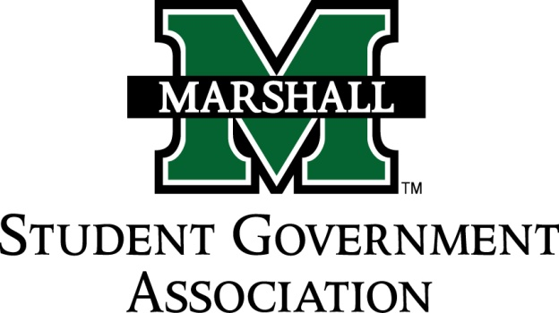

STUDENT SENATE
SESSION 71
October 22nd, 2013
MEETING 9

CALL TO ORDER
INVOCATION
PLEDGE OF ALLEGIANCE
ROLL CALL

OLD BUSINESS
SB 71.08 Funding Bill (Alpha Chi Sigma) PASSED
- Honorary chemistry fraternity

NEW BUSINESS

Deviation by Senator Waugman
- Misuse of funds by Alpha kappa Psi?
- Must return funds previously given by SGA and are on probation for the spring of 2014 for receiving funding.
- Must pay by January 12th

MESSAGE FROM EXECUTIVES
Student Body President – Elisha “E.J.” Hassan
- Update on Syllabus bank resolution. It is currently in the Academic budget and policy committee.
- Food Pantry: Still open for names for the new food pantry. Please give suggestions to executive branch members. Possible names “aisle 37” and “Marco Mart”.
- Memorial fountain ceremony on November 14^{th @} 12:00pm. (Required event, you receive a school excuse). Classes will not be canceled.
Student Body Vice President- Ashley Lyons
- Dress code for memorial ceremony. You need to be in professional dress.
- If you have not given shirt order give it to Ashley ASAP. Please bring money for crewnecks by Friday. Ashley will be in the office to take payments from 8-11 and 3-4. Write checks to Marshall University.
- Sign up for veteran run. To run or volunteer. November 16th @ 8:00am
Chief of Staff – Jordan Wooldridge
- Directories will be passed on Thursday and Friday because of rain last week. Will table in the student center to hand them directly to students (All day).
Senate President Pro-Tempore – Nick Chancey
- Positive comments on senates progress thus far this semester.
Senate Parliamentarian – Chad Thompson
- Email sent last week sent through Marshall email. Please review this documentation and get with Chad if they need to be changed.
Senate Treasurer – Duncan Waugaman
- Meeting next week, room to be determined.
- Thanks to committee for professionalism on the misuse of funds issue.
Campus Life and Service Committee – Bekkah Brown
- Look for a meeting set up this week.
Constituency Project Committee – Cameron Ross
- Meeting tonight right after senate.

DEAN MEETING REPORTS
- COB: Will meet again October 30th at 12:00pm. Pumpkin painting October 28 at 6pm in the College of Business. Wants to put benches in the hallways. New ideas coming forward. A lot of upcoming events. Day with the dean is November ?.
MESSAGES FROM ADVISORS
Executive Advisor - Dean Steve Hensley
Senate Advisor – Matt James
- University is bringing in a marketing firm for research. Focus group for upperclassmen at 5:45 tomorrow in student resource center.
CONCERNS OF THE STUDENT BODY
- Clarification of program for faster registration.
OPEN FORUM
- Thompson: Disconnect in fees for graduate fees.
- Grimes: Youth Leadership School. If you’re interested please see Senator Grimes
- Roberts: Delta Zeta turtle tug. Spaghetti dinner
- Kline: Rotaract club event on Polio.
- Ross: International Thanksgiving dinner
ADJOURNMENT

