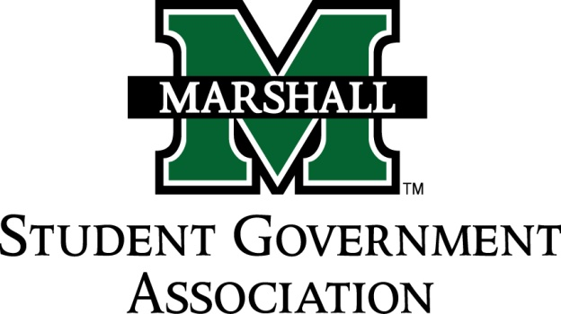

STUDENT SENATE
SESSION 74
November 1, 2016
MEETING 10
CALL TO ORDER
INVOCATION
PLEDGE OF ALLEGIANCE
ROLL CALL
OLD BUSINESS
SB 74.23 (Alpha Phi Sigma)
NEW BUSINESS
SB 74.24 (Phi Alpha Theta)
SB 74.25 (Chi Alpha Christian Fellowship)
Campus Activities Board – Talk about Greater Collaboration
MESSAGE FROM EXECUTIVES
Student Body President – Matt Jarvis
Student Body Vice President – Emily Kinner
Senate President Pro-Tempore – Alex O’Donnell
Senate Parliamentarian – Ethan Higginbotham
Senate Treasurer – Eli Duduit
Senate Campus Life and Committee Chairwoman – Sophia Mills
Senate Apprenticeship Director – Jada Williams
MESSAGES FROM ADVISORS
Vice President of Student Affairs – Cedric Gathings
Assistant Dean of Student Affairs / Executive Advisor – Matthew James
Senate Advisor – Michelle Barbour
CONCERNS OF THE STUDENT BODY
OPEN FORUM / ADJOURNMENT

