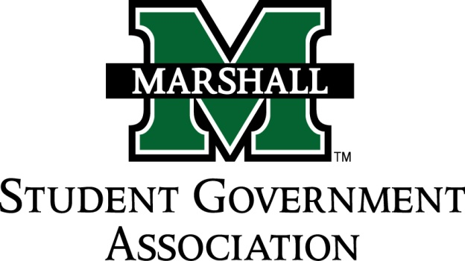

STUDENT SENATE
SESSION 74
September 27, 2016
MEETING 5

CALL TO ORDER
INVOCATION
PLEDGE OF ALLEGIANCE
ROLL CALL
OLD BUSINESS
SB 74.07 (Pre-Physical Therapy Club)
SB 74.08 (Cricket Club)
NEW BUSINESS
SB 74.09 (MU PROS)
SB 74.10 (Student Nurses Association)
SB 74.11 (American Society of Mechanical Engineers)
SB 74.12 (Marshall University Athletic Training Association)
MESSAGE FROM EXECUTIVES
Student Body President – Matt Jarvis
Student Body Vice President – Emily Kinner
Senate President Pro-Tempore – Alex O’Donnell
Senate Parliamentarian – Ethan Higginbotham
Senate Treasurer – Eli Duduit
Senate Campus Life and Committee Chairwoman – Sophia Mills
Senate Apprenticeship Director – Jada Williams
DEAN MEETING REPORTS
MESSAGES FROM ADVISORS
Vice President of Student Affairs – Cedric Gathings
Assistant Dean of Student Affairs / Executive Advisor – Matthew James
Senate Advisor – Michelle Barbour
CONCERNS OF THE STUDENT BODY
OPEN FORUM / ADJOURNMENT

