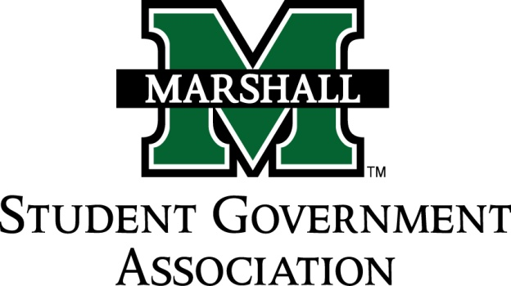

STUDENT SENATE
SESSION 74
October 4, 2016
MEETING 6
CALL TO ORDER
INVOCATION
PLEDGE OF ALLEGIANCE
ROLL CALL
OLD BUSINESS
SB 74.09 (MU PROS)
SB 74.10 (Student Nurses Association)
SB 74.11 (American Society of Mechanical Engineers)
SB 74.12 (Marshall University Athletic Training Association)
NEW BUSINESS
SB 74.13 (Et Cetera Literary Guild)
SB 74.14 (MU Professional Wrestling Club)
SB 74.15 (Sado Club)
SB 74.16 (Rotaract Club)
SB 74.17 (Indian Student Association)
SR 74.02 (Sen. Griffith)
Oath of Office – New Senators and Senate Apprentices
Senate-Constituent Engagement Initiative
MESSAGE FROM EXECUTIVES
Student Body President – Matt Jarvis
Student Body Vice President – Emily Kinner
Senate President Pro-Tempore – Alex O’Donnell
Senate Parliamentarian – Ethan Higginbotham
Senate Treasurer – Eli Duduit
Senate Campus Life and Committee Chairwoman – Sophia Mills
Senate Apprenticeship Director – Jada Williams
MESSAGES FROM ADVISORS
Vice President of Student Affairs – Cedric Gathings
Assistant Dean of Student Affairs / Executive Advisor – Matthew James
Senate Advisor – Michelle Barbour
CONCERNS OF THE STUDENT BODY
OPEN FORUM / ADJOURNMENT

