Information about the Syllabus Checker AI Agent
Marshall University, Office of Assessment and Strategic Initiatives
Fall 2025, Dr. Allison Carey

Who can use this tool:
- Anyone with a Marshall University login can access this tool through a link on the Office of Assessment webpage. (See How-to, below).
- This tool could prove useful for faculty who are building their Spring ’26 syllabi, for adjunct faculty who are creating a Marshall syllabus for the first time, for curriculum committees who need to review syllabi, etc.

Limitations of the tool:
- Like with any AI, the tool sometimes hallucinates and generates incorrect information. To be sure, a human needs to check.
- The tool especially struggles with comparing the syllabus’s course description with the course description in the catalog, and it has the most difficulty with courses that are cross-listed or 400/500-level.

How to access this tool:
- Go to https://www.marshall.edu/assessment/university-assessment/ and click on “Syllabus Checker Agent” (under Key Links on the right of the page). (See screenshot 1 below.)
- You might be prompted to log in to the Marshall system (your Marshall username and password).
- You will then be prompted to add this agent (called “Syllabus Checker Nov2025_aec”) to your account. Click “Add.”
- Once the agent is added to your account, you’ll see it listed in the menu on the left. (See screenshot 2.)

How to use this tool:
- In the dialog box (see screenshot 3), you can either type a prompt (“could you check a syllabus for me?” —screenshot 4), or you can just skip right to uploading a syllabus.
- To upload a syllabus, click on the plus sign (+), select “Upload images and files,” find your syllabus in the file navigation windows, select it, then click “Open.” (See screenshot 5.)
- Once it uploads, hit “enter” (or “return”) to start the Checker.
- If you’d like to save the results for later, click on the file icon in the icons at the very end of the results (the icon on the far left), then paste the results (which are now on your clipboard) into a Word document. Save. (See screenshot 6.)

Screenshot 1:

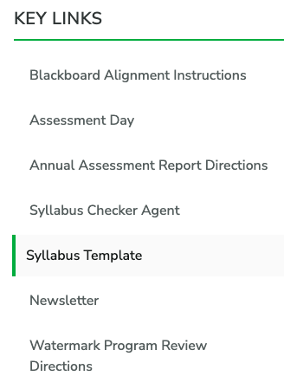

Screenshot 2:
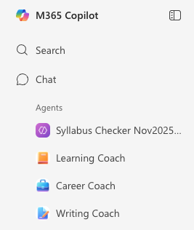

Screenshot 3:
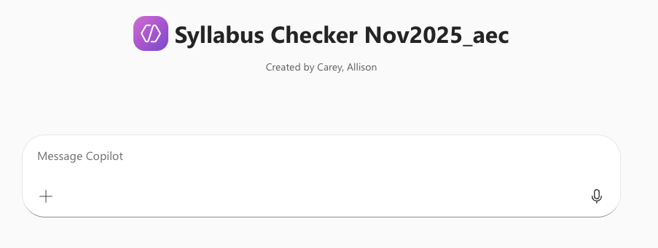

Screenshot 4:
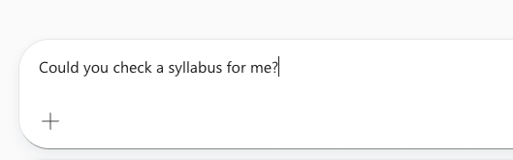

Screenshot 5:
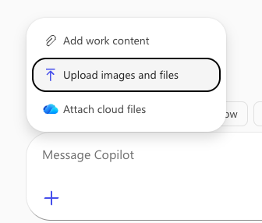

Screenshot 6:
