Notes on Syllabus Accessibility, Marshall University
Prepared by Dr. Allison Carey, Associate Provost for Assessment & Strategic Initiatives (1/12/2026)

NOTE: The Spring 2026 MU Syllabus template (available 12/8/25) meets accessibility standards. But if you used an older version of the Marshall syllabus template (and are updating an older syllabus file for your Spring ’26 syllabus), Blackboard Ally will find at least a couple of accessibility problems with your syllabus.

An approach that might be simpler? Download the new syllabus template and use that. But if you want to update your old file, the instructions below will walk you through the process. Although these steps might appear complicated, it will take you about 5 minutes to update your syllabus for accessibility!

Here’s what those typical accessibility issues (for the old syllabus template) are and how to fix them:

- In Blackboard, my accessibility rating for an older syllabus (saved as a PDF) was quite low (see red icon in Screenshot 1a below). I clicked on the accessibility rating-icon to get more information, and Ally told me that the document had 3 problems [Screenshot 1b]:
  - the document wasn’t “tagged” [an invisible setting for screen-readers],
  - the language wasn’t set for the document [an invisible setting for screen-readers], and
  - the document wasn’t titled [another invisible setting for screen-readers].
  - (Note: I was expecting to see a 4th problem—the Marshall logo needs “alt-text” so a screen-reader can interpret the image. See Step 7 below.)

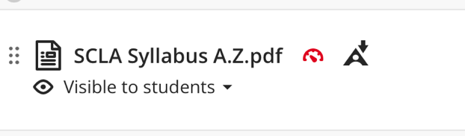 Screenshot 1a

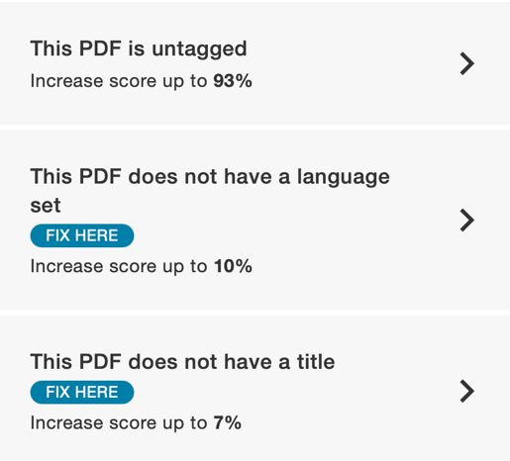 Screenshot 1b

- Fixing problems b & c was simple: I could make those fixes within Ally. I clicked on “Fix Here,” and I selected a language from the dropdown menu and clicked “Apply Fix,” and then I typed in a document title and clicked “Apply Fix.” See the example in Screenshot 2.

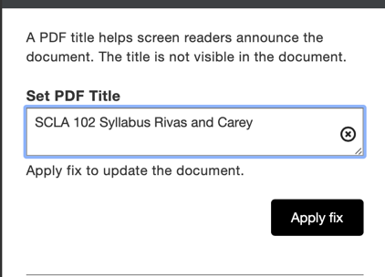 Screenshot 2

- Fixing problem “a” (the document is untagged) is more complicated, AND the lack of tags lowers my accessibility score a lot (Screenshot 3)! If you click on that item in the list of problems (Screenshot 1b), and then click on “How to tag a PDF,” then Ally will probably tell you to find your original Microsoft Word file and fix that. If you have that file handy, awesome. (In Microsoft Word, open the doc, go to the “Tools” menu, and select “Check Accessibility” from the dropdown.) HOWEVER, the following directions will walk you through fixing your PDF file.

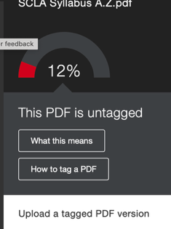 Screenshot 3

- To tag this PDF, you’ll need to use the desktop app-version of Adobe Acrobat Pro. If you already have this software installed, skip to step #5. All Marshall University faculty and staff should have access to Adobe Acrobat Pro for free. If you need to install this software, follow these directions:
  - Go to Marshall’s Software page https://www.marshall.edu/it/training/availablesoftware/
  - Click Adobe Acrobat
  - Sign in with your University Credentials
  - Select Download Acrobat apps in the top right-hand corner. Download and install on your computer.

- Open Adobe Acrobat Pro and then open your saved PDF file of your syllabus. You should see a menu of tools along the left of the screen (to the left of your document): Screenshot 5a. (If you don’t see the tool menu, click on “All Tools” at top.) At the bottom of that menu, click on “View More,” then scroll down until you see “Prepare for accessibility” (Screenshot 5b).

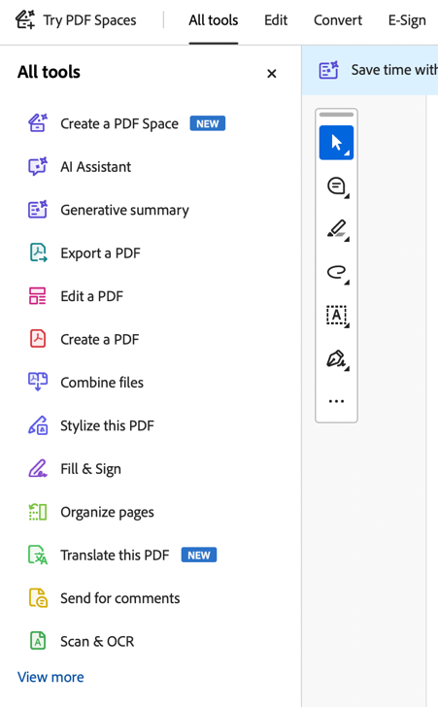 Screenshot 5a

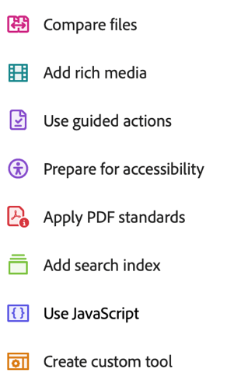 Screenshot 5b

- On the “Prepare for accessibility” menu (Screenshot 6), select “Automatically tag PDF.” Run that process.
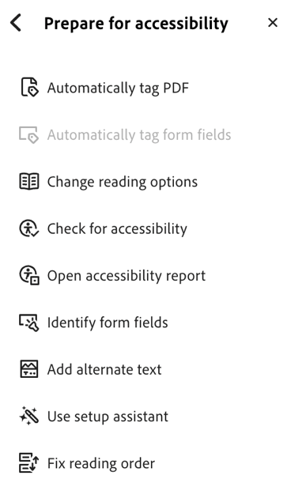 Screenshot 6

- Once that finishes, let’s go ahead and fix the 4th problem that we know is there: the Marshall logo needs to have “alt text” added for screen readers. Click on “Add alternate text” from the “Prepare for accessibility” menu.

- In the pop-up box (Screenshot 8), type in “Marshall University logo,” then click “Save & Close.”
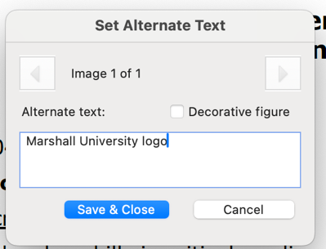 Screenshot 8

- Now, if you save this revised file and upload it to Ally, you’ll probably see a much improved score (Screenshot 9)!

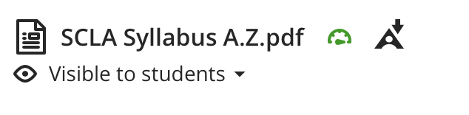 Screenshot 9

- It’s possible that your PDF syllabus file might have other accessibility issues beyond the ones from the old syllabus template. (Maybe you have other images that need alt text?) You can use these same steps (plus the “Check for accessibility” report in Adobe Acrobat Pro) to diagnose and fix those issues.
- Important note: Whenever you run the “Check for accessibility” in Adobe Acrobat Pro, it will almost always say there are 2 issues with the document, even if Ally gives it a perfect score (Screenshot 11): Adobe recommends a manual check—a human being looking through a human eye—of whether the document is in a logical reading order and whether the document has good color contrast, even if Adobe thinks those two things are fine.

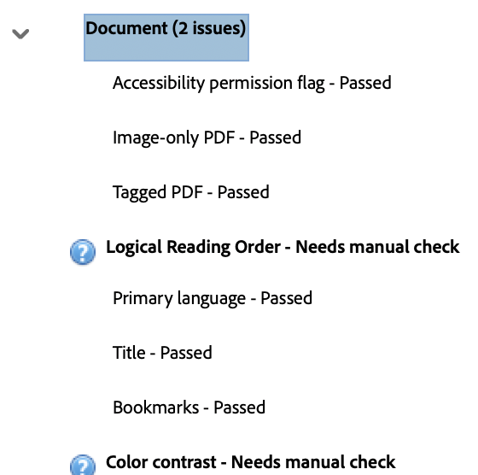Screenshot 11

