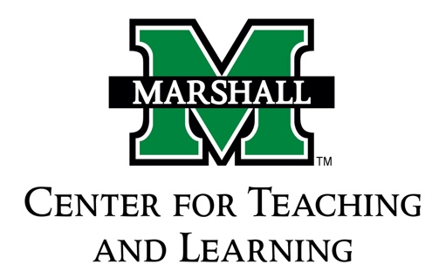

**Community-Based Learning Program**

Community-Based Learning Option Contract

Student Name 901 –

Student Email Date of Application

Student Degree Program

Course Subject, Number, and Section CRN

Semester/Year Credit Hours

Instructor Instructor’s Email

After working together to come up with the CBL project the instructor/students will submit the following to the Office of the Community-Based Learning Program, Old Main 109.

1. typed responses to the following:

* Describe the CBL requirements that will supplement the regular coursework, how these activities will enhance the coursework, and how you will benefit from it.
* Briefly describe the contract requirements and how your work will be evaluated for CBL credit.
* Specialized work depends on regular contact between the student and the professor to assess the progress of the project and deepen the student/faculty relationship. Describe the agreement made regarding this requirement.

1. this form with the required signatures below

**These two items are due in hard copy to the Office of the Community-Based Learning Program, Old Main 109 no later than 4:00 p.m. on the second Friday of the semester.**

AGREEMENT TO TERMS DESCRIBED ABOVE

Student Date

Instructor Date

COMMUNITY-BASED LEARNING PROGRAM APPROVAL

Director, Community-Based Learning Program Date