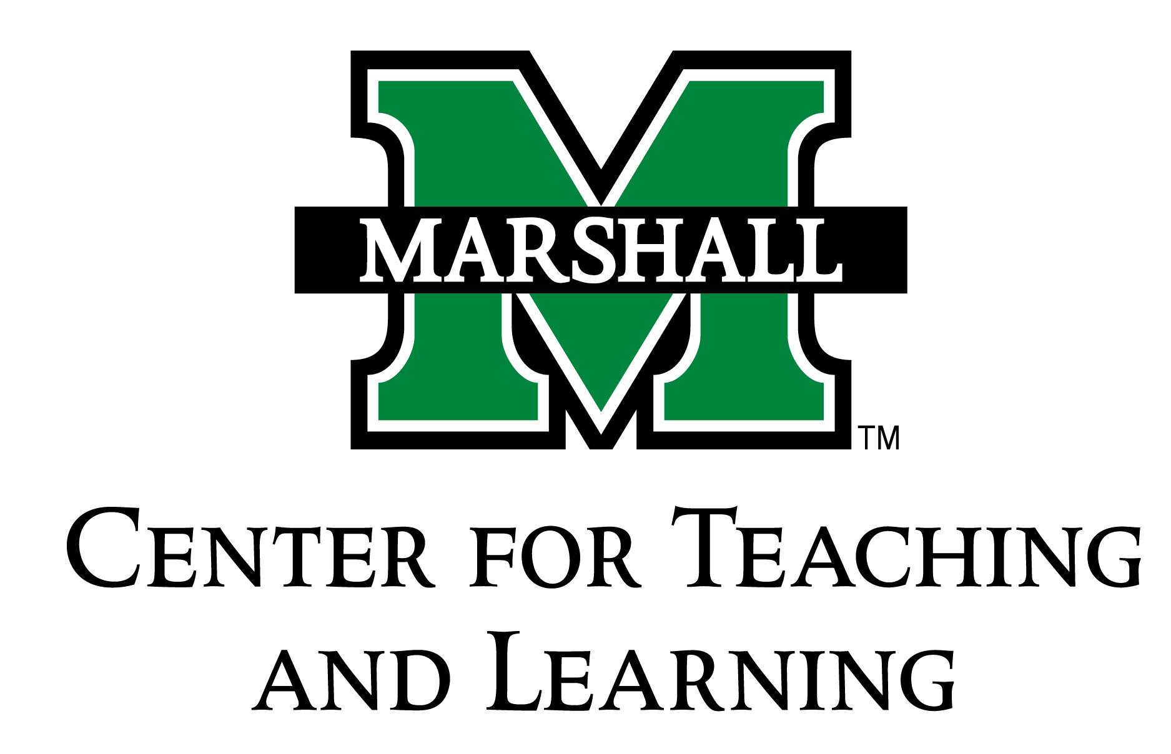

**Community-Based Learning Option**

Information for Students and Faculty

The Community-Based Learning option (CBL-option) provides flexibility for both faculty and students. Faculty, who may have opportunities to provide experiential learning in the community for some - but not all - of the students in a class can use the CBL-option for select students. Students, who are interested in taking on additional challenges and experiences to support their learning, may ask faculty if community-based learning opportunities exist for them. In either case, an individual student may enter into an agreement with a course instructor to provide those additional opportunities. That agreement is the CBL-Option Contract and reflects additional and different kinds of work as that being done by the other students in the class.

*Requirements*

The requirements for a CBL-option course are similar to those for courses with the CBL designation. These include:

1. The work must be academically relevant.
2. The contract must include a course outcome specifically focused on community-based learning.
3. The assignments must include at least one short reading on civic/community engagements.
4. The student must complete a minimum of 10 hours of contact in or with the community.
5. The assignments must include regular, structured, and graded reflection assignments.
6. CBL work must account for at least 20% of the course grade.

Please note these additional considerations:

1. The experience should run throughout the semester, whenever possible, and contracts - with signatures - must be submitted to the Community-Based Learning Program in 109 Old Main by 4:00 pm on the second Friday of the semester.
2. Changes to previously signed contracts must occur before week six of the term.
3. The course may revert to a non-CBL status by the end of week ten with the instructor's permission and notification to the Director of the Community-Based Learning Program.

*For Students*

Members of the faculty are under no obligation to participate in the CBL option. Faculty enter into a CBL option contract as a courtesy to students. It is not a faculty member's responsibility to design the CBL option content for you. Bring your ideas to your instructor along with suggestions of things that you would benefit from doing that would add honors value to the class. For example, in the past students have engaged in various course-related or interdisciplinary projects, experiments, case studies, in-class or public presentations, collaborative research and writing, and peer tutoring. Overall, the semester goal is a more enriched and expanded experience with course content. Simply doing more work, or simply doing that work in the community, does not necessarily constitute CBL work.

*For Faculty*

Thank you for considering a CBL-option for a student(s) in your class. We hope that spending additional time with an especially motivated and engaged student will benefit you as well. Please offer guidance in the planning of the CBL-option, but you should include the student(s) assist in the planning the CBL project. When the contract has been accepted in the CBL Program, you will receive by email an electronic copy of the contract. At the end of the semester, you will receive another email from the Director of the Community-Based Learning Program asking whether the student has fulfilled the contract. You will have an opportunity to comment on the student's work at this time. **When you receive the email at the end of the semester, please respond as soon as you can. We cannot attach CBL credit to the student's transcript until we receive confirmation from you.**