Default Report
Third-Year Teacher Employee Survey 2019-2020
January 28th 2021, 1:28 pm EST
New Custom Page

# | Answer | % | Count
1 | Elementary School | 72.00% | 18
2 | Middle / Junior High School | 20.00% | 5
3 | High School | 8.00% | 2
 | Total | 100% | 25

Q2 - Please select your type of school.

# | Please select your type of school. | Mean
1 | Please select your type of school. | 1.41

# | Field | Minimum | Maximum | Mean | Std Deviation | Variance | Count
1 | Please select your type of school. | 1.00 | 3.00 | 1.36 | 0.62 | 0.39 | 25

# | Answer | % | Count
1 | Elementary School | 72.00% | 18
2 | Middle / Junior High School | 20.00% | 5
3 | High School | 8.00% | 2
 | Total | 100% | 25

Q3 - Using the drop-down menu below, please select the number of third-year teachers at your school.
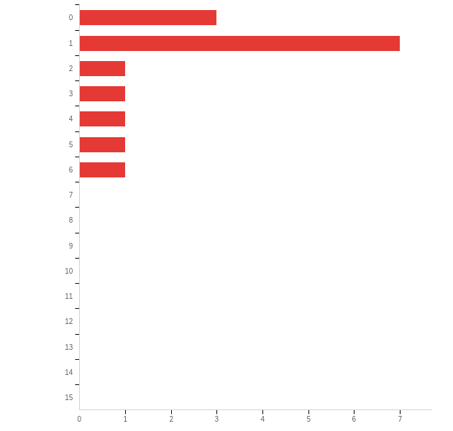

# | Field | Minimum | Maximum | Mean | Std Deviation | Variance | Count
1 | Using the drop-down menu below, please select the number of third-year teachers at your school. | 1.00 | 7.00 | 2.80 | 1.80 | 3.23 | 15

# | Answer | % | Count
1 | 0 | 20.00% | 3
2 | 1 | 46.67% | 7
3 | 2 | 6.67% | 1
4 | 3 | 6.67% | 1
5 | 4 | 6.67% | 1
6 | 5 | 6.67% | 1
7 | 6 | 6.67% | 1
8 | 7 | 0.00% | 0
9 | 8 | 0.00% | 0
10 | 9 | 0.00% | 0
11 | 10 | 0.00% | 0
12 | 11 | 0.00% | 0
13 | 12 | 0.00% | 0
14 | 13 | 0.00% | 0
15 | 14 | 0.00% | 0
16 | 15 | 0.00% | 0
 | Total | 100% | 15

Q5 - For each statement below, please indicate your overall rating of all third-year teachers who are working under your supervision during this academic year.
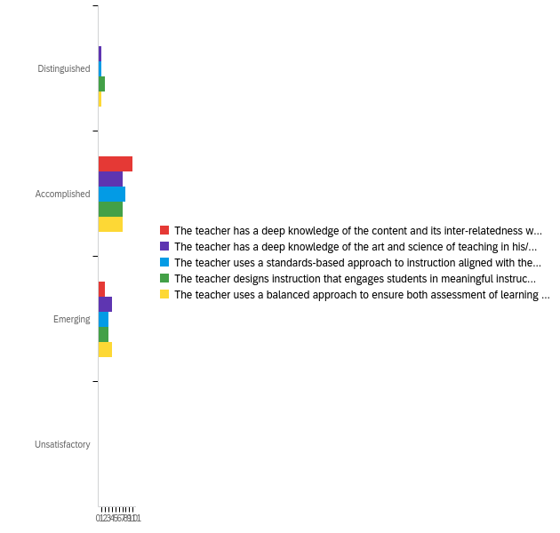

# | Field | Minimum | Maximum | Mean | Std Deviation | Variance | Count
1 | The teacher has a deep knowledge of the content and its inter-relatedness within and across the disciplines and can move beyond basic content competency to ensure student mastery of skills necessary for success in life and work. (1A: Core Content) | 2.00 | 3.00 | 2.17 | 0.37 | 0.14 | 12
2 | The teacher has a deep knowledge of the art and science of teaching in his/her specific content and can facilitate experiences that advance creativity, innovation, and problem solving. (1B: Pedagogy) | 1.00 | 3.00 | 2.25 | 0.60 | 0.35 | 12
3 | The teacher uses a standards-based approach to instruction aligned with the state and local curriculum and sets instructional goals and objectives that describe what students will learn. (1C: Setting Goals and Objectives for Learning) | 1.00 | 3.00 | 2.17 | 0.55 | 0.31 | 12
4 | The teacher designs instruction that engages students in meaningful instructional activities that support the WV Content Standards and Objectives and that result in intentional student learning. (1D: Designing Instruction) | 1.00 | 3.00 | 2.08 | 0.64 | 0.41 | 12
5 | The teacher uses a balanced approach to ensure both assessment of learning and assessment for learning to provide both teacher and students information to guide future learning. (1E: Student Assessment) | 1.00 | 3.00 | 2.25 | 0.60 | 0.35 | 12

Q6 - For each statement below, please indicate your overall rating of all third-year teachers who are working under your supervision during this academic year.
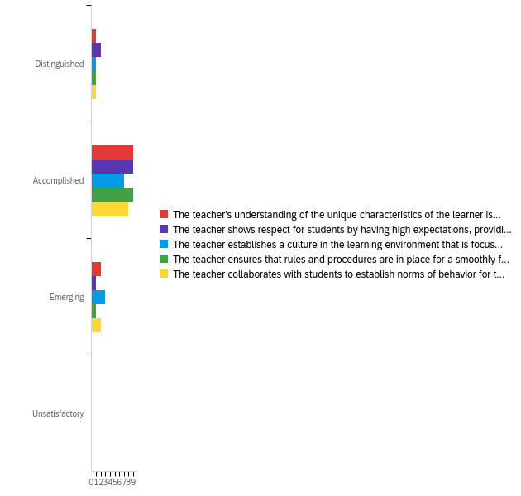

# | Field | Minimum | Maximum | Mean | Std Deviation | Variance | Count
1 | The teacher's understanding of the unique characteristics of the learner is evidenced in the design of learning activities which are developmentally appropriate and differentiated to engage all students in the learning process. (2A: Understanding Intellectual/Cognitive, Social, and Emotional Development) | 1.00 | 3.00 | 2.08 | 0.49 | 0.24 | 12
2 | The teacher shows respect for students by having high expectations, providing management frameworks that clearly define roles and procedures, using respectful language, communicating interest in students as individuals and encouraging student collaboration. (2B: Creating an Environment of Respect and Rapport) | 1.00 | 3.00 | 1.92 | 0.49 | 0.24 | 12
3 | The teacher establishes a culture in the learning environment that is focused on learning and that reflects the importance of the work undertaken by both students and the teacher. (2C: Establishing a Culture for Learning) | 1.00 | 3.00 | 2.18 | 0.57 | 0.33 | 11
4 | The teacher ensures that rules and procedures are in place for a smoothly functioning learning environment evidenced by the efficient use of time and resources. (2D: Implementing Classroom Procedures) | 1.00 | 3.00 | 2.00 | 0.43 | 0.18 | 11
5 | The teacher collaborates with students to establish norms of behavior for the learning environment that ensure a focus on learning. (2E: Managing Student Behaviors) | 1.00 | 3.00 | 2.09 | 0.51 | 0.26 | 11

# | Question | Distinguished |  | Accomplished |  | Emerging |  | Unsatisfactory |  | Total
1 | The teacher's understanding of the unique characteristics of the learner is evidenced in the design of learning activities which are developmentally appropriate and differentiated to engage all students in the learning process. (2A: Understanding Intellectual/Cognitive, Social, and Emotional Development) | 8.33% | 1 | 75.00% | 9 | 16.67% | 2 | 0.00% | 0 | 12
2 | The teacher shows respect for students by having high expectations, providing management frameworks that clearly define roles and procedures, using respectful language, communicating interest in students as individuals and encouraging student collaboration. (2B: Creating an Environment of Respect and Rapport) | 16.67% | 2 | 75.00% | 9 | 8.33% | 1 | 0.00% | 0 | 12
3 | The teacher establishes a culture in the learning environment that is focused on learning and that reflects the importance of the work undertaken by both students and the teacher. (2C: Establishing a Culture for Learning) | 9.09% | 1 | 63.64% | 7 | 27.27% | 3 | 0.00% | 0 | 11
4 | The teacher ensures that rules and procedures are in place for a smoothly functioning learning environment evidenced by the efficient use of time and resources. (2D: Implementing Classroom Procedures) | 9.09% | 1 | 81.82% | 9 | 9.09% | 1 | 0.00% | 0 | 11
5 | The teacher collaborates with students to establish norms of behavior for the learning environment that ensure a focus on learning. (2E: Managing Student Behaviors) | 9.09% | 1 | 72.73% | 8 | 18.18% | 2 | 0.00% | 0 | 11

Q7 - For each statement below, please indicate your overall rating of all third-year teachers who are working under your supervision during this academic year.
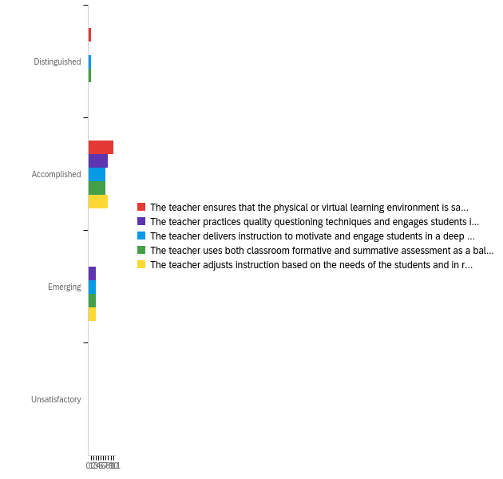

# | Field | Minimum | Maximum | Mean | Std Deviation | Variance | Count
1 | The teacher ensures that the physical or virtual learning environment is safe, and that there is maximum flexibility in the use of physical space in a physical learning environment. (2F: Organizing the Learning Environment) | 1.00 | 2.00 | 1.91 | 0.29 | 0.08 | 11
2 | The teacher practices quality questioning techniques and engages students in discussion. (3C: Questioning and Discussion Techniques) | 2.00 | 3.00 | 2.27 | 0.45 | 0.20 | 11
3 | The teacher delivers instruction to motivate and engage students in a deep understanding of the content. (3D: Student Engagement) | 1.00 | 3.00 | 2.18 | 0.57 | 0.33 | 11
4 | The teacher uses both classroom formative and summative assessment as a balanced approach to instructional decision making. (3E: Use of Assessments in Instruction) | 1.00 | 3.00 | 2.18 | 0.57 | 0.33 | 11
5 | The teacher adjusts instruction based on the needs of the students and in response to &quot;teachable moments.&quot; (3F: Flexibility and Responsiveness) | 2.00 | 3.00 | 2.27 | 0.45 | 0.20 | 11

# | Question | Distinguished |  | Accomplished |  | Emerging |  | Unsatisfactory |  | Total
1 | The teacher ensures that the physical or virtual learning environment is safe, and that there is maximum flexibility in the use of physical space in a physical learning environment. (2F: Organizing the Learning Environment) | 9.09% | 1 | 90.91% | 10 | 0.00% | 0 | 0.00% | 0 | 11
2 | The teacher practices quality questioning techniques and engages students in discussion. (3C: Questioning and Discussion Techniques) | 0.00% | 0 | 72.73% | 8 | 27.27% | 3 | 0.00% | 0 | 11
3 | The teacher delivers instruction to motivate and engage students in a deep understanding of the content. (3D: Student Engagement) | 9.09% | 1 | 63.64% | 7 | 27.27% | 3 | 0.00% | 0 | 11
4 | The teacher uses both classroom formative and summative assessment as a balanced approach to instructional decision making. (3E: Use of Assessments in Instruction) | 9.09% | 1 | 63.64% | 7 | 27.27% | 3 | 0.00% | 0 | 11
5 | The teacher adjusts instruction based on the needs of the students and in response to "teachable moments." (3F: Flexibility and Responsiveness) | 0.00% | 0 | 72.73% | 8 | 27.27% | 3 | 0.00% | 0 | 11

Q8 - For each statement below, please indicate your overall rating of all third-year teachers who are working under your supervision during this academic year.
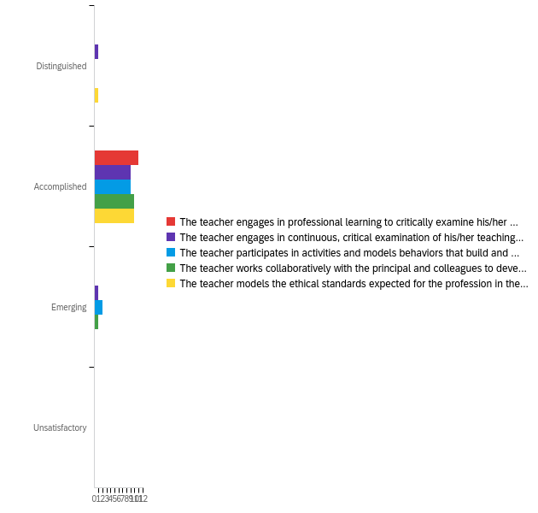

# | Field | Minimum | Maximum | Mean | Std Deviation | Variance | Count
1 | The teacher engages in professional learning to critically examine his/her professional practice and to engage in a continuous cycle of self-improvement focused on how to learn, teach and work in a global, digital society. (4A: Professional Learning) | 2.00 | 2.00 | 2.00 | 0.00 | 0.00 | 11
2 | The teacher engages in continuous, critical examination of his/her teaching practice and makes adjustments based on data. (4C: Reflection on Practice) | 1.00 | 3.00 | 2.00 | 0.43 | 0.18 | 11
3 | The teacher participates in activities and models behaviors that build and sustain a learner centered culture. (5C: Learner-Centered Culture) | 2.00 | 3.00 | 2.18 | 0.39 | 0.15 | 11
4 | The teacher works collaboratively with the principal and colleagues to develop and sustain student support systems that enable learning. (5D: Student Support Systems) | 2.00 | 3.00 | 2.09 | 0.29 | 0.08 | 11
5 | The teacher models the ethical standards expected for the profession in the learning environment and in the community. (5I: Ethical Standards) | 1.00 | 2.00 | 1.91 | 0.29 | 0.08 | 11

# | Question | Distinguished |  | Accomplished |  | Emerging |  | Unsatisfactory |  | Total
1 | The teacher engages in professional learning to critically examine his/her professional practice and to engage in a continuous cycle of self-improvement focused on how to learn, teach and work in a global, digital society. (4A: Professional Learning) | 0.00% | 0 | 100.00% | 11 | 0.00% | 0 | 0.00% | 0 | 11
2 | The teacher engages in continuous, critical examination of his/her teaching practice and makes adjustments based on data. (4C: Reflection on Practice) | 9.09% | 1 | 81.82% | 9 | 9.09% | 1 | 0.00% | 0 | 11
3 | The teacher participates in activities and models behaviors that build and sustain a learner centered culture. (5C: Learner-Centered Culture) | 0.00% | 0 | 81.82% | 9 | 18.18% | 2 | 0.00% | 0 | 11
4 | The teacher works collaboratively with the principal and colleagues to develop and sustain student support systems that enable learning. (5D: Student Support Systems) | 0.00% | 0 | 90.91% | 10 | 9.09% | 1 | 0.00% | 0 | 11
5 | The teacher models the ethical standards expected for the profession in the learning environment and in the community. (5I: Ethical Standards) | 9.09% | 1 | 90.91% | 10 | 0.00% | 0 | 0.00% | 0 | 11

Q9 - What are the major strengths of third-year teachers from Marshall University?

What are the major strengths of third-year teachers from Marshall University?
Respect, professionalism, work ethic, teachable
My third year teacher is strong in her relationships with student, parents, administration, and staff She is also strong in work ethic.
willingness to adapt and institute change
Use of technology, understanding of making every minute count, importance of planning for all students
Adaptability
They demonstrate strong collaboration skills to learn from their colleagues.
Compassion and caring for their students
The teacher has been very cooperative with the administration, and works well with his colleagues.
Community interaction
Willingness to take constructive criticism without being offended and using the suggestions given.

Q10 - What are the major weaknesses of third-year teachers from Marshall University?

What are the major weaknesses of third-year teachers from Marshall University?
depth of knowledge in reading instruction/phonology
Classroom management, using data and assessments, managing and pacing the curriculum
in the beginning classroom management, this took some guidance and she became much better
None
None that stand out as typical concerns.
Content integration
He 's had a problem meeting professional expectations.
Activities to promote higher thinking levels
None that we have at our school.

