Initial Level Teacher-in-Residence

Introduction:

The Initial Level of the COEPD currently participates in the Teacher-in-Residence (TIR) program with sixteen (16) WV counties. The TIR Program is an intensively supervised and mentored residency program for prospective teachers during their senior year that refines their professional practice skills and helps them gain the teaching experience needed to demonstrate competence as a prerequisite to certification to teach in the West Virginia public schools. Teacher-in-Residence Programs require authorization of the WVBE pursuant to W.Va Code 18A-3-1(e).

Summary/Analysis:

Beginning with the Fall semester of 2014, the initial level program has increased the number of TIR agreements and placements each year, and currently several WV counties are participating in the partnership. As can be seen from the chart below, the number of participating counties has sharply risen from three (3) in 2014 to the current sixteen (16). The initial level continues to work to develop additional agreements and has a goal of partnering with twenty-five counties by the year 2022.

Teacher-in-Residence Agreements
Year | # of Counties with Agreements | # of Candidates Placed
2014-15 | 3 | 0
2015-16 | 15 | 3
2016-17 | 15 | 6
2017-18 | 16 | 4
2018-19 | 16 | 6
2019-20 | 16 | 9
2020-21 | 16

Current TIR agreements are predominantly located in the counties surrounding Huntington, WV and in high need geographical areas, such as the southern coalfields of WV and the increasingly populated eastern panhandle. The chart below highlights the specific counties in the state that currently have agreements with the college.

WV Counties with TIR Agreements

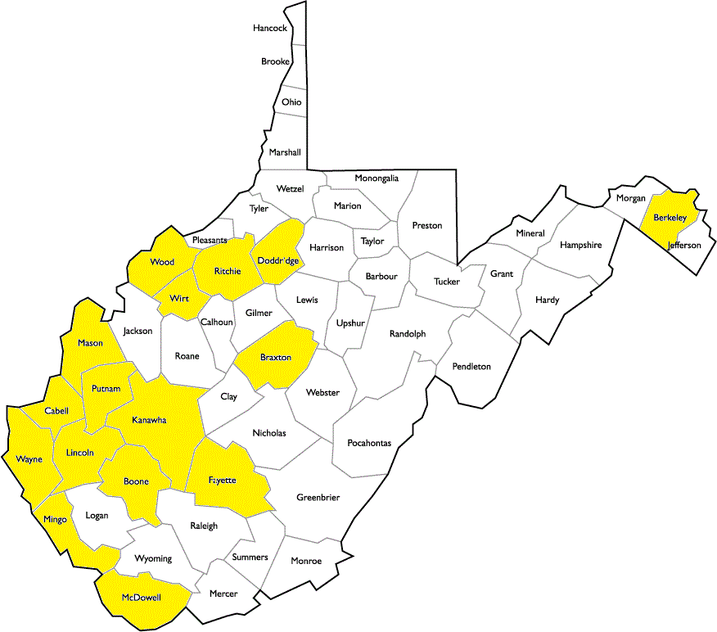

In addition to tracking where Teacher-in-Residence candidates are placed, the initial level of the COEPD also monitors the content areas of the placements. As can be noted from the chart below, high school English is the most common area, with fifty (50%) of the placements. Following the trends for placements helps the initial level recruit candidates who have an interest in the subject areas most likely to be placed and eventually employed.

Teacher-in-Residence Content Areas
Semester | # of Candidates Placed | Content Area of Placements | School | County
Fall 2017 | 1 | 1 High School Math | St. Albans High School | Kanawha
Spring 2018 | 3 | 1 Elementary  2 High School English | Hugh Dingess Elementary  Capital/Tolsia High School | Logan  Kanawha/Wayne

Data:
Several data sources from the Teacher-in-Residence program are tracked by the initial level. Data are collected on both “Indicators of Teaching Effectiveness” and on the “Impact on Student Learning”.
Teacher-in-Residence “Indicators of Teaching Effectiveness” Data

The following tables document the teaching effectiveness of the TIR teachers, as measured by both the county mentor and the university supervisor.

During the Spring 2018 semester, one English teacher and one elementary teacher were placed. The same rubric to measure teaching effectiveness was used to evaluate each one. The results are listed in the table below.

Spring 2018, N = 2
West Virginia Professional Teaching Standards (WVPTS) Mentor and Supervisor Evaluations for TIR Candidates
ELEMENTS | Spring 2018
 | TIR  Mentor Evaluation  (n = 2) |  |  |  |  |  | TIR  Supervisor Evaluation  (n = 2)
 | $$\overline{x}$$ | Percentage |  |  |  |  | $$\overline{x}$$ | Percentage
 |  | D | A | E | U | N/A |  | D | A | E | U | N/A
STANDARD 1: CURRICULUM & PLANNING
1.1 Content Knowledge | 3.5 | 50 | 50 | 0 | 0 | 0 | 4.0 | 100 | 0 | 0 | 0 | 0
1.2 Standards Driven Instruction | 3.5 | 50 | 50 | 0 | 0 | 0 | 3.0 | 0 | 100 | 0 | 0 | 0
1.3 Assessment Approach | 4.0 | 100 | 0 | 0 | 0 | 0 | 4.0 | 100 | 0 | 0 | 0 | 0
STANDARD 2: THE LEARNER AND THE LEARNING ENVIRONMENT
2.1 Characteristics of Learners | 4.0 | 100 | 0 | 0 | 0 | 0 | 3.0 | 0 | 100 | 0 | 0 | 0
2.2 Appropriate Learning Environment | 4.0 | 100 | 0 | 0 | 0 | 0 | 3.5 | 50 | 50 | 0 | 0 | 0
2.3 Learner-Centered Culture | 3.5 | 50 | 50 | 0 | 0 | 0 | 4.0 | 100 | 0 | 0 | 0 | 0
STANDARD 3: TEACHING
3.1 Instructional Strategies | 4.0 | 100 | 0 | 0 | 0 | 0 | 3.0 | 0 | 100 | 0 | 0 | 0
3.2 Learning Activities | 4.0 | 100 | 0 | 0 | 0 | 0 | 3.5 | 50 | 50 | 0 | 0 | 0
3.3 Assessment Driven Instruction | 4.0 | 100 | 0 | 0 | 0 | 0 | 3.5 | 50 | 50 | 0 | 0 | 0
STANDARD 4: PROFESSIONAL RESPONSIBILITIES FOR SELF-RENEWAL
4.1 Professional Development | 3.5 | 50 | 50 | 0 | 0 | 0 | 3.0 | 0 | 100 | 0 | 0 | 0
4.2 Collaboration with Colleagues | 3.5 | 50 | 50 | 0 | 0 | 0 | 4.0 | 100 | 0 | 0 | 0 | 0
STANDARD 5: PROFESSIONAL RESPONSIBILITIES FOR SCHOOL AND COMMUNITY
5.1 School-Wide Collaboration | 3.5 | 50 | 50 | 0 | 0 | 0 | 3.0 | 0 | 100 | 0 | 0 | 0
5.2 Working with Community | 3.0 | 0 | 100 | 0 | 0 | 0 | 3.5 | 50 | 50 | 0 | 0 | 0
5.3 Practices and Policies | 3.0 | 0 | 100 | 0 | 0 | 0 | 3.0 | 0 | 100 | 0 | 0 | 0
STANDARD 6: Student Learning
6.1 Measurable Progress | 3.5 | 50 | 50 | 0 | 0 | 0 | 3.0 | 0 | 100 | 0 | 0 | 0

ELEMENTS | Mentor Evaluation  TIR (n = 3) |  |  |  |  | Supervisor Evaluation  TIR (n = 3)
 | $$\overline{x}$$ | Percentage |  |  |  | $$\overline{x}$$ | Percentage
 |  | T | A | U | N/A |  | T | A | U | N/A
STANDARD 7: PROFESSIONAL CONDUCT
Policy and Procedure | 3.0 | 100 | 0 | 0 | 0 | 3.0 | 100 | 0 | 0 | 0
Time and Goal Management | 3.0 | 100 | 0 | 0 | 0 | 3.0 | 100 | 0 | 0 | 0
Schedule | 3.0 | 100 | 0 | 0 | 0 | 3.0 | 100 | 0 | 0 | 0
Respect | 3.0 | 100 | 0 | 0 | 0 | 3.0 | 100 | 0 | 0 | 0
Appearance | 3.0 | 100 | 0 | 0 | 0 | 3.0 | 100 | 0 | 0 | 0
Self-Control | 3.0 | 100 | 0 | 0 | 0 | 3.0 | 100 | 0 | 0 | 0
Integrity | 3.0 | 100 | 0 | 0 | 0 | 3.0 | 100 | 0 | 0 | 0
Critical Thinking | 3.0 | 100 | 0 | 0 | 0 | 3.0 | 100 | 0 | 0 | 0
Adaptability | 3.0 | 100 | 0 | 0 | 0 | 3.0 | 100 | 0 | 0 | 0
Commitment to Students | 3.0 | 100 | 0 | 0 | 0 | 3.0 | 100 | 0 | 0 | 0
Commitment to Diversity | 3.0 | 100 | 0 | 0 | 0 | 3.0 | 100 | 0 | 0 | 0
Commitment to Technology | 3.0 | 100 | 0 | 0 | 0 | 3.0 | 100 | 0 | 0 | 0
Commitment to Profession | 3.0 | 100 | 0 | 0 | 0 | 3.0 | 100 | 0 | 0 | 0

During the Fall 2017 semester, one math teacher was placed. The results are listed in the table below

Fall 2017, N = 1
West Virginia Professional Teaching Standards (WVPTS) Mentor and Supervisor Evaluations for TIR Candidates
ELEMENTS | Fall 2017
 | TIR  Mentor Evaluation  (n = 1) |  |  |  |  | TIR  Supervisor Evaluation  (n = 1)
 | $$\overline{x}$$ | Percentage |  |  |  | $$\overline{x}$$ | Percentage
 |  | D | A | E | U |  | D | A | E | U
STANDARD 1: CURRICULUM & PLANNING
1.1 Content Knowledge | 4.0 | 100 | 0 | 0 | 0 | 4.0 | 100 | 0 | 0 | 0
1.2 Standards Driven Instruction | 4.0 | 100 | 0 | 0 | 0 | 4.0 | 100 | 0 | 0 | 0
1.3 Assessment Approach | 4.0 | 100 | 0 | 0 | 0 | 3.0 | 0 | 100 | 0 | 0
STANDARD 2: THE LEARNER AND THE LEARNING ENVIRONMENT
2.1 Characteristics of Learners | 4.0 | 100 | 0 | 0 | 0 | 4.0 | 100 | 0 | 0 | 0
2.2 Appropriate Learning Environment | 4.0 | 100 | 0 | 0 | 0 | 4.0 | 100 | 0 | 0 | 0
2.3 Learner-Centered Culture | 4.0 | 100 | 0 | 0 | 0 | 4.0 | 100 | 0 | 0 | 0
STANDARD 3: TEACHING
3.1 Instructional Strategies | 4.0 | 100 | 0 | 0 | 0 | 3.0 | 0 | 100 | 0 | 0
3.2 Learning Activities | 4.0 | 100 | 0 | 0 | 0 | 3.0 | 0 | 100 | 0 | 0
3.3 Assessment Driven Instruction | 4.0 | 100 | 0 | 0 | 0 | 3.0 | 0 | 100 | 0 | 0
STANDARD 4: PROFESSIONAL RESPONSIBILITIES FOR SELF-RENEWAL
4.1 Professional Development | 4.0 | 100 | 0 | 0 | 0 | 4.0 | 100 | 0 | 0 | 0
4.2 Collaboration with Colleagues | 4.0 | 100 | 0 | 0 | 0 | 3.0 | 0 | 100 | 0 | 0
STANDARD 5: PROFESSIONAL RESPONSIBILITIES FOR SCHOOL AND COMMUNITY
5.1 School-Wide Collaboration | 4.0 | 100 | 0 | 0 | 0 | 3.0 | 0 | 100 | 0 | 0
5.2 Working with Community | 4.0 | 100 | 0 | 0 | 0 | 3.0 | 0 | 100 | 0 | 0
5.3 Practices and Policies | 4.0 | 100 | 0 | 0 | 0 | 3.0 | 0 | 100 | 0 | 0
STANDARD 6: Student Learning
6.1 Measurable Progress | 4.0 | 100 | 0 | 0 | 0 | 4.0 | 100 | 0 | 0 | 0

ELEMENTS | Mentor Evaluation  TIR (n = 3) |  |  |  |  | Supervisor Evaluation  TIR (n = 3)
 | $$\overline{x}$$ | Percentage |  |  |  | $$\overline{x}$$ | Percentage
 |  | T | A | U | N/A |  | T | A | U | N/A
STANDARD 7: PROFESSIONAL CONDUCT
Policy and Procedure | 3.0 | 100 | 0 | 0 | 0 | 3.0 | 100 | 0 | 0 | 0
Time and Goal Management | 3.0 | 100 | 0 | 0 | 0 | 3.0 | 100 | 0 | 0 | 0
Schedule | 3.0 | 100 | 0 | 0 | 0 | 3.0 | 100 | 0 | 0 | 0
Respect | 3.0 | 100 | 0 | 0 | 0 | 3.0 | 100 | 0 | 0 | 0
Appearance | 3.0 | 100 | 0 | 0 | 0 | 3.0 | 100 | 0 | 0 | 0
Self-Control | 3.0 | 100 | 0 | 0 | 0 | 3.0 | 100 | 0 | 0 | 0
Integrity | 3.0 | 100 | 0 | 0 | 0 | 3.0 | 100 | 0 | 0 | 0
Critical Thinking | 3.0 | 100 | 0 | 0 | 0 | 3.0 | 100 | 0 | 0 | 0
Adaptability | 3.0 | 100 | 0 | 0 | 0 | 3.0 | 100 | 0 | 0 | 0
Commitment to Students | 3.0 | 100 | 0 | 0 | 0 | 3.0 | 100 | 0 | 0 | 0
Commitment to Diversity | 3.0 | 100 | 0 | 0 | 0 | 3.0 | 100 | 0 | 0 | 0
Commitment to Technology | 3.0 | 100 | 0 | 0 | 0 | 3.0 | 100 | 0 | 0 | 0
Commitment to Profession | 3.0 | 100 | 0 | 0 | 0 | 3.0 | 100 | 0 | 0 | 0

Teacher-in-Residence “Impact on Student Learning” Data
During the TIR, candidates complete the Teacher Performance Assessment documenting their impact on student learning. Below are the data results for Fall 2017 and Spring 2018.

During the Spring 2018 semester, two English teachers and one elementary teacher were placed. The same impact on student learning rubric was used to measure each one. The results are listed in the table below.

 | WV TPA – Spring 2018, N = 3
 |  | Mean | Distinguished | Accomplished | Emerging | Unsatisfactory
Task 1 | Implications of Community, School, & Family Factors | 2.67 | 0 | 66.7%  (2) | 33.3%  (1) | 0
 | Implications of Classroom Factors | 3.00 | 33.3%  (1) | 33.3%  (1) | 33.3%  (1) | 0
 | Implications of Individual Student Factors | 2.67 | 0 | 66.7%  (2) | 33.3%  (1) | 0
Task 2 | Standards | 3.33 | 33.3%  (1) | 66.7%  (2) | 0 | 0
 | Learning Goals | 3.00 | 0 | 100%  (3) | 0 | 0
 | Anticipated Student Challenges | 2.67 | 0 | 66.7%  (2) | 33.3%  (1) | 0
Task 3 | Alignment with Learning Goals | 2.67 | 0 | 66.7%  (2) | 33.3%  (1) | 0
 | Assessment Criteria/Technical Soundness | 2.33 | 0 | 33.3%  (1) | 66.7%  (2) | 0
 | Balance of Assessments | 2.67 | 0 | 66.7%  (2) | 33.3%  (1) | 0
Task 4 | Factors in Planning | 2.67 | 0 | 66.7%  (2) | 33.3%  (1) | 0
 | Consultation | 3.00 | 33.3%  (1) | 33.3%  (1) | 33.3%  (1) | 0
 | Instructional Strategies | 2.67 | 0 | 66.7%  (2) | 33.3%  (1) | 0
 | Instructional Strategy/Rationale | 2.67 | 0 | 66.7%  (2) | 33.3%  (1) | 0
 | Learning Resources (including technology) | 2.67 | 0 | 66.7%  (2) | 33.3%  (1) | 0
 | Differentiated Instruction | 3.00 | 33.3%  (1) | 33.3%  (1) | 33.3%  (1) | 0
Task 5 | Classroom Set-up and Organization | 3.00 | 0 | 100%  (3) | 0 | 0
 | Classroom and Behavior Management | 2.67 | 0 | 66.7%  (2) | 33.3%  (1) | 0
 | Flexibility | 3.00 | 0 | 100%  (3) | 0 | 0
 | Questioning Strategies | 2.67 | 0 | 66.7%  (2) | 33.3%  (1) | 0
 | Student Engagement | 3.00 | 0 | 100%  (3) | 0 | 0
Task 6 | Clarity and Representation of Evidence | 2.33 | 0 | 33.3%  (1) | 66.7%  (2) | 0
 | Interpretation of Data | 2.33 | 0 | 33.3%  (1) | 66.7%  (2) | 0
 | Evidence of Impact | 2.33 | 0 | 33.3%  (1) | 66.7%  (2) | 0
Task 7 | Insights on Teaching and Learning | 2.33 | 0 | 33.3%  (1) | 66.7%  (2) | 0
 | Professional Collaborative Practice | 3.00 | 33.3%  (1) | 33.3%  (1) | 33.3%  (1) | 0
 | Implications for Future Teaching | 3.00 | 0 | 100%  (3) | 0 | 0
 | Professional Growth | 2.67 | 0 | 66.7%  (2) | 33.3%  (1) | 0

During the Fall 2017 semester, one math teacher was placed. The results are listed in the table below.

 | WV TPA – Fall 2017, N = 1
 |  | Mean | Distinguished | Accomplished | Emerging | Unsatisfactory
Task 1 | Implications of Community, School, & Family Factors | 4.00 | 100%  (1) | 0 | 0 | 0
 | Implications of Classroom Factors | 4.00 | 100%  (1) | 0 | 0 | 0
 | Implications of Individual Student Factors | 4.00 | 100%  (1) | 0 | 0 | 0
Task 2 | Standards | 4.00 | 100%  (1) | 0 | 0 | 0
 | Learning Goals | 4.00 | 100%  (1) | 0 | 0 | 0
 | Anticipated Student Challenges | 4.00 | 100%  (1) | 0 | 0 | 0
Task 3 | Alignment with Learning Goals | 4.00 | 100%  (1) | 0 | 0 | 0
 | Assessment Criteria/Technical Soundness | 4.00 | 100%  (1) | 0 | 0 | 0
 | Balance of Assessments | 3.00 | 0 | 100%  (1) | 0 | 0
Task 4 | Factors in Planning | 4.00 | 100%  (1) | 0 | 0 | 0
 | Consultation | 4.00 | 100%  (1) | 0 | 0 | 0
 | Instructional Strategies | 4.00 | 100%  (1) | 0 | 0 | 0
 | Instructional Strategy/Rationale | 4.00 | 100%  (1) | 0 | 0 | 0
 | Learning Resources (including technology) | 4.00 | 100%  (1) | 0 | 0 | 0
 | Differentiated Instruction | 3.00 | 0 | 100%  (1) | 0 | 0
Task 5 | Classroom Set-up and Organization | 4.00 | 100%  (1) | 0 | 0 | 0
 | Classroom and Behavior Management | 3.00 | 0 | 100%  (1) | 0 | 0
 | Flexibility | 4.00 | 100%  (1) | 0 | 0 | 0
 | Questioning Strategies | 4.00 | 100%  (1) | 0 | 0 | 0
 | Student Engagement | 4.00 | 100%  (1) | 0 | 0 | 0
Task 6 | Clarity and Representation of Evidence | 4.00 | 100%  (1) | 0 | 0 | 0
 | Interpretation of Data | 3.00 | 0 | 100%  (1) | 0 | 0
 | Evidence of Impact | 4.00 | 100%  (1) | 0 | 0 | 0
Task 7 | Insights on Teaching and Learning | 4.00 | 100%  (1) | 0 | 0 | 0
 | Professional Collaborative Practice | 3.00 | 0 | 100%  (1) | 0 | 0
 | Implications for Future Teaching | 3.00 | 0 | 100%  (1) | 0 | 0
 | Professional Growth | 3.00 | 0 | 100%  (1) | 0 | 0

