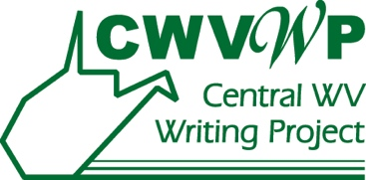

**West Virginia Young Writers Contest**

## Permission Release and Website Form

# Must be completed by all county 1st place winners

# and included with entry in the state contest

I (student name) __________________________________do hereby authorize WV Young Writers Contest to publish my writing entitled:

_____________________________________________________________________________

I grant West Virginia Young Writers permission to publish this work in any form or publication, including programs, magazines, books, and websites. I retain the right to publish it in the future.

I grant Central West Virginia Writing Project permission to publish my name, photograph, or moving image on websites or in print or other media.

I attest this work is my original work and has not been previously published. I accept full responsibility for any damage caused by my plagiarism.

Student Signature: _____________________________________________

Date: _____________________________

**Parent or Legal Guardian sign below to grant permission:**

Signature: _____________________________________________ Date: _______________

Print name: _________________________________________________________________

Number/Street: _________________________________________________________________

City/Town: _______________________________________________

Zip Code: _________________________

State: _______________

e-mail: ___________________________________________ Phone: _____________________