  - Activating your teams course
  - online Learning
Fall 2020

ONLINE READY WEBSITE HAS ADDITIONAL MATERIALS AND UPDATES

Microsoft Teams virtual Meetings

how to activate your students in your course team
Activating your enrolled students in your Course Team if you intend to use it for teaching virtually in each of your courses is an easy process, but it is important that you follow the first steps to set up Teams correctly.
Marshall is implementing the School Data Sync function so a Team will automatically be created for your course in MS Teams. Once the Sync has created your Course Team, go into Teams and click on the “Teams” icon on the left to see your complete list. Choose the one for the class you wish to activate.
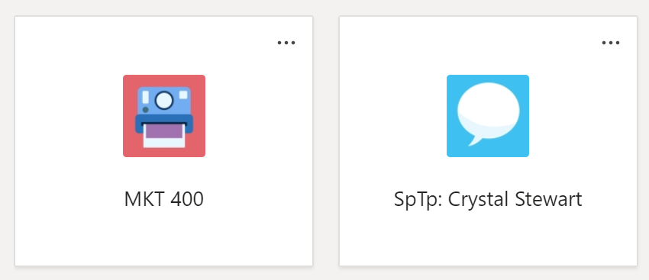
You will receive this general instruction notification before being taken into your Course Team. Click “OK.”
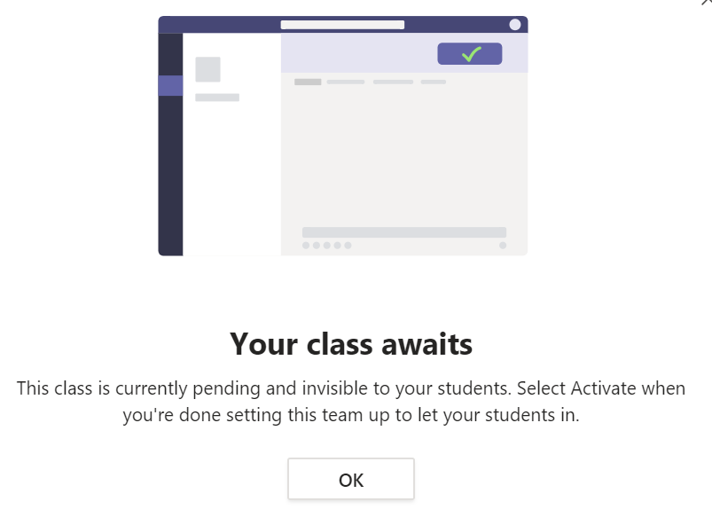

This will open your Course Team. There will be a notification at the top to “Activate” your student’s enrollment into your course. Please note, once you activate, this action cannot be undone. 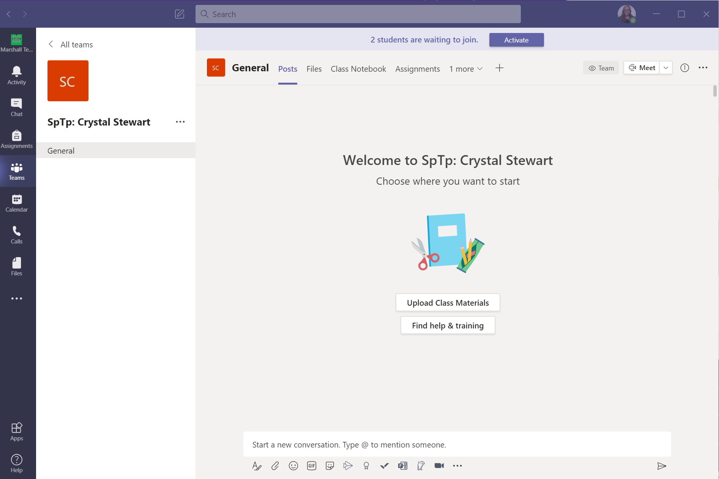
Click the “Activate” button once more to verify.
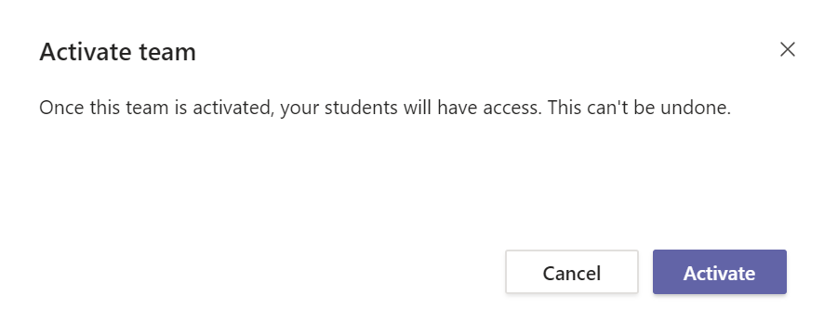

Your Course Team is now active, and students will receive a notification under their Activity section in Teams. They will also receive a Marshall email notifying them they have been added to a Team.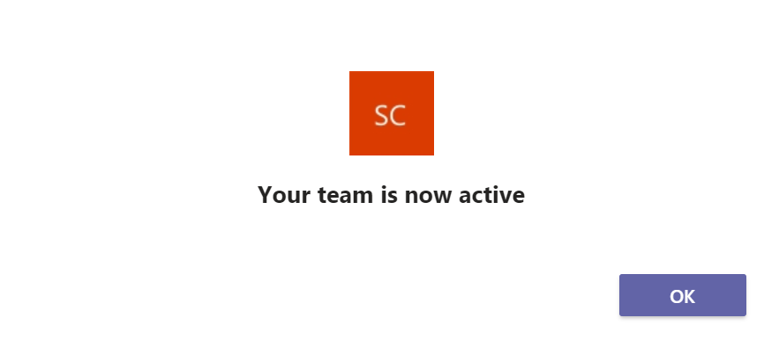
To review the enrollments in your Course Team, select More Actions (…) next to the Team name and choose “Manage team.” You can add a GA, TA, or Peer Mentor to your course by clicking on the “Add member” button.
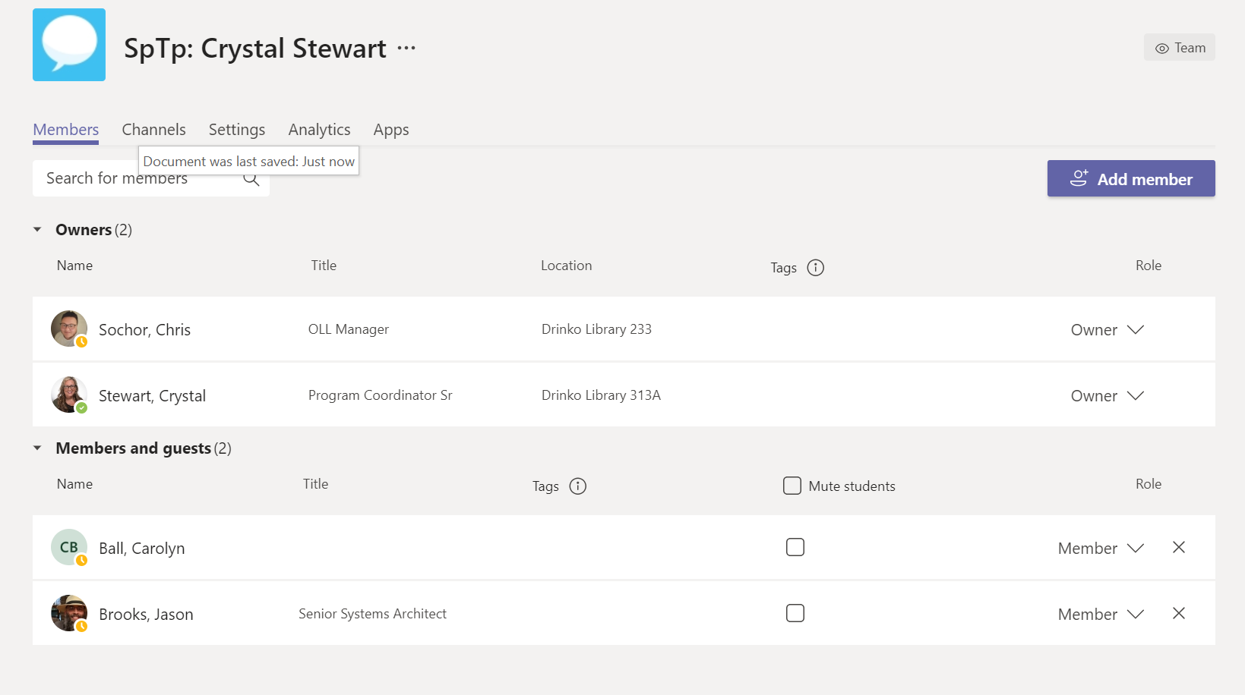
To view the entire list of members, click on Members and guests and the tab will expand. Your course list will automatically sync with Banner daily.

For fun, if you’d like to change the Theme of your course, click on “Settings” on this screen, select “Team Theme,” and click “Change Theme.”

Sharing with Students
You should share the link to the Class Team directly with students in the corresponding Blackboard course and additionally in an email to your class so they know where they should be meeting and how the first day of the class.
- To the right of the Class Team name, select More Actions (…) and click “Get link to team.”
- Copy the link.
- You must share with students so they know how to access the class the first day, and they have a link to refer to in case they delete their email.
  - Blackboard: navigate to the Start Here or Content area of the course, scroll over Build Content, and select Web Link. Add the URL to the Team as the URL in the weblink. Click Submit. The link will be added to the bottom of the screen. To the left of the web link title, hold down your mouse button and move the information to the top of the screen so students will see it.
  - You can email the link directly to students from your Marshall email.
Regardless of the method you choose, please make sure to inform students, PRIOR to the first day of class, how they should meet you virtually.

Accepting students as members
When you Activate your course in Teams, students are sent an email asking them to “Accept” this enrollment. The students must click the link to “Accept.”
Once students have clicked “Accept,” their name appears in the Pending membership area. Beside the course name in Teams, click “Manage team.” Depending on how large your Team app is expanded on your screen will determine whether you see “Pending Requests” right away, or need to click on more (# more) to see the “Pending Requests” link. You can accept all pending students one-at-a-time or individually.
