
Blackboard Grade Center

Quick Guide for Faculty

Blackboard Grade Center

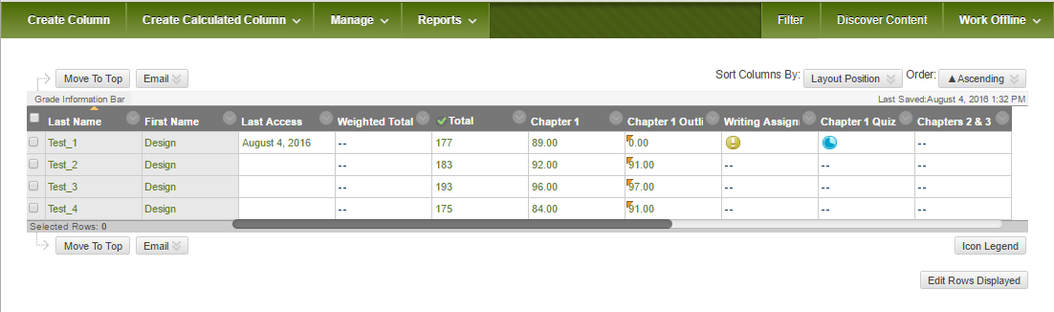
The Grade Center is more than just a way to record students' grades; it is a dynamic and interactive tool, allowing faculty to record data, calculate grades, and monitor student progress. In the Grade Center, faculty can provide and manage students' grades for a variety of assessments, including assignments, tests, discussion board posts, journals, blogs, and wikis. Faculty can also create grade columns for any activities or requirements that require grading but do not require submission through Blackboard, such as special projects, participation, or attendance.
1
2
3
4

Action Bar:
  - Create Column- Creates a column that represents a gradable item in the course.
  - Create Calculated Column – Calculated columns combine data from multiple columns to attain performance results. Choose from: Average, Minimum/Maximum, Total, or Weighted.
  - Manage – Customize and manage the Grade Center. Choose from Grading Periods, Grading Schemas, Categories, Smart Views, Column Organization (where you can reorder columns and view hidden columns), and Row Visibility.
  - Reports – Create a customized, printable report, or view grade history.
- Course Roster – Syncs with Banner to provide an up-to-date and accurate list of all student registered for a course.
- Column Menu – Provides access to a column’s settings, including Quick Column Information, Edit Column Information, Column Statistics, Set as External Grade, Hide from Students (on/off), Sort Ascending, Sort Descending, Hide from Instructor View, and Delete Column.
- Work Offline - Download the Grade Center into an Excel spreadsheet for working offline. The spreadsheet can be uploaded back to the grade center after grades have been recorded. (If you would like to learn how to do this, please ask the Design Center – designcenter@marshall.edu)
If you have any questions or concerns, please contact the Design Center:
Email: designcenter@marshall.edu
Phone: (304)696-7117
Office: Drinko Library 235

Accessing Grade Center in Blackboard

- Log into Blackboard at http://www.marshall.edu/muonline/

- Click into the course where you would like to input grades.
- In the Control Panel, click Grade Center, then Full Grade Center.

Creating a Column

- From the Full Grade Center page, click the Create Column button
- Provide a Column Name
- Select the other options as appropriate*
- Click Submit
*Note: See Editing Column Information for detailed listing of column options. Also, if you have created an assignment or other assessment, the corresponding column will automatically be created.

Grading an Assignment with Comments
- Click Grade Center and select Needs Grading.
- All assignments with attempts can be created by clicking on the first assignment.
- Once you grade the first assignment, and select grade next, you will be taken to the next assignment.

Show/Hide Columns

- Click the downward chevron in the column heading you want to hide from students.
- Select Hide from Students (on/off).
- The column will now display a circle with a red line, indicating it is hidden from students.
- To unhide a column, repeat steps 1 and 2.

Entering or Changing a Grade

- From the Full Grade Center page, point to and click the desired cell.
- Type the new or corrected value
- Press Enter on the keyboard.
-OR-
- From the Grade Details page, point to the desired cell, and click the downward chevron and select View Grade Details
- Select Edit Grade and type the new value in the Current Grade Value box and add any feedback
- Click Save

Editing Column Information

- Click the downward chevron in the column heading to be edited.

- Select Edit Column Information
- Provide or change the Grade Center Display Name.
- Determine Primary Display for grading (Score, Text, Letter, or Complete/Incomplete)
- Determine Secondary Display (Optional)
- Select a pre-created Category (Optional) *Make sure you input a Category if you are using the Weighted Column.
- Provide a value for the Points Possible
- Provide a Due Date (Optional)
- Determine the column’s Options (default settings are recommended)
- Click Submit.

Downloading the Grade Center

- Located in the far right side of the Full Grade Center, click Work Offline.
- Select Download
- Select Data to Download (Full Grade Center, Selected Columns, or User Information)
- Select Comma or Tab Delimiter Type (Tab delimited is recommended for use in Excel)
- Select a Download Location on your local computer
- Click Submit

