Setting up Your Grade Center for Weighted Grades
Categories: Grade Center Categories are a reflection of the categories you have set in your course syllabus as the weighted grades. For example, Homework, Quizzes, Midterm, and Final may all be worth 25% each. You probably have multiple homework attempts and multiple quizzes, so how do we get the Blackboard Grade Center to calculate the Weighted Total for us?
Easy—and it all starts with Categories.
- Navigate to the Grade Center. Scroll over the Manage tab and choose Categories. | - On the Categories page, create Categories that reflect the weighted categories listed on your Syllabus.  - You must give them a name, but the description is not necessary.  - Hit Submit.
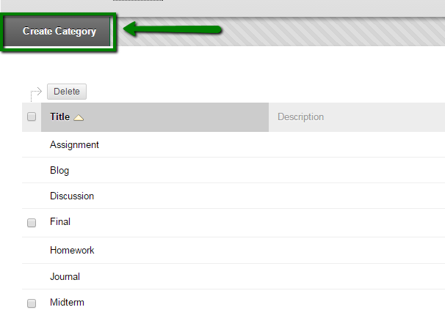

Weighted Total Column
Weighted Total Column: In the Grade Center, courses now come with a Weighted Total column already present and ready to Edit. Weighted total columns will calculate your Total percentage for you once you have your column set up properly with Categories.
- Navigate to your course Grade Center. Scroll over the Weighted Total column, click the drop-down arrow beside it, and choose Edit Column Information. *You must have categories created before you move to this step. If you do not, back up a step and create your categories.*
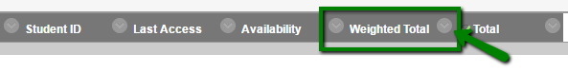
- Scroll down to the Select Columns Area. Please note the picture below. You will be choosing Categories here and not individual gradebook columns. Click on a Category, hit the arrow button beside it, and then enter the percentage that category is worth. *Add all of your categories in this step, the Total Weight must equal 100% before you are allowed to Submit.*
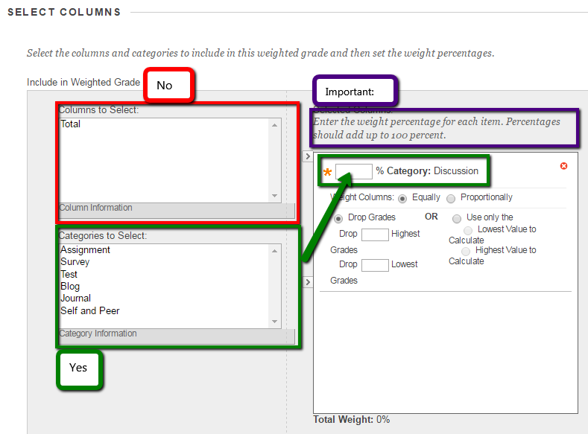
- Hit Submit

Hide the Total Point Column from Students
Each gradebook comes with a default Weighted Column and a default Total Column. If you’re using Weighted Grades, you don’t want the students to see their total number of points on the regular Total Column. Why? The total number of points they have earned, divided by the total number of points possible isn’t giving them an accurate representation of their grade and will confuse students.
This is why we need to hide the default Total Column from students in this situation.
- In the Grade Center, click on the drop-down arrow beside the default Total column.
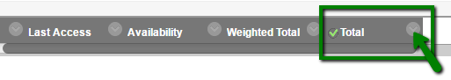
- Click Edit Column Information.
- Scroll down to Options. The second option indicated whether or not to show the column to students. Choose No. Hit Submit.
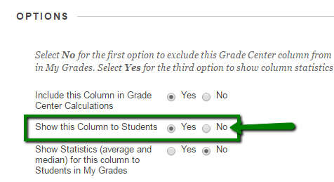

Creating a New Column for Entering a Grade
If students are handing work to you in class, you need to create a Grade Center column for each of those assignments. *If you use Blackboard for turning in assignments, or for online discussion or quizzes, then Blackboard will automatically create a column for you and you can choose the Category when
you are setting up the assignment/quiz.
Blackboard automatically creates Grade Center columns for tools that are used for turning in student work. There are a few caveats: you need to go back and check your automatically created columns in the Edit Column Information mode to make sure that the correct Category for YOUR grade criteria is applied.

For example, you create an Assessment and name it Quiz 1.
Blackboard has created a column for you and categorized this as an Assessment. You will need to edit the column information to categorize your Quiz as a Quiz if that is a weighted grade listed on your syllabus.
- Navigate to the Grade Center. Click Create Column.
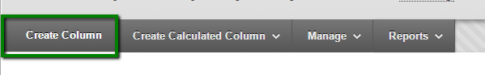
- Name your Column the assignment name. | - Scroll down and note that Categories is above the asterisk for where you enter total points the assignment is worth.
- Apply the proper Category to your column. | - Assign a point value to your assignment.
- Remember to hit Submit to save your work.

Notes
- Every column in your grade center must be associated with a category in order for grades to be calculated properly.
- Edit Column Information will get you to the page where you can choose a Category for each column, especially if you have weights that are named differently than the tool you used.

