Quick guide for course teams:
  - Student Edition -Marshall Online Learning

getting to & running Meetings

Joining a Meeting
There are multiple ways to join a meeting. When viewing a Teams meeting in a calendar, like Outlook or the Calendar app on Teams, you will see a Join button appear on the calendar meeting 5 minutes prior to the start of the event; you can join that way. You can also join by double-clicking on the calendar invite and selecting Join. In an email invite, there is a link to Join Microsoft Teams Meeting. Some instructors are also making the link to the Meeting available on the Posts page in your Team course.
Prior to joining the meeting fully, you can set your webcam and microphone to be on or off. In many cases, the mic and webcam will be ON by default. Click the buttons beside the video and mic icons to turn your audio and webcam on and off, both prior to joining a meeting and during.
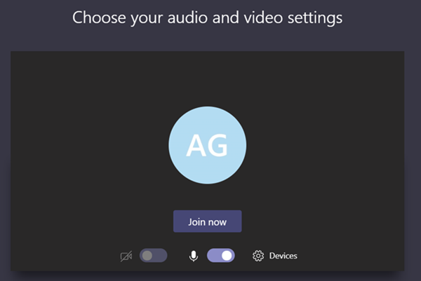
Note: If you have not downloaded the Teams app, you can still join the meeting in a web browser. Participants will need to enter their name and allow access to the mic and webcam prior to entering the meeting via browser.

Meeting Settings Inside the Meeting
Once you have launched a Meeting, you have control over some settings at that time, such as your device settings (choosing your audio and video inputs and outputs), entering full screen mode, choosing whether or not to blur your background or choose a background effect, live captioning, a viewable keypad, starting and stopping a recording, and the ability to turn off the video feed of all incoming student participants. To get to meeting settings, click the “…” (this icon is called More Options).
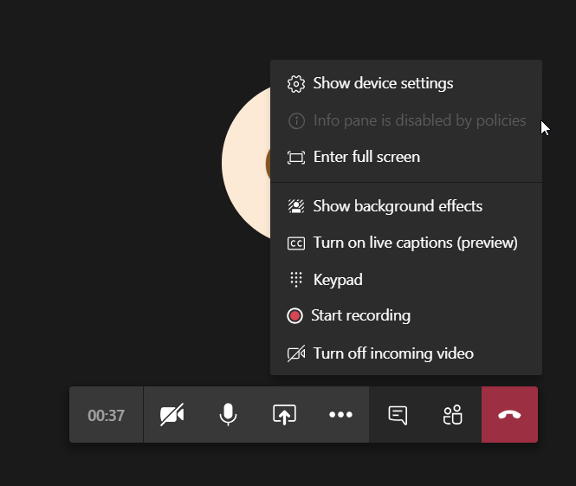
Note: Once a meeting recording has started, a banner will appear at the top of the meeting to alert all users that a recording is in progress. Users can “Dismiss” out of the alert on their end of the meeting.

Showing Background Effects
Background effects are a popular way to not only add levity to remote learning, but also allow for students who are in a shared space, or do not wish to show their surroundings during meetings, an option for blurring their background.
You can change your background effect prior to joining a meeting, while you are choosing your audio and video settings. You can also change them during the meeting by accessing More Options (… ).

Different Options on the Meeting Toolbar

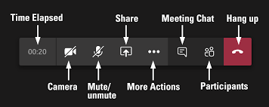
End
More Options

Managing Participants
The Participants area will show you all the people in the meeting.
Use the Raise your hand feature when you have a question.

Meeting Chat
Students can see chat, upload files, share gifs and emojis throughout the duration of the meeting time. Once a meeting chat begins, you can also access the meeting chat in the Chats app area of the Teams app. The chat for the team meeting will continue to show in Chats, allowing you to review chats from the meeting, reiterate a point, or share an additional file even after the meeting has ended.
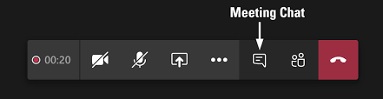
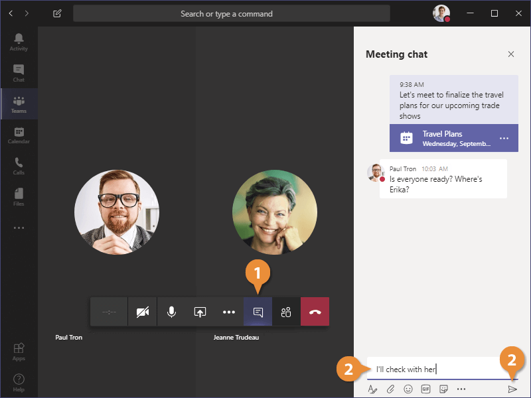
Number 1 is the Chat icon and Number 2 is where you and students enter your chat message.

Sharing Your Screen
If your instructor asks you to share your screen, you can choose to share your entire Desktop or just a Window. Best practice is to choose a window to share. This is less difficult for the system to manage and will give students the best opportunity to be able to see your video if they are experiencing poor connection.
To get started, click the Sharing option from the Teams toolbar (1):
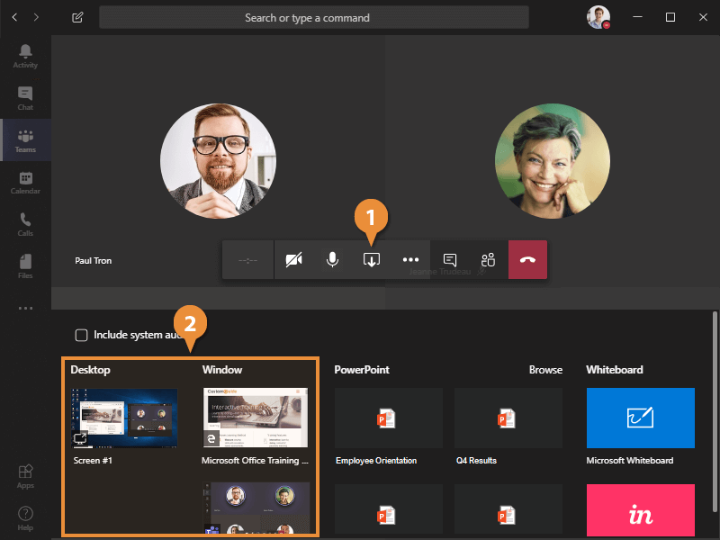
- If you want to include the audio of something you are showing on your screen, check to “Include system audio.”
- You can choose to share Desktop or a Window. Open what you want to show in a browser and then select the window.
- You can also share uploaded PowerPoints.
- You can utilize the Whiteboard app (in Office 365), and other apps that you have chosen to use and incorporate into your class team.
- Once you are sharing, you can allow others control of your mouse.

Common issues

Can’t share your screen on a Mac? Follow these instructions:
• Click the Apple menu.
• Then, go to System Preferences > Click Security & Privacy > Privacy tab.
• Click Screen Recording.
• Click the lock icon to make changes.
• If required, enter your admin password.
• Finally, click the checkbox next to Microsoft Teams.
• A notification window will ask you to restart it. Agree.
• Restart the Teams app and try to share.
If this does not resolve the issue, contact itservicedesk@marshall.edu.

Having connection issues?
- In the Team Meeting, beside the audio button, select More Options (…).
- Select Turn off incoming video. This will greatly reduce the required speed necessary to run the Meeting.

