Instructions for Using Zoom Mobile App

**1. Download the Zoom Mobile App on your device from the App Store**

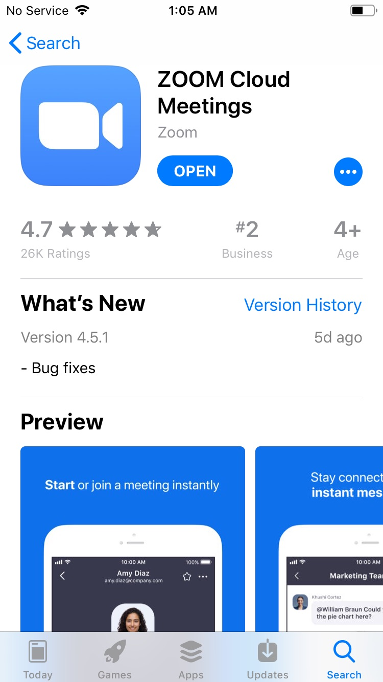

**2. Open the Zoom App and allow the app to access your microphone and camera.**

**3. Click on the link to join the Zoom meeting that was provided by your Instructor or Host.**   
The Zoom app will open. If the link does not automatically open the meeting, the Meeting I.D. it asks you to provide is the string of numbers at the end of the link.   
  
**For example**, if the link is: https://marshall.zoom.us./j/123456789, *the I.D. is* 123456789. If you’re asked to enter the meeting I.D., this is what the screen will look like:

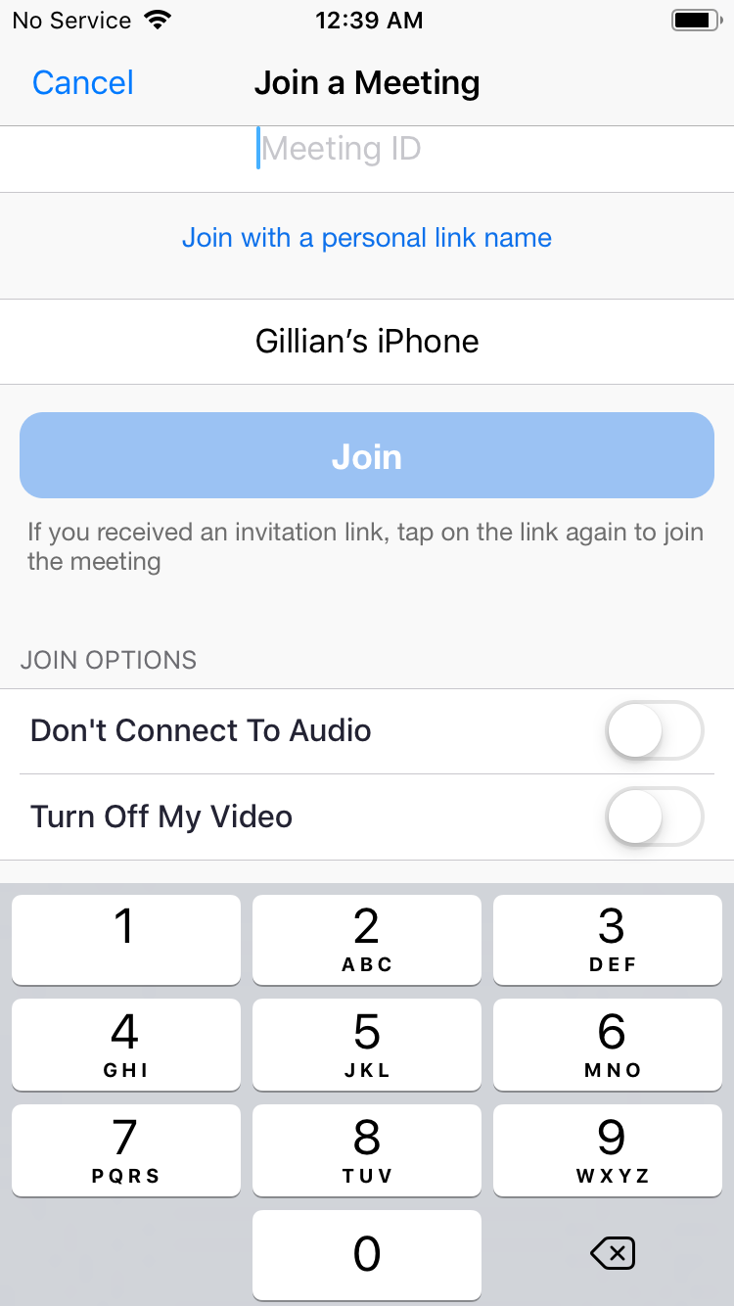

4. **Once you have clicked on the link to join the media and the app has started, you will be prompted:**To hear others, please join audio. Choose Call using Internet Audio.

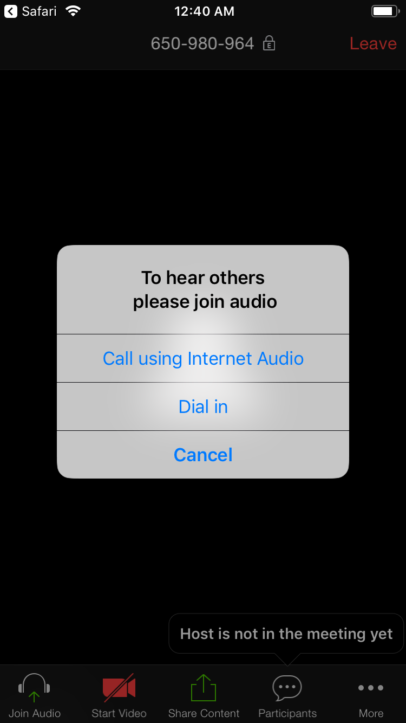

**5. If you click “Join Audio” then your mic will not be muted. You must click this to talk.**

***If you are getting feedback*** while you are in a session:

A. Make sure your mic is muted if you are not speaking.  
B. If you have clicked Join Audio in order to speak, turn down your phone’s speaker volume while you are speaking. The audio feeding through your phone speaker will go back into your mic—this is what causes a feedback loop.

**6. If you click “Start Video,” your video will start streaming YOU.**