  - ZOOM Managing & Sharing passcode
Fall 2020

Zoom passcode update
Zoom will start requiring the use of a passcode to access Zoom meetings, by September 27, 2020. Students will need to use a passcode to join the meeting.

Accessing passcodes
Every Zoom Meeting has a passcode associated with it that is automatically created when you create the Zoom meeting. Prior to this update, students would be able to click on the meeting link in Blackboard and connect directly into the meeting; however, now participants will need to enter the passcode to join.

passcodes for new meetings
To access and view the passcode for new meetings:
1. Navigate to your Blackboard course, and click on the Zoom link on the course menu.
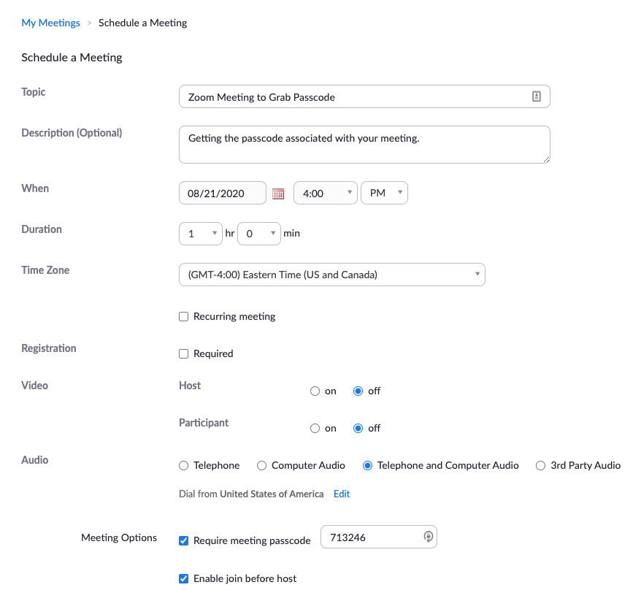
2. Create your meeting as you normally would, adding Topic, Date, Time, and Duration.
3. Under Meeting Options, note the “Require meeting passcode” area. All Zoom meetings will require a passcode.
4. You can either highlight and copy the passcode that is automatically created, or you can change the passcode to your choice.
5. No matter the passcode, you will need to share this passcode with students. If your meetings are recurring, then you only need to share once. If you use multiple meetings, you will need to share the passcode for each meeting.
(The meeting passcode and meeting ID are not the same. You need the passcode).

Passcodes for previously created upcoming meetings
Navigate to your Blackboard course and click the Zoom meeting link on the course menu. The “Upcoming Meetings” is the default page. Any meetings you have already created in the course are listed on this page.
Click on the meeting “Topic” link, as noted below as “Zoom Passcode” (that’s the meeting name in this example).
The Meeting ID is not the same as the passcode.
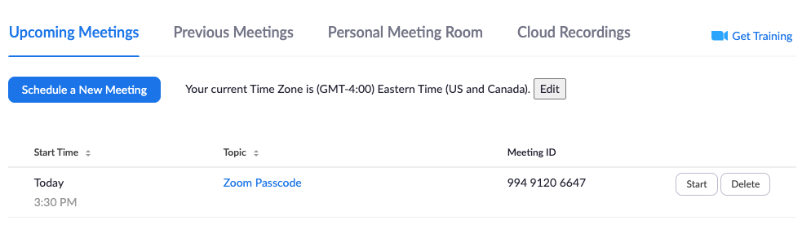
For previously created meetings, you will need to use the passcode provided.
