Online ELI Language Program
Required Applications
[From MU IT Website https://marshall.edu/it]
- Computer with Windows 10 Pro or current version of macOS.
  - More information at https://www.marshall.edu/it/recommendations
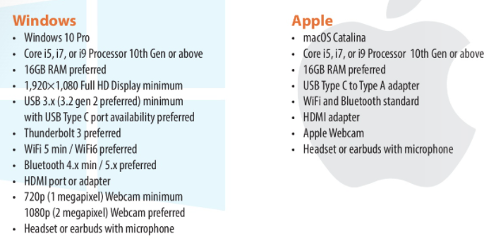
NOTE: for specific brand and versions recommended for new purchases see Marshall University Marshall Recommended Devices (bkstr.com). For currently owned computers, see technology checklist on https://www.marshall.edu/it/recommendations [Is my current Windows 10 or macOS Catalina computer adequate?]

- MyMU Portal https://marshall.edu/mymu Single sign on to…
  - general MU information
  - your personal and academic information
  - Blackboard—Learning Management System

- MUOnline Portal https://marshall.edu/muonline Takes you directly to
  - Blackboard—Learning Management System. Use this portal to open your ELI courses for instruction and assignments. https://marshall.edu/muonline

- Microsoft Office 365
  - Available to all MU students: https://www.marshall.edu/it/office365; no additional payment.
  - Office 365 Education for Students is an Office 365 plan that is available at no additional charge to current Marshall students
  - Allows students to install the latest version of Office on up to 5 PCs (Windows 10) or Macs (macOS)and on other mobile devices including Android, iPad®, and Windows tablets. It includes 1 TB of OneDrive storage, managed by Marshall University, for schoolwork and homework. In addition, students can edit and collaborate using Office Online, Yammer, and SharePoint Sites.
  - Includes versions of Outlook, Teams, Word, PowerPoint, Excel, OneNote, OneDrive (1TB, of personal cloud storage accessible from any device), SharePoint, and Microsoft 365 Exchange Email with 100GB storage quota.

- Multi-Factor Authentication (MFA) REQUIRED (protects your personal and Marshall data from online threats). Sign up here: https://marshall.edu/mfa

Recommended Applications
- Endpoint Protection
  - Antivirus software to protect your computer. See Endpoint Protection – (marshall.edu) for software your computer.

