A Pooling Method for Use on Low Copy Number and Historic Remains

Harrison D. Redd, B.S., Graduate Student, Marshall University Forensic Science Center, 1401 Forensic Science Drive, Huntington, WV 25701

Abstract
Degraded skeletal remains generally contain limited quantities of nuclear DNA (nucDNA) and thus DNA-based identification efforts often target the mitochondrial DNA (mtDNA) control region due to the relative abundance of intact mtDNA as compared to nucDNA. In many cases, however, the discriminatory power of mtDNA is inadequate to permit identification and therefore, STR analysis becomes essential. Unfortunately, commercial Short-Tandem-Repeat (STR) kits such as the AmpFlSTR® Applied Biosystems® Y filer™ PCR Amplification kit (Life technologies), AmpFlSTR® MiniFiler™ PCR Amplification Kit (Life technologies) or PowerPlex16 HS PCR Amplification kit (Promega) require input DNA quantities greater than what is typically extracted from highly degraded bone samples and as a result, amplification is generally unsuccessful when using the manufacturer’s instructions.
To address this problem, mtDNA at the Armed Forces DNA Identification Laboratory (AFDIL) adopted a low copy number (LCN) Y Filer™ protocol for working with ancient remains. This LCN protocol requires an increased amount of Taq polymerase and increased cycles during PCR amplification. To be reported, an allele must be observed above stochastic threshold in at least 2 out of 3 or more independent amplifications of the same extraction mix. This protocol has increased the success rates for generating 4 or more alleles (the minimum number of alleles needed to generate a formal report) to 40%. Unfortunately, in many cases STR profiles remain incomplete.
Currently, 0.2-0.25g of bone powder is digested with a demineralization buffer (0.5M EDTA and 1% N-lauroylsarcosine) and proteinase K; concentrated with an Amicon® Ultra-4 Centrifugal Filter Unit and purified twice with the MinElute™ PCR Purification kit (Qiagen). Preliminary optimization experiments started with increasing the amount of bone powder to 0.5g or 1.0g (2 or 4 times) which resulted in a nonlinear increase in DNA yield. Therefore, one possible explanation for the low DNA yield observed with the addition of increased amounts of bone powder is the binding competition between DNA and humic acids for the silica membrane of the MinElute™ column. The goal of this project was to increase STR typing success rates by increasing the DNA concentration from bone extracts by finding a way to limit the effects of humic acid binding competition.(3)
Presented here is a protocol where multiple 0.2-0.25g bone powder samples were extracted, pooled and concentrated in a way to limit humic acid competition for the silica membrane. The extracts were quantified and (LCN) Y Filer amplified before and after pooling. Results show that pooling 3 or 4 extracts produces the most significant increase in alleles meeting minimum reporting guidelines.
Introduction
When attempting to analyze the DNA of historic remains it is imperative to have the highest level of purity possible along with a high concentration. When processing historic DNA samples they are almost always in the form of bone powder. Since the calcium can be an inhibitor to DNA analysis it is imperative to remove as much as possible while retaining the DNA within the bone.(5) Along with calcium, humic acid, an acid found in soil, can compete with DNA for the silica filter of the different filtration techniques used in DNA extraction.(3,5,6) This competition can cause a lower amount of DNA to be retrieved in the extraction which will not benefit downstream analysis.
The project described in this paper sought to improve the extraction of historic samples by introducing a pooling method into the process that would concentrate the extracted DNA while at the same time limiting the amount of inhibitors carried along in the extraction. This research was developed based on the idea that it would be beneficial to any groups that worked commonly with low copy number DNA samples.(3)
The K208 cases being analyzed by Joint POW/MIA Accounting Command (JPAC) were part of the driving force behind this project. The K208 cases are two hundred and eight “coffins” that were given to the US by the Democratic People’s Republic of Korea between the years of 1993 and 1994, coffins that contained the remains of US service members from the Korean War. (1) When the coffins were obtained they were reported to have one individual per coffin according to Korean officials. After analyzing the remains found in the coffins, JPAC anthropologists found that it was actually a minimum of two different individuals per coffin. Due to the mixing of remains and poor documentation the K208 cases have become a giant puzzle that utilizes multiple sources of evidence in order to identify each service member represented. DNA has helped in making identifications in the K208 cases but it has its limitations. Most often when working with ancient to historic remains it is more common to retrieve a mitochondrial DNA profile instead of a nuclear profile.(1) While a mito profile is useful it does not have the discriminatory power of nuclear DNA. It is not a surprise for multiple sets of remains to have the same profile due to the maternal inheritance of the mtDNA (e.g. brothers have the same mtDNA).
Having a full nuclear DNA profile almost guarantees that an identification could be made as long as a proper familial reference profile is available. The importance of nuclear DNA profiles in identification was the driving force behind the research performed in this project. The use of the pooling method showed overall higher allele calls meeting minimum reporting guidelines in samples where 3-4 samples were pooled together.

Methods and Materials
Samples
The samples for this project came from multiple sources and all were provided by AFDIL. The collection of samples was composed of bones dating back to World War II and gave a broad spectrum of time frames which seemed beneficial to providing support for the method. It should be noted that the 89A and 09A samples were samples that had been used one year ago for a validation of the Demin 2 Extraction method, these samples were kept refrigerated at -30 ⁰C for the duration of the year.
A large collection of the samples were used from a previous validation and had been put through varying amounts of filtration with MinElute™ filters. All samples went through two rounds of MinElute™ by the end of sample processing.
All samples went through the same treatment plan though some were already extracted prior to the project. One set of the samples that were ground into bone powder by laboratory personnel and put through the Demin 2 extraction method in order to retrieve the DNA. After the samples had been put through one round of MinElute™ purification and eluted in 100 µL they were split in half and pooled in a single tube. After pooling, the pooled samples and unpooled samples were put through another round of MinElute™ purification and were eluted, in 50 µL.
After pooling and further purification, the samples were aliquotted for quantification using the Applied Biosystems® Quantifiler Duo (Life Technologies™, Foster City, CA). Once the quantification results were obtained the samples were prepared for Low Copy Number (LCN) Applied Biosystems® Y filer (Life Technologies™, Foster City, CA) amplification. It is important to reiterate that both the pooled and unpooled samples went through the exact treatment. This not only visualized the improvement provided by pooling but also provided a quality control step in case contamination occurred within the pooled sample it would be most likely due to a contaminated solitary extract. After amplification the samples were fun first on an Applied Biosystems®3130 XL (Life Technologies™, Foster City, CA) and later run on as Applied Biosystems®3500 XL(Life Technologies™, Foster City, CA) which provided data that had less pull up due to off scale peaks.
In order to determine how many extracts were the best amount for pooling, the number of extracts pooled was varied. There were cases were separated into those with two, three, and four extracts. All the cases, no matter the number of extracts, were treated with the same methods.
Extraction(4)
The first step of preparing the samples for the project was extraction. While there were many samples that were already extracted prior to the experiment, there were a collection that were still only bone powder. In order extract the DNA from the bone powder, the Demin 2 extraction method, developed by AFDIL, was used. The first step in the Demin 2 method is the addition of the extraction buffer (EDTA 0.5 M, 0.5% Sodium N-lauroylsarcosinate and 100 lL proteinase K at 20 mg ⁄mL) to the samples. The sample is then incubated at 56ºC overnight on a rotating rack to prevent stagnation and buildup. The following day the samples are removed from the incubator and are centrifuged briefly. The liquid is removed from the tube and added to an Amicon Ultra-4 (Millipore Corp., Bedford, MA) which concentrates the sample until less than 100 µL remains. At this point the sample was removed from the Amicon and prepared for purification via MinElute™.

Purification

Once the samples were extracted, or for some, removed from the fridge or freezer they were put through a preliminary purification utilizing the MinElute™ (Qiagen™, Venlo, Limburg). The MinElute™ is a purification filter that incorporates a silica based filter which binds the DNA. The process for the MinElute™ includes multiple steps that serve to bind the DNA, rinse the DNA and then release the DNA from the filter. Before using the MinElute™ the sample is first mixed with 5 volumes of buffer Pb, based on the amount of sample which was generally 100 µL. The mixture was then added to the MinElute™ filter and spun in a centrifuge for 1-2 minutes at 25000 RPM. The flow through was discarded and 750 µL of buffer Pe is added to the sample. Again the sample is centrifuged, this time twice at 1 minute each time. The flow through was again removed and the tubes were centrifuged an additional time in order to ensure all the buffer Pe had been removed. Once all the previous steps had been followed the filter was placed in a clean tube and 100 µL of water was added in order to elute the DNA.
This was only the first round of purification the samples went through at this point each sample was split into two aliquots of equal volumes. One half of the aliquots was pooled while the other half was left unpooled. After the pooling occurred all the samples were put through another round of MinElute™ purification, but were instead eluted in 50 µL of water instead of 100 µL.
Pooling
The process of pooling was simply combining one half of the aliquots into a separate centrifuge tube. The number of aliquots pooled together was generally based on the condition of the samples that were received. Most samples had already been previously prepared into sets of two or three extracts. The samples with four extracts were either extracted at the time of research or selected from a large collection that contained over twelve extracts of each sample.
Quantification
Quantification was done by an AFDIL employee using Quantifiler Duo. Aliquots of 5 µL were prepared from the newly purified samples and quantified usually the morning after purification. Once quantification was completed the results were analyzed in order to determine the amount of sample to use for the amplification step. If a sample had an unusually high quant value it was quantified a second time to ensure the value was reliable.
Amplification (7)
When working with historic samples it is expected that the concentration of DNA in a sample is going to be extremely low. In order to have a chance to get reportable results AFDIL developed a low copy number Applied Biosystems® Y filer protocol that focused on low concentration samples. Almost every case was amplified using three different volumes of input DNA, 1 µL, 5 µL, and 9.2 µL. Using the LCN Applied Biosystems® Y filer protocol called for an increased amount of Taq polymerase as well as additional cycles on the thermocycler.
There are some additional issues that come into play when using the LCN Applied Biosystems® Y filer protocol. Since the protocol uses an increased amount of Taq and cycles there is a greater chance of artifacts showing up in the final results. Due to the increased amount of artifacts it is important to apply well developed stutter filters on to the data to prevent confusion.
Capillary Electrophoresis
By utilizing the LCN protocol better results were obtained especially with the historic samples. After amplification the samples were run on the Applied Biosystems® 3130 XL and later on the Applied Biosystems® 3500 XL. The switch between the Applied Biosystems® 3130 XL and Applied Biosystems® 3500 XL occurred because some results were highly concentrated, causing a heavy amount of pull up on the Applied Biosystems®3130 XL. Since the Applied Biosystems®3500 XL has a higher RFU threshold it provided cleaner and clearer data.
After being run on the CE the data was analyzed using Applied Biosystems® Genemapper® ID-X software. All of the settings for Applied Biosystems® Genemapper® ID-X softeare were previously created by AFDIL.
Data Analysis
Since the goal of this experiment was to improve STR results by increasing the number of alleles called in the profile, the data analysis was based on comparing the number of alleles called in the individual extracts to the number of alleles called in the pools. The samples were run in triplicate and alleles were only confirmed as present if they were seen at least in two of the replicates.
Results:
Table 1
Number of Extracts Pooled | Cases with Equal or Better Results | Total Number of Cases | Success Rate
Two | 7 | 14 | 50%
Three | 3 | 4 | 75%
Four | 8 | 9 | 88.9%
Total | 18 | 27 | 66.6%

As can be seen in Table 1 the results were separated out based on the number of extracts pooled. As mentioned earlier the samples were divided based on the number of extracts. By splitting up the extracts, two questions were answered. First was the pooling successful and second how many extracts are ideal for the pooling method. As can be seen in Table 1 four extracts was the most successful with 88.9% success rate. The cases that only used two pools were incapable of showing defined improvement and it seems that pooling two extracts would not be a beneficial use of sample. Even the overall results showed a 66.6% success rate overall in the entire experiment.
It was important to analyze just how susceptible LCN Applied Biosystems® Y filer was to artifacts when combined with the pooling method. In order to determine the reliability of the protocol, the most common artifact seen, drop in alleles, were counted to determine how often they occurred.
Table 2
Number of Extracts Pooled | Number of Drop in Alleles | Total Number of Alleles | Percent of Alleles deemed Drop in
Two | 15 | 726 | 2.1%
Three | 12 | 366 | 3.3%
Four | 16 | 451 | 3.5%
Total | 43 | 1543 | 2.7%

As can be seen in Table 2 the amount of alleles that were seen as drop in never exceeded 3.5% for the separate amounts and only 2.7% for the overall total. When it came to the artifacts occurring within amplifications it was more common for the drop in alleles to occur in the cases where three extracts were pooled.
Table 3
Number of Extracts Pooled | Amplifications with Drop in Alleles | Total Number of Amplifications | Percent Affected by Artifacts
Two | 13 | 130 | 10%
Three | 9 | 48 | 18.8%
Four | 12 | 108 | 11.1%
Total | 34 | 286 | 11.9%

Table 3 shows the amount of amplifications that were effected by drop in alleles. The total percentage was only 11.9% of the 286 amplifications performed.
Improvement of DNA Concentration of Pool
It can be expected that by pooling the samples together the concentration of DNA should increase. While theoretically this should be true there were multiple instances when it was found that DNA was lost during the pooling process, according to the quant data. The reason behind the loss was partially attributed to the general amount of loss expected with the MinElute™ purification system as well as competition with humic acid. Humic acid is commonly found in soil and competes with DNA for binding to the MinElute™ filter. While some samples showed decreases in the final DNA concentration, most showed the expected increase, though not always to the amount that should have occurred if calculated with 100% success. The following are three cases that used two, three and four pools and the change in concentration that occurred due to the pool.
Graph 1
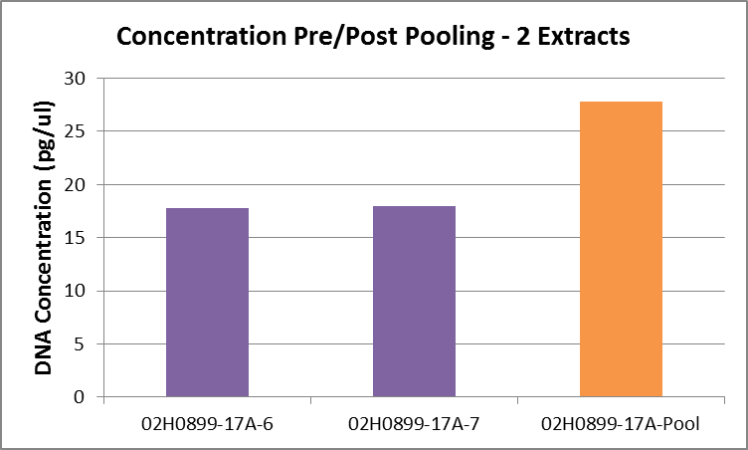

Graph 2
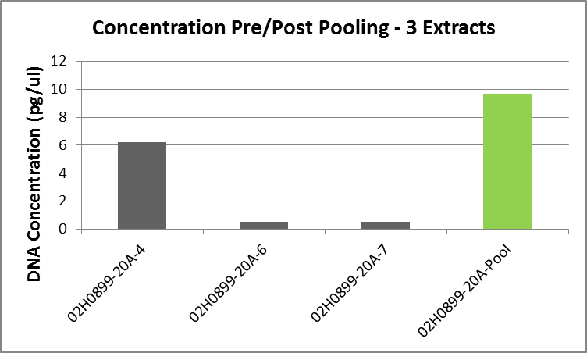

Graph 3
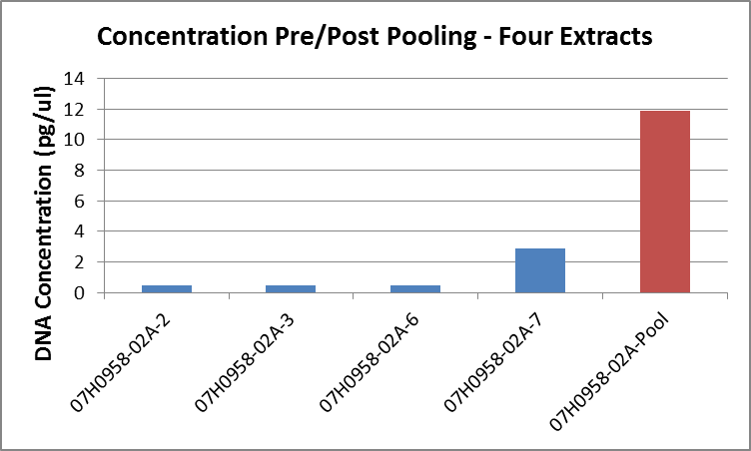

As can be seen in all three graphs above the pooling had the ability to increase the concentration by impressive amounts. In Graph 1 the two extracts which each quanted at about 16 pg/µL the final concentration was about 27 pg/µL. In Graph 2 the extracts quanted at 6 pg/µL, and <0.5 pg/µL the final pool was found to be >9 pg/µL. Finally in the four extract pool the greatest concentration change occurred with three extracts being quanted at <0.5 pg/µL and 2.2 pg/µL and the pool concentration being 12 pg/µL.
Over all Results:
Table 4: Results of Two Extract Pooled Samples
Sample | # of Alleles Called | Male DNA (pg/ul)
17A-6 | 15 | 17.8
17A-7 | 17 | 18
17A-P | 17 | 27.8
27A-2 | 1 | UND
27A-3 | 5 | 6.2
27A-P | 3 | 28.7
27A-6 | 13 | 10.7
27A-7 | 15 | 28.9
27A-P | 16 | 46
47A-2 | 0 | 3.5
47A-3 | 0 | UND
47A-P | 0 | 3.1
47A-6 | 2 | UND
47A-7 | 2 | UND
47A-P | 6 | 3.2
75A-1 | 12 | 12.7
75A-2 | 5 | 2.8
75A-P | 12 | 10.5
07A-3 | 0 | UND
07A-4 | 0 | UND
07A-P | 0 | UND
03A-2 | 10 | 6.7
03A-7 | 9 | 9.8
03A-P | 6 | 7.7
17A-2 | 0 | UND
17A-3 | 0 | UND
17A-P | 0 | UND
02A-1 | 4 | UND
02A-2 | 0 | UND
02A-P | 3 | UND
02A-3 | 2 | UND
02A-4 | 7 | 7
02A-P | 7 | 6.4
17A-6 | 0 | UND
17A-7 | 0 | UND
17A-P | 5 | UND
22A-1 | 0 | UND
22A-2 | 0 | UND
22A-P | 0 | UND

Table 4 is a representation of the overall results from the samples that had two extracts pooled. The rows with a red or green background and a “-P” were the pools. If the background of the pool row is red then it means the pool did not improve the results of the samples. If the background is green it means the pool did as well or improved the results.
Table 5: Results of Three Extract Pooled Samples
Sample | # of Alleles Called | Male DNA (pg/ul)
49A-2 | 9 | 8.5
49A-3 | 3 | 12.4
49A-6 | 11 | 13.1
49A-Pool | 13 | 6.7
17A-1 | 8 | 15.8
17A-2 | 6 | 15
17A-4 | 0 | 14
17A-Pool | 13 | 18.1
20A-4 | 2 | 4.4
20A-6 | 0 | UND
20A-7 | 8 | UND
20A-Pool | 6 | 9.7
12A-2 | 0 | UND
12A-3 | 0 | UND
12A-7 | 3 | 3.9
12A-Pool | 9 | 3.2

Like Table 4, Table 5 is an overall representation of the results from samples pooled with three extracts. Unfortunately there were only a handful of cases that could be used for the three extract pooling and further studies would hopefully look at more.
Table 6: The Results of 4 Extracts pooled three sets of 09 Cases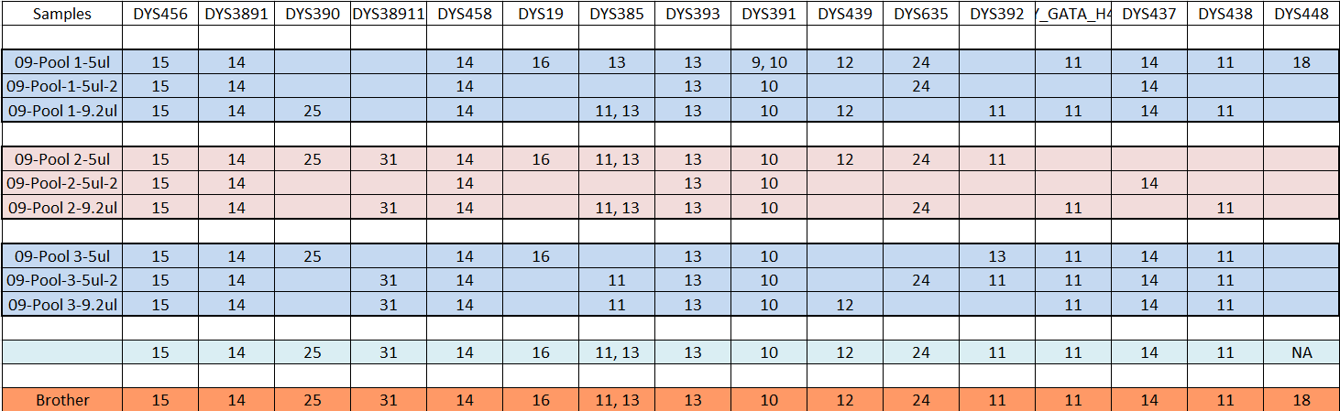
Table 6 is the results of the first set of pools made with four extracts each. The 09 cases were previously used in a different validation and had been in the fridge for many months. There were over twelve extracts available to pool of the 09 case so three sets of four were made to create pools. The individual extracts were not quanted prior to the pooling so the change in concentration was unknown. At the bottom of the table the familial reference is present which shows that the proper profile was obtained.

Table 7: The Results of 4 Extracts pooled three sets of 89 Cases
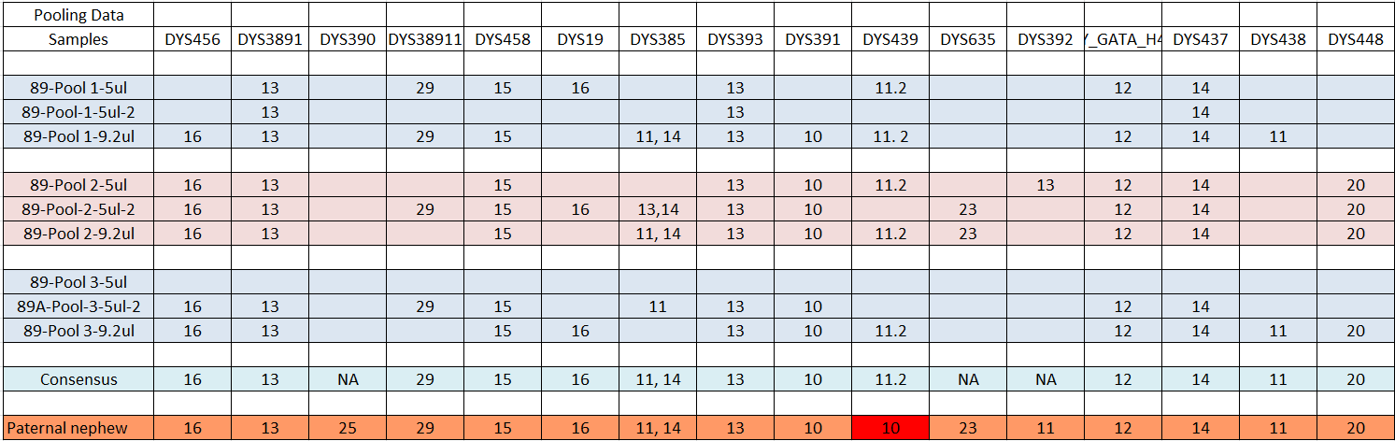
Table 7 is the same as Table 6 except that it is showing the 89 cases which used the same methods as the 09 cases. Within the 89 cases there was an 11.2 allele being called consistently within the pools. It was found that the 11.2 allele corresponded to a specific bacterium contaminant which was found in the area the remains were retrieved from in Asia.

Graph 4: The results of 4 extracts pooled for the 06 case
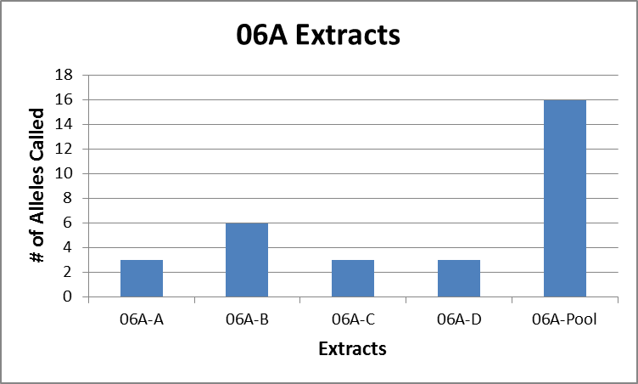

Graph 4 was the representation of the data from the 06A case. The 06A case was a solid bone that was ground into bone powder specifically for this project. 06A is one of the few samples that went through the DEMIN extraction process this summer.

Discussion/Conclusions

Overall the project succeded in proving that pooling of samples is a viable option for improving STR results of historic and ancient samples. The success of the project, as seen in Table 1, shows the samples had an 88.9 % success rate. This simple result proved both that pooling four extracts led to the best result and the method could improve STR results. The pooling of the four extracts led to an almost complete YSTR profile when the extracts (left untreated) managed to result in a maximum of 6 alleles. The 09 and 89 cases were unique because they were samples that had been refridgerated for over a year after being used for a previous validation. The 09 and 89 samples had been previously amplified with the AmpFISTR® MiniFiler™ PCR Amplification Kit in which they had resulted in a maximum of five alleles. When 09 and 89 were used with the pooling method it was astonishing to see almost complete profiles come back in the results for YSTR as well as MiniFiler.
The two extract pooling was not as successful as the four extract pooling. In Table 4 it shows that at times it was not always the concentration that would have been theoretically reached with the combination of the two extracts. For example if you take 03A-2 and 03A-7, 6.7 pg/µl and 9.8 pg/µl respectivly, should have a combined concentration of 16.5 pg/µl but instead have a pooled concentration of 7.7 pg/µl. The final pool concentration was seen to have lower amounts than expected multiple times and the reason was considered to be due to the MinElute™ purification step. Further testing of DNA retention could be beneficial at ensuring a maximum amount of the DNA is recovered during the pooling process.
The primary reason this process was developed was to mitigate the inhibition brought on from samples buried in the soil. As mentioned earlier a major inhibitor found in historic burial samples is humic acid which competes with DNA for the silica filter of the MinElute™. By using multiple small samples (instead of one large sample) and pooling them in order to limit the amount of inhibitors associated with each portion. With the results found throughout the project show that the pooling method can improve results with a high success rate and even on long stagnant samples.
In order to further inprove this method there would need to be further tests performed with a focus on replication of the results in order to test the reliability of process. It would also be prudent to attempt this process on more recent bones but still highly degraded due to environmental issues. There would also have to be a validation of the process as a whole before it could be used for casework.
Acknowledgements and Disclaimer
This experiment benefited from the input of Dr. Charla Marshall, Dr. Odile Loreille, and Dr. Pamela Staton, all of who provided assistance and critiques of the presentation of the experiment. The author would like to thank the analysts and employees of the Armed Forces DNA Identification Laboratory who gave valuable input to this project and made the experience within their lab worthwhile. The opinions and assertions contained herein are solely those of the authors and are not to be construed as official or as views of the US Department of Defense, its branches, the U.S. Army Medical Research and Materiel Command, the Armed Forces Medical Examiner System, the Federal Bureau of Investigation, or the U.S. Government.

References
- Adams, Bradley J., and John E. Byrd. "Chapter 19." Commingled Human Remains: Methods in Recovery, Analysis and Identification. 1st ed. Vol. 1. Amsterdam: Elsevier/Academic, 2014. 420-23.
- Graham, David R., Ashley N. Bybee, Susan L. Clark-Sestak, and Michael S. Finnin. "Assessment of DoD’s Central Identification Lab and the Feasibility of Increasing Identification Rates." INSTITUTE FOR DEFENSE ANALYSES (2009): 17-21.
- Harry, M., B. Gambier, Y. Bourezgui, and E. Garnier-Sillam. "Evaluation of Purification Procedures for DNA Extracted from Rich Organic Samples: Interference with Humic Substances." Analusis 27.5 (1999): 439-41.
- Loreille, Odile M., Ryan L. Parr, Kevin A. Mcgregor, Colleen M. Fitzpatrick, Chriss Lyon, Dongya Y. Yang, Camilla F. Speller, Michael R. Grimm, Michael J. Grimm, Jodi A. Irwin, and Edward M. Robinson. "Integrated DNA and Fingerprint Analyses in the Identification of 60-Year-Old Mummified Human Remains Discovered in an Alaskan Glacier." Journal of Forensic Sciences 55.3 (2010): 813-18.
- McCord, Bruce, Kerry Opel, Maribel Funes, Silvia Zoppis, and Lee M. Jantz. "An Investigation of the Effect of DNA Degradation and Inhibition on PCR Amplification of Single Source and Mixed Forensic Samples." US Department of Justice (2011): 1-66. NCJRS. 15 Sept. 2014.
- Parr, Ryan L., Shawn W. Carlyle, and Dennis H. O'rourke. "Ancient DNA Analysis of Fremont Amerindians of the Great Salt Lake Wetlands."American Journal of Physical Anthropology 99.4 (1996): 507-18.
- Sturk, Kimberly A., Michael D. Coble, Suzanne M. Barritt, and Jodi A. Irwin. "Evaluation of Modified Applied Biosystems® Y filer™ Amplification Strategy for Compromised Samples." Croatian Medical Journal 50.3 (2009): 228-38.

