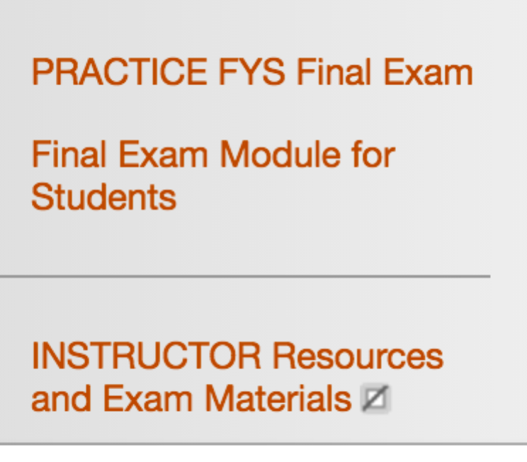
FYS Faculty Meeting
8-9 am, Tuesday, Nov. 15, 2016
Drinko 349
Agenda

Old Business
FYS Final Exam – visit this area in Blackboard/MUOnline to preview the Final Exam (PLEASE don’t share that with students in advance of the Final Exam). However, DO make use of the Practice Exam and allow students to practice. The Practice Exam contains updated exam directions/definitions, etc.

New Business
FYS participation in the COLA Undergraduate Research and Creativity Conference – Robin Riner (10 min)

Demo of a successful activity/instruction plan – Sabrina Thomas (20-25 min)
HIP Project presentation – Damien Arthur, Bill Gardner & more (20-25 min)
Please regularly visit www.marshall.edu/fys - particularly the Faculty tab for updates and resources

Open Forum – questions, comments, suggestions

Jennifer’s resources - posted in her FYS MUOnline sections – feel free to use/revise/whatever:

Student Handbook: http://www.marshall.edu/student-affairs/files/15-16-Code-of-Conduct.pdf

- Marshall University Creed: see pp 1-2
- Code of Student Rights and Responsibilities: see pp 2-3
- Group Responsibility: see pp 3-4
- STANDARDS PROSCRIBED CONDUCT AND SANCTIONS: see pp 9-

FYS - Learning Outcomes - Let's revisit the purpose of FYS by reviewing the learning outcomes. See Syllabus (link to Jennifer’s syllabus) pp 2-3

Marshall University President Jerome Gilbert’s statement the morning after the presidential election (linked to his email via MUOnline)

Opportunity to listen, learn, contribute and discuss:

Campus Conversation on Civil Discourse this Thursday, November 17 at 6:00 in MSC Room BBE5. The topic is “What is the future of civility in the digital age?” and will be facilitated by Alexander Heffner of the PBS show, “The Open Mind.”

