The Ghost of Bobby Dunbar – Instructional Plan & Assignments
*FYS Student Learning Outcomes include: Information Literacy, Inquiry-based Thinking, Integrative Thinking and Metacognitive Thinking. This assignment incorporates all three of those outcomes as well as Ethical and Civic Thinking, which is not one of the five LOs emphasized by FYS but is one of Marshall’s nine LOs.
An important component to critical/integrative thinking is to be able to consider an issue from different points of view and to consider how a single story or backstory can be an impediment to critical thinking. This assignment will challenge you to do just that!
Time needed: 2 – 3 class periods depending on how in-depth you wish to go
Materials needed: Internet access and speakers (projector and screen ideal but not absolutely necessary). *If you wish students to engage in some information literacy and inquiry based thinking, a laptop computer/iPad for each group will be necessary.
Opening Activity
Chapter One of the Critical Thinking text focus on the issue of backstories and how they can serve as impediments to critical thinking.
- Listen: Listen to “Small Thoughts in Big Brains,” a portion of This American Life Episode #293 http://www.thisamericanlife.org/radio-archives/episode/293/a-little-bit-of-knowledge?act=1
- Write: Ask students to write about and share a backstory of their own.
- Share: Ask students to share their backstories
Santa Claus Easter Bunny
Power plant smokestacks = cloud machines
Chocolate milk only comes from brown cows
Tooth fairy Xing
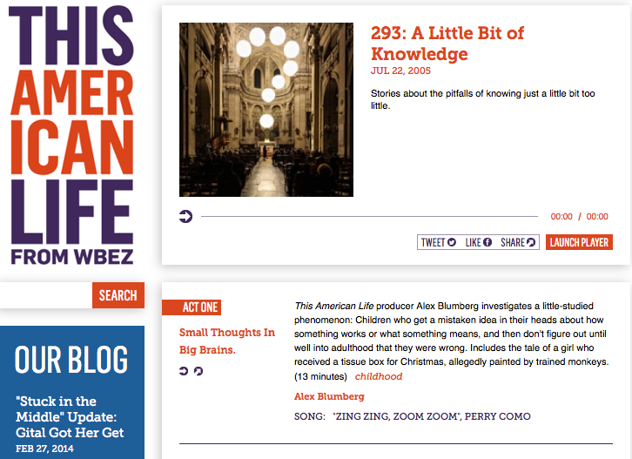
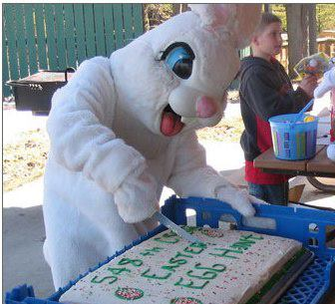

Many examples of backstories are funny and relatively harmless. What happens, however, when a backstory (or as others call it, the single story) has greater, more serious implications?
- Listen: Listen to The Danger of a Single Story by Chimamanda Adichie: http://www.ted.com/talks/chimamanda_adichie_the_danger_of_a_single_story
This is an 18 minute TED talk from July 2009.
This leads into the activity The Ghost of Bobby Dunbar. Synopsis: In 1914 in the South, two little boys go missing. About 8 months later, a little boy is found … in the company of one William Walters. Who is it? Who is the little boy? Bobby Dunbar or Bruce Anderson? What happens affects three families in significant ways for more than 100 years. Each of the three families have their own versions of the story and are firm in their beliefs. Each believes that its story, its backstory or single story is the correct story. What happens 100+years later when the original incident as well as the three family stories are re-examined and subjected to critical thinking? Here we have an example of backstories and single stories as impediments to critical thinking and what happens they are subjected elements of critical thinking (integrative thinking, inquiry-based thinking and metacognitive thinking).
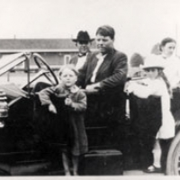
THE GHOST OF BOBBY DUNBAR
- Listen to: This American Life episode #352 http://www.thisamericanlife.org/radio-archives/episode/352/the-ghost-of-bobby-dunbar#
- More info: http://www.acaseforsolomon.com/about-the-book/
Students: The first letter of your last name will determine the family whose point of view you are assigned to represent:
Dunbar family – Last names A-G
Anderson family – Last names H-P
Walters family – Last names O-Y

PART ONE
Based on the individual/family assigned to you, complete a reflective journal entry that addresses the following points:
- Name of character or family assigned to you:
- From that character’s point of view and the character’s family members, what happened? What was this character’s role? Base your reflection in this part on the situation as it was in 1912 and the following trial and coverage. Write from a first person point of view – become that character.
- Now, fast forward (in your thinking) to then end of this story as presented in this episode of This American Life. What has changed from your character’s and family’s point of view now that more facts are known? How do these new developments make you feel? Again, write from a first person point of view – be that character.
How long does your journal entry need to be? As long as it needs to be to address the points above thoughtfully. Aim for at least 300 words, but that’s just the minimum. Take the time you need to work out your thoughts thoroughly. This isn’t a formal essay; I want you to write freely. However, run spell check and check your grammar before submitting. Type your entry in the box below and submit.
PART TWO
- Groups meet based on last name:
  - Dunbar family – Last names A-G
  - Anderson family – Last names H-P
  - Walters family – Last names O-Y
- Compare notes based on what you learned via the This American Life episode as well as information from the book’s website.
- Listen to this episode of the Diane Rehm show to get more information.
- Prepare for a two-part debate/conversation. In each group, students decide who will portray family members from 1914 and who will represent descendants from 2000+. The instructor will serve as moderator/talk show host. First, we will bring together family members from 1914 for a discussion. The instructor will prompt students/family members, who must be able to articulate what happened from their individual family members’ points of view. Likewise, in the second part of the discussion, the instructor (you may call upon your inner Maury Povich) will prompt
- Bobby Dunbar Discussion moderated by instructor
- Debrief - Bobby Dunbar Learning Outcome Writing Assignment
Bobby Dunbar Learning Outcome Writing Assignment
Of the five learning outcomes FYS focuses on, which one (NOT Ethical and Civic Thinking) do you think best connects to the Bobby Dunbar activity we’ve been investigating over the last two weeks?

Bobby Dunbar Learning Outcome Writing Assignment
Your name: _____________ Date: _______________
In Class Writing Assignment:
Select the one learning outcome you think best aligns with the Bobby Dunbar case.
a. Name it and in your own words, describe the learning outcome. What does it mean?
b. Specifically, how did the Bobby Dunbar activity help us address this learning outcome?
For instance, in Ethical and Civic Thinking, a person examines the origins of a core belief and the ethical principles it is based on. In the Bobby Dunbar case, I had to think about why the Dunbar family believed that the boy found 8 months later was their son, Bobby. If I were the mother, Lessie, I would rather believe that my little boy is alive, because what would the alternative be? That he was eaten by an alligator? I don’t want to have to face that kind of trauma. I’d rather believe that I have my little boy back with me safe and sound. Now, if I were Percy, the father, at the point of finding the little boy, perhaps I would want to console my wife who has been a wreck since our son disappeared; plus, I’m use to getting my own way. The origins of my belief come from the fact that I was born into a family that wields power in this area. My family has political power. Streets and businesses are named after the Dunbars. How does that happen? That comes from a history of strong-minded and strong-willed men. We make things happen. So, if I can make it so that this little boy is our missing son Bobby, I will do that.

