DEPARTMENT OF GEOLOGY

**2023 FRESHMAN SCHOLARSHIPS**

The Department of Geology plans to award 1 to 2 $1,500 scholarships to incoming freshmen who intend to major in Geology in Fall 2023. The awards will be made on a competitive basis. Applicants should have ACT scores (Math, Verbal, Natural Science) of at least 22. A 2-page essay outlining your interests in Geology and your career objectives must accompany your application.

**High school seniors** who qualify should apply for the Fall 2023 scholarship

by

May 16th 2023

The award amount will be $1,500. Selection will be based primarily on high school GPA, ACT scores, and essay outlining your interest and career goals. The following criteria must also be met:

1. The recipient must have declared Geology as his/her major and must maintain the major during the scholarship period.
2. The recipient must meet with the Geology Dept. Chair before registering for the Fall semester, and have their schedule approved.
3. 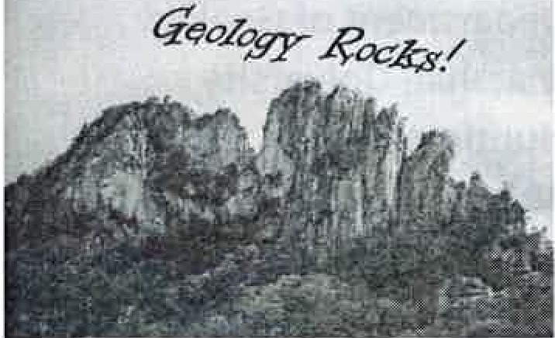The applicant must maintain at least a B average in Geology courses during the Fall semester. $750 of the $1500 will be awarded at the beginning of the full semester, and the remaining$ 750 will be awarded in December, 2023/ January 2024. The Geology scholarship will be used to pay for any tuition and books not covered by other grants or scholarships.

Successful candidates will be notified by June 1, 2023 .

**GEOLOGY DEPARTMENT SCHOLARSHIP APPLICATION FOR HIGH SCHOOL SENIORS**

**Fall 2023**

Name of Applicant: _ Date of Application: _

Address:

Street/Box

City Zip _

State ---

Contact Info:

Phone EmaiI

High School: _

Overall High School GPA through Fall 2022: _ ACT Scores: Sat Scores:

Math

Reading -----

Science ------

Other

Math Reading _

Science ------

Other

Please submit this form along with a 2-page, double-spaced essay outlining your interests and career goals to:

Dr. Aley EI-Shazly Professor & Chair Department of Geology **Marshall University Huntington, WV 25755**

**304-696-6756**

[**elshazly@marshall.edu**](mailto:elshazly@marshall.edu)