Robert E. Fox Field Camp Scholarship
Summer - 2015
Application Deadline: MARCH 30, 2015

The Marshall University Department of Geology is pleased to announce the availability of a scholarship to be applied to tuition and expenses for a geology field camp in 2015. The amount of the scholarship is $2500. In cases where two strong candidates apply, the scholarship may be split so that both can attend field camp.

This scholarship is provided through the generosity of Robert Fox, who graduated from Marshall with a B.S. in Geology in 1952 and from the University of Illinois with an M.S. in Geology in 1953. Mr. Fox has had a long and distinguished career as a petroleum geologist. Most field camps run for 6 weeks and are for 6 hours of credit. Applicants may apply for camps that are from 4 to 8 weeks in length and from 4 to 8 credit hours.

Applicant must be a junior or senior, full-time, B.A. or B.S. Geology Major. Prior coursework must meet the prerequisites specified by the field camp and will usually include at least GLY 200 (or 110), 210L, 201, 211L, 313, 325, 421 or 423. Selection of the successful candidate will be made by Geology Department faculty and will based on:

1) GPA in Geology,
2) overall GPA,
3) degree option (preference for BS over BA),
4) financial need,
5) academic and career objectives, and
6) whether field camp will be used to fulfill the capstone requirement.

Application forms available from Department Chair
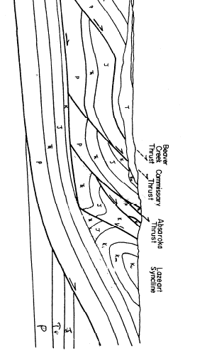

GEOLOGY SUMMER FIELD CAMP SCHOLARSHIP APPLICATION--2015

Name of Applicant:___________________________ I.D. #:________________

Date of Application:_________________________

Permanent Address:
Street/Box:___________________________________
City:_________________________State______Zip:___________
Phone Number:____________________

Local Address:
Street/Box:_______________________________________
City:_________________________State:____/Zip:___________
Phone Number:____________________
E-mail: __________________________

Major:_____________________

Overall GPA through F-14:__________ (Credit hours completed: _____ )

Geology GPA through F-14:_________ (Credit hours completed: _____ )

Total Credit Hours for Spring 2015: _________

Geology Credit Hours for Spring 2015: _________

Other forms of financial support that you have or for which you are applying:
(Scholarships, Work Study, Grants, etc.)

Expected Family Contribution (EFC) [from 2014-2015 FAFSA financial aid form]

$ _______________________

Name of School Offering Field Camp:___________________________

Starting date and duration of field camp:___________________________

Field Camp location:___________________

Application deadline:________________

Please include with this application:
1) brochure or downloaded info on instructors, scope, location, costs, etc.;
2) detailed (typed, Excel recommended), itemized budget of all costs that you anticipate will be associated with field camp (include travel to and from field camp location, as well as tuition, lodging, food, etc.); and
3) 1-page (typed) statement outlining your academic and career objectives and how this field camp would help you achieve them.

Submit applications and all supporting material to Department Chair in S176/ S131.

