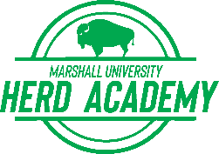

STUDENT QUESTIONNAIRE

Any student wishing to enroll in any college course under the College Credit Plus program must complete this questionnaire.
A student eligible to participate in College Credit Plus and admitted to a college/university will enroll in actual college courses, which may include “mature subject matter” as defined in Ohio Revised Code 3365.035.

Circle one choice in response to each question:

- Do you possess the necessary social and emotional maturity to participate in the College Credit Plus program?

[YES] [NO]

2. Are you ready to accept the responsibility and independence that a college classroom demands?

[YES] [NO]

Student Information – PLEASE TYPE OR PRINT:
Student Name: _______________________________________________________________
Name of High School (or homeschooled): __________________________________________

Student Signature: _______________________________________________ Date: _________________

RETURN THIS COMPLETED FORM TO THE COLLEGE/UNIVERSITY IN WHICH THE STUDENT IS ENROLLING. FOLLOW THE COLLEGE’S INSTRUCTIONS TO SUBMIT THIS FORM.
Michelle Biggs, Director of the Herd Academy
1 John Marshall Drive
Huntington, WV 25755
Miller138@marshall.edu

Although a signature by the student is not required by law, a college or university may wish to include it.

