Dynamic Forms: Managing Co-Signers
Dynamic Forms allows administrators to manage co-signers of individual forms. This is helpful when re-sending email notifications to co-signers or changing co-signers when a form is directed to the wrong individual.
These instructions are applicable to Dynamic Forms users with Form Admin access.
- Login to Dynamic Forms by going to MyMU Employee tab (or Faculty) Services Dynamic Forms link.

- To the right of the form name, click the number in the Multi column. If a form has been submitted, but not all co-signers have signed it, the form will be located in the Multi queue.
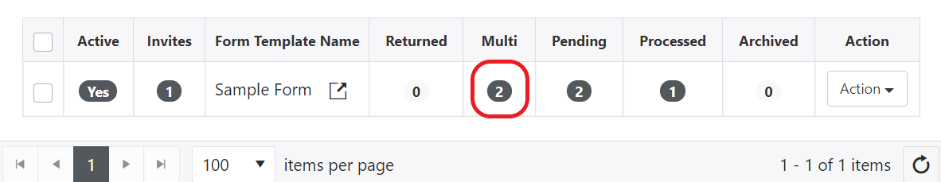

- Find the form in question by Submit Date or another field on the form. To the left of the form, click Actions, then Manage Co-Signers and a new window will open.
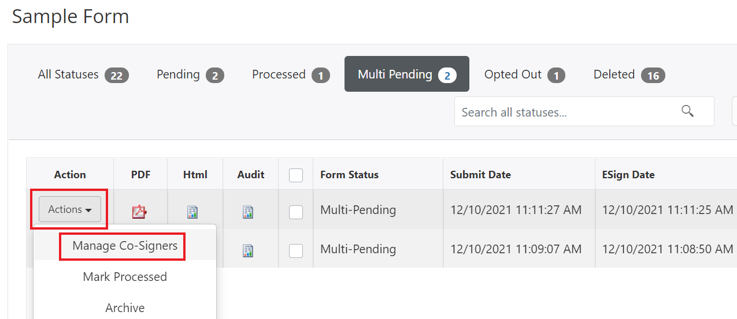

- To resend a notification to a co-signer, click Actions next to their name, then Resend Email. The individual will receive another notification to sign the form, including a link to visit the form directly.

To Edit the co-signer, click Edit Cosigner and continue to Step 5.
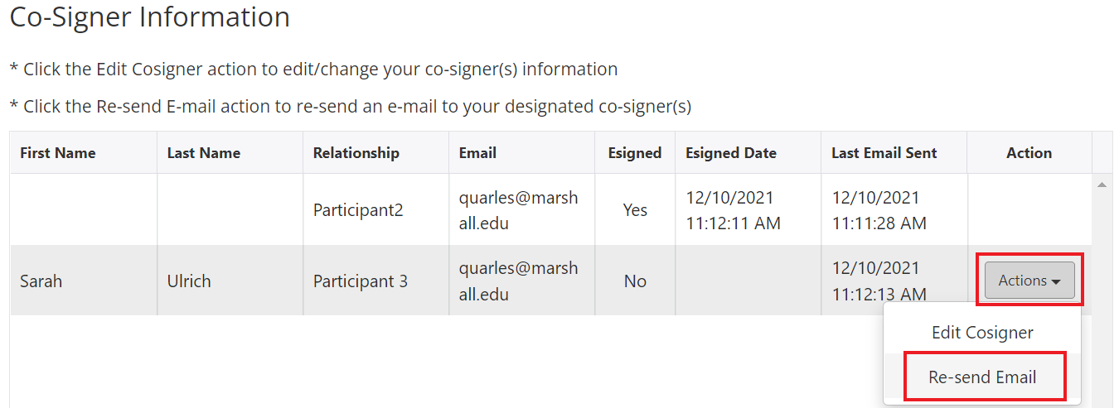
- After clicking Edit Cosigner, a new window will open. Enter the first name, last name, and email address of the new co-signer. *Be sure to enter the co-signer’s UPN email address, not their vanity address (ie. username@marshall.edu. Dynamic Forms will not accept first.lastname@marshall.edu format).
Click Save and Re-send Email so the new co-signer receives a notification and link.
