BANNER DATA EXTRACT

The extract option for a Banner form has been made available to those individuals with query privileges to said Banner form. Though the data will be stored in an electronic format outside of Banner, the information is not to be shared with individuals that do not have current query privileges to that data. In addition, all electronic storage of this information should be properly secured to protect the information from inappropriate access.

Using the Data Extract feature of Banner will allow a user to download information from an on-line form to an Excel spreadsheet. Currently, three forms (FGIBDST, FGITRND, and FGIOENC) have been set-up to use this feature.

DOWNLOADING TEMPLATES FROM THE WEB

The FGIBDST , FGITRND, and FGIOENC templates allow the user to download extracted information into a spreadsheet that has established column headers and formulated dollar amounts.

To download these spreadsheet templates from the web to your desktop, go to http://www.marshall.edu/accounting/. Select “Forms (Currently in place). Look under “Banner Related” for the instructions and templates.

To save the template to your desktop, open the template in Excel and save as follows:

Select “File”
Select “Save As”
Select “Local Disk (C:)”
Select “Documents and Settings”
Select “user_name”
Select “Application Data”
Select “Microsoft”
Select “Templates”

C:\Documents and Settings\user_name\Application Data\Microsoft\Templates

Make sure the “Save as type” reads “Templates”.

Saving the templates in this manner will allow quick access to them from Excel.

DOWNLOADING TO WINDOWS XP

Select the template you wish to download.
Save to “File” “Program Files” “Microsoft Office” “Templates” “1033”
Save this as a Microsoft Excel Spreadsheet.
When the download is completed, select “Open”.
After the spreadsheet is open, select “File” and “Save As” using the same file name, but changing the File type to “Template”. Save
This will put the template in the General Templates folder on Excel.

If you have any problems downloading these templates from the web, please contact Selah Wilson or Linda Mollohan via e-mail.
FGIBDST EXTRACT

To extract data from FGIBDST, access that form as you normally would for on-line inquiry purposes.

Once the information appears on the screen, go to “Help” on the toolbar and select “Extract Data No Key.”

You will see the following block of information, indicating the file where the extracted data has been stored.

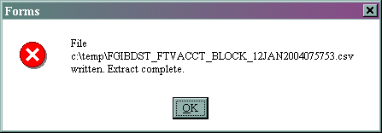

In Excel, retrieve the FGIBDST template by selecting “File” and “New”. Look under “General Templates” and select this document.

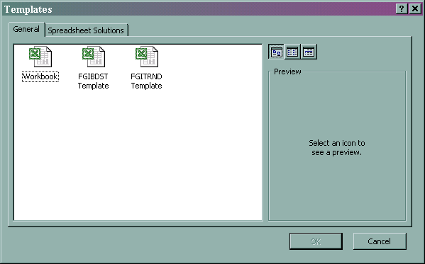

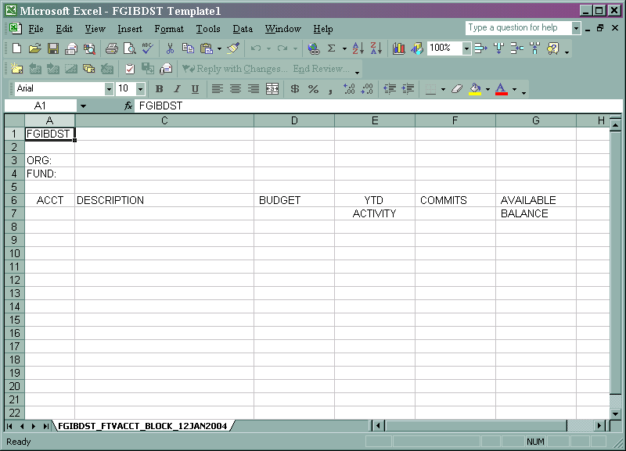

On the toolbar, go to “Data”, then “Import External Data”, then “Import Data”

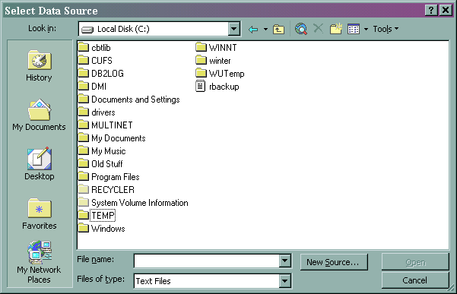

Select the “TEMP” folder, then select the appropriate extracted FGIBDST file. Make sure that “Files of type:” reads “Text Files”, “All Files”, or “All Data Sources”.

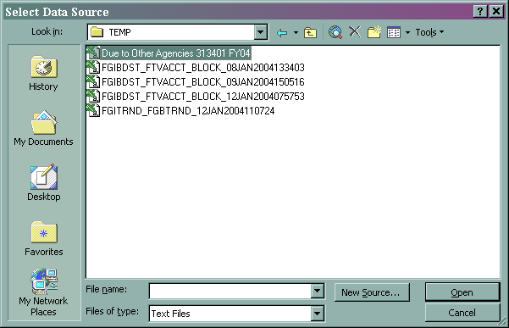

When the extracted file is selected, the Text Import Wizard Screen should appear.

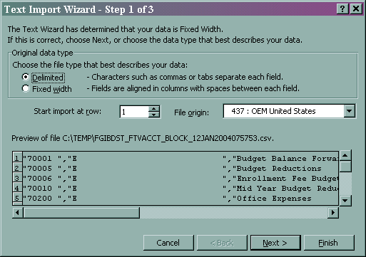

Select “Delimited” as the Original Data Type. Go to the Next screen.

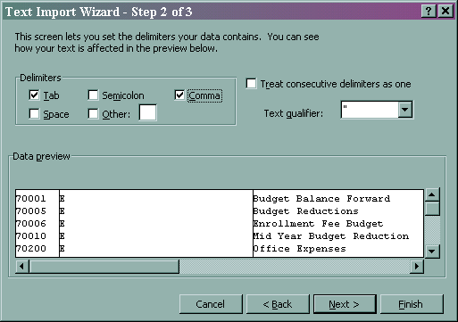

Select “Tab” and “Comma” as the Delimiters. Select “Finish”.

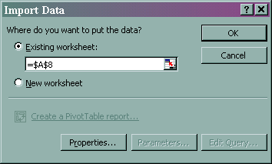

Select “Existing worksheet;” and change the option to “=$A$8”.

Click on “OK”. This will put the data into the template.

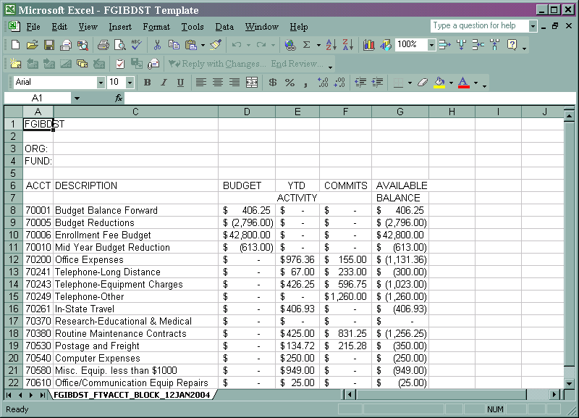

IMPORTANT!!! You must now save the file as an Excel file by going to “File” and “Save as”. You may save this under the file name and folder of your choice. If you do not do this, you will be unable to use other Excel functions on the spreadsheet and may corrupt your template file.

FGITRND EXTRACT

To extract data from FGITRND, access that form as you normally would for on-line inquiry purposes.

Once the information appears on the screen, go to “Help” on the toolbar and select “Extract Data No Key.”

You will see the following block of information, indicating the file where the extracted data has been stored.

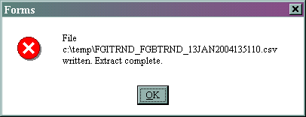

In Excel, retrieve the FGITRND template by selecting “File” and “New”. Look under “General Templates” and select the document.

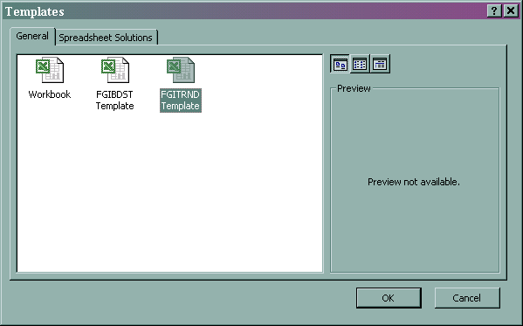

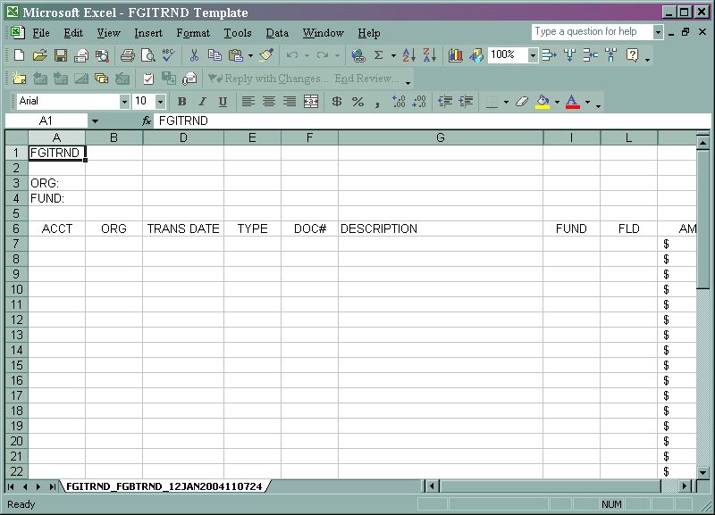

On the toolbar, go to “Data”, then “Import External Data”, then “Import Data”

Select the “TEMP” folder, then select the appropriate extracted FGITRND file. Make sure that “Files of type:” reads “Text Files”, “All Files”, or “All Data Sources”.

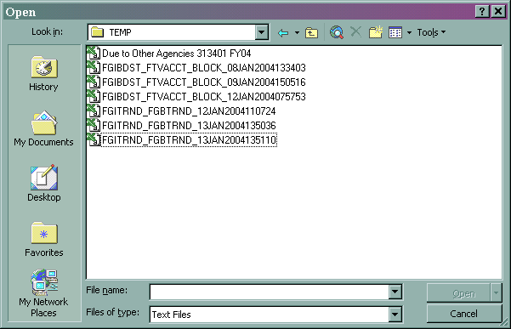

When the extracted file is selected, the Text Import Wizard Screen should appear.

Select “Delimited” as the Original Data Type. Go to the Next screen.

Select “Tab” and “Comma” as the Delimiters. Select “Finish”.

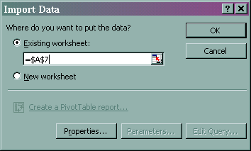

Select “Existing worksheet;” and change the option to “=$A$7”.

Click on “OK”. This will put the data into the template.

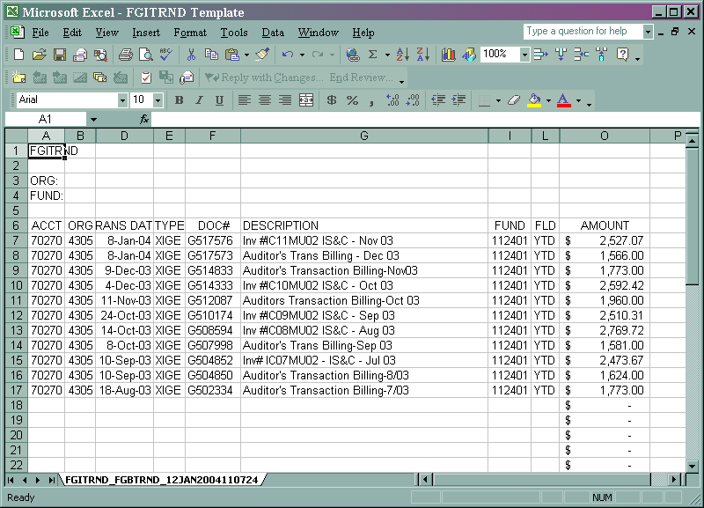

IMPORTANT!!! You must now save the file as an Excel file by going to “File” and “Save as”. You may save this under the file name and folder of your choice. If you do not do this, you will be unable to use other Excel functions on the spreadsheet and may corrupt your template file.

FGIOENC EXTRACT

To extract data from FGIOENC, access that form as you normally would for on-line inquiry purposes.

Once the information appears on the screen, go to “Help” on the toolbar and select “Extract Data No Key.”

You will see the following block of information, indicating the file where the extracted data has been stored.

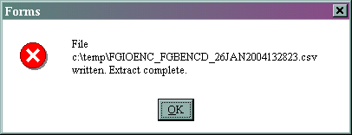

In Excel, retrieve the FGIOENC template by selecting “File” and “New”. Look under “General Templates” and select the document.

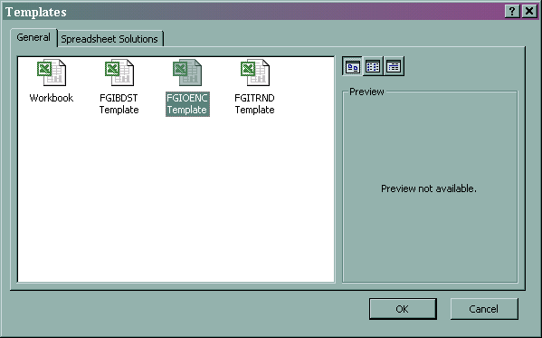

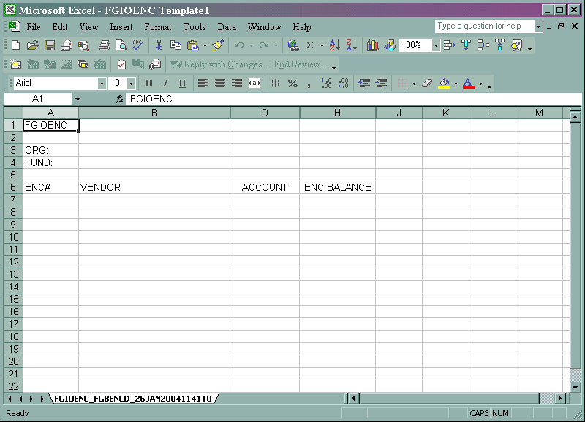

On the toolbar, go to “Data”, then “Import External Data”, then “Import Data”

Select the “TEMP” folder, then select the appropriate extracted FGIOENC file. Make sure that “Files of type:” reads “Text Files”, “All Files”, or “All Data Sources”.

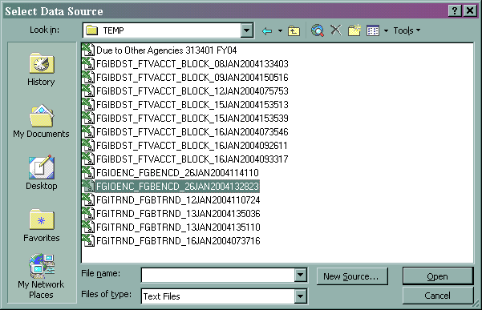

When the extracted file is selected, the Text Import Wizard Screen should appear.

Select “Delimited” as the Original Data Type. Go to the Next screen.

Select “Tab” and “Comma” as the Delimiters. Select “Finish”.

Select “Existing worksheet;” and change the option to “=$A$7”.

Click on “OK”. This will put the data into the template.

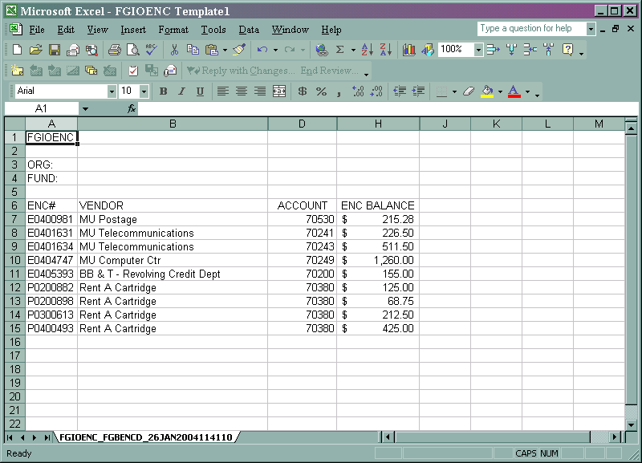

IMPORTANT!!! You must now save the file as an Excel file by going to “File” and “Save as”. You may save this under the file name and folder of your choice. If you do not do this, you will be unable to use other Excel functions on the spreadsheet and may corrupt your template file.

TIPS FOR EXTRACTING DATA

When extracting data from these on-line forms, remember that information contained in these on-line forms is current for all transactions that have been posted year-to-date at the time you are viewing the form.

If expense information is needed for a particular month, you may retrieve the information by going to FGIBDST and select “Transaction Detail Information” (FGITRND). Select “Rollback”. On the first line of information, delete the account code if you want to see all transactions or enter the particular account code you are investigating. In the block labeled “Prd”, enter the fiscal month you want information on (July=01, August=02, etc.). Do “Control” “Page Down”. In the block labeled “Fld”, type in “YTD”. Click on the “F8” key. This will extract all transactions for that particular fiscal month for the requested account codes.

Neither the FGIBDST nor FGITRND forms allow for year-to-date information to be requested as of the end of a particular month. You may want to extract each month separately and then build a year-to-date spreadsheet with that information.

