

*This program is presented by the College of Arts and Media   
through the School of Music.*

               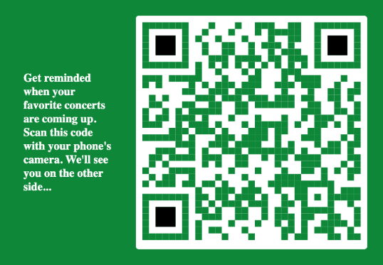

**TuesDAY, March 1, 2022**

|  |  |  |  |  |
| --- | --- | --- | --- | --- |
|  |  | [**Event**](https://www.marshall.edu/music/calendar/?trumbaEmbed=view%3Devent%26eventid%3D155007821)  time   |  |  | | --- | --- | | Location: | [Smith Music Hall](https://www.marshall.edu/music/calendar/?trumbaEmbed=view%3Dobject%26objectid%3D1104720%26key%3De88226112ff561e5c184e324a3ed0a2e) | |

**TueSDAY, march 1, 2022**

|  |  |  |  |  |  |
| --- | --- | --- | --- | --- | --- |
|  |  |  | [**Event**](https://www.marshall.edu/music/calendar/?trumbaEmbed=view%3Devent%26eventid%3D155007821)  time   |  |  | | --- | --- | | Location: | [Smith Music Hall](https://www.marshall.edu/music/calendar/?trumbaEmbed=view%3Dobject%26objectid%3D1104720%26key%3De88226112ff561e5c184e324a3ed0a2e) | |

**TueSDAY, march 1, 2022**

|  |  |  |  |
| --- | --- | --- | --- |
|  |  |  | [**Event**](https://www.marshall.edu/music/calendar/?trumbaEmbed=view%3Devent%26eventid%3D154681285)  time  Location: [Smith Music Hall](https://www.marshall.edu/music/calendar/?trumbaEmbed=view%3Dobject%26objectid%3D1104720%26key%3De88226112ff561e5c184e324a3ed0a2e) |

**TueSDAY, march 1, 2022**

|  |  |  |  |
| --- | --- | --- | --- |
|  |  |  | [**Event**](https://www.marshall.edu/music/calendar/?trumbaEmbed=view%3Devent%26eventid%3D154681285)  time  Location: [Smith Music Hall](https://www.marshall.edu/music/calendar/?trumbaEmbed=view%3Dobject%26objectid%3D1104720%26key%3De88226112ff561e5c184e324a3ed0a2e) |

**PROGRAM NOTES**

**PROGRAM**

Please silence all devices and hold applause   
until the end of each complete work.