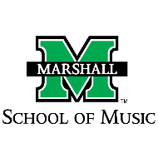
Marshall University School of Music

Spending Authorization Form

To use any School of Music funds, faculty and staff must receive approval by the SOM Director and then submit this form (completed and signed) along with other required spending paperwork submitted to the College of Arts and Media for payment.*

Date _______________________________

Amount requested
(SOM) _______________________________

This request is for annual Professional Development Funds. YES_____ NO_____

Name ___________________________________________________

Purpose of
Funding ___________________________________________________

___________________________________________________

___________________________________________________

___________________________________________________
(Provide as much detail as possible. If this request is for use of professional development funds, include the name and location of conference, research trip, training, etc. and the dates and faculty role (presenter, attendee/participant, researcher, etc.)

_______________________________________________
Signature (individual making request)

_______________________________________________
SOM Director signature

(*Before submitting this form to the College of Arts and Media, file a copy of the signed form with the School of Music.)

