

Senior Recital

Name, instrument

*This program is presented by the College of Arts and Media   
through the School of Music.*

**TuesDAY, OctoBER 5, 2021**

|  |  |  |  |  |
| --- | --- | --- | --- | --- |
|  |  | [**Event**](https://www.marshall.edu/music/calendar/?trumbaEmbed=view%3Devent%26eventid%3D155007821)  time   |  |  | | --- | --- | | Location: | [Smith Music Hall](https://www.marshall.edu/music/calendar/?trumbaEmbed=view%3Dobject%26objectid%3D1104720%26key%3De88226112ff561e5c184e324a3ed0a2e) | |

**THURSDAY, OCTOBER 7, 2021**

|  |  |  |  |  |  |
| --- | --- | --- | --- | --- | --- |
|  |  |  | [**Event**](https://www.marshall.edu/music/calendar/?trumbaEmbed=view%3Devent%26eventid%3D155007821)  time   |  |  | | --- | --- | | Location: | [Smith Music Hall](https://www.marshall.edu/music/calendar/?trumbaEmbed=view%3Dobject%26objectid%3D1104720%26key%3De88226112ff561e5c184e324a3ed0a2e) | |

|  |  |  |
| --- | --- | --- |
|  |  | [**Event**](https://www.marshall.edu/music/calendar/?trumbaEmbed=view%3Devent%26eventid%3D154681285)  time  Location: [Smith Music Hall](https://www.marshall.edu/music/calendar/?trumbaEmbed=view%3Dobject%26objectid%3D1104720%26key%3De88226112ff561e5c184e324a3ed0a2e) |

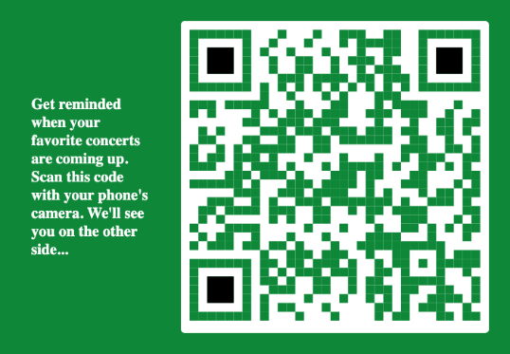

Day, Month date, time pm

location

Accompanied by:

Accompanist name, piano

**PROGRAM NOTES**

**PROGRAM**

**program notes.**

Please silence all devices and hold applause   
until the end of each complete work.

*Title Composer*

Date

Title Composer

Date

Name, instrument